

Ditton Lodge Primary School Child Protection Procedures
Date: September 2025 Next review due by September 2026
Our Designated Safeguarding Staff

 |  |  | 
John Hollick | Lisa Tweed | Sarah Eaton | Katie Farnham
Designated Safeguarding Lead (DSL) | Executive Head/ Deputy DSL | Deputy DSL | Deputy DSL
jhollick@dittonlodgeprimary.co.uk | ltweed@dittonlodgeprimary.co.uk | seaton@dittonlodgeprimary.co.uk | kfarnham@dittonlodgeprimary.co.uk
 | 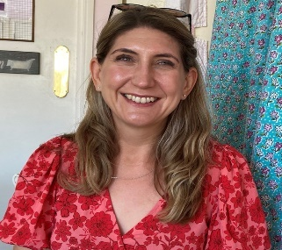 |  | 
Anna Shicluna | Gemma Hewitt | Gemma Frost | Jemma Lynch  Steve Watts
Deputy DSL | Safeguarding Governor | Director of Education | Trust Safeguarding Leads
ashicluna@dittonlodgeprimary.co.uk | ghewitt@houldsworthvalleyacademy.co.uk | gfrost@unitysp.co.uk | TrustDsl@unitysp.co.uk

