

**FX6 BURSARY FORM LINKS AND QR CODES**

Application Form - Travel Expenses -

<https://forms.office.com/e/mm6Nr8VTqB> <https://forms.office.com/e/APcfWJXYsJ>

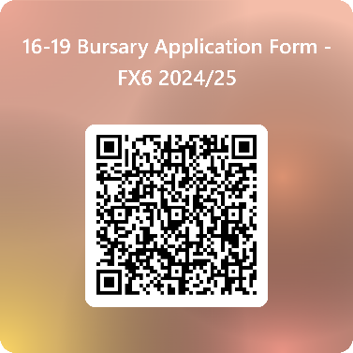 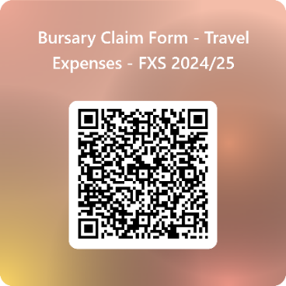

Course Materials - School Trips and Visits -

<https://forms.office.com/e/eFW44BGVnb> <https://forms.office.com/e/mE6nWKACfz>

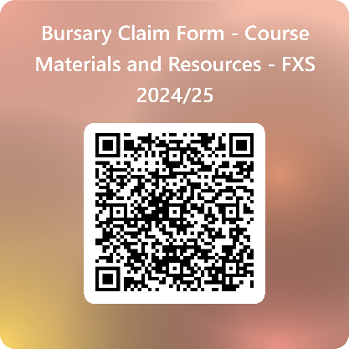 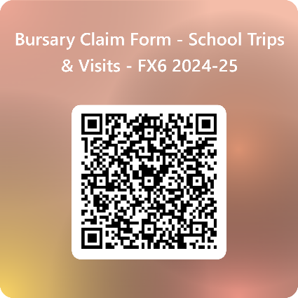

Other Expenses -

<https://forms.office.com/e/P8pFQz22A8>

