# Relationships and Sex Education Policy - Draft



|  |  |  |
| --- | --- | --- |
| **Approved** |  | **Date:** |
| **Last reviewed on:** |  |  |
| **Next review due by:** |  |  |

**Contents**

1. Aims ................................................................................................................................................................. 3

2. Statutory requirements .................................................................................................................................... 3

3. Policy development.......................................................................................................................................... 3

4. Definition .......................................................................................................................................................... 3

5. Curriculum ....................................................................................................................................................... 4

6. Delivery of RSE ............................................................................................................................................... 4

7. Roles and responsibilities ..............................................................................................................................4-5

8. Parents’ right to withdraw ................................................................................................................................ 5

9. Training ............................................................................................................................................................ 6

10. Monitoring arrangements............................................................................................................................... 6

Appendix 1: Curriculum map ............................................................................................................................ 7-8

Appendix 2: By the end of primary school children should know ......................................................................9-12

**Aims**

The aims of relationships and sex education (RSE) at our school are to:

* Provide a framework in which sensitive discussions can take place
* Prepare children for puberty, and give them an understanding of sexual development and the importance of health and hygiene

 Help children develop feelings of self-respect, confidence and empathy

 Create a positive culture around issues of sexuality and relationships

 Teach children the correct vocabulary to describe themselves and their bodies

**Statutory requirements**

As a primary academy we must provide relationships education to all children as per section 34 of the [Children and Social work act 2017.](http://www.legislation.gov.uk/ukpga/2017/16/section/34/enacted)

We do not have to follow the National Curriculum but we are expected to offer all children a curriculum that is similar to the National Curriculum including requirements to teach science which would include the elements of sex education contained in the science curriculum.

In teaching RSE, we are required by our funding agreements to have regard to [guidance](https://www.gov.uk/government/consultations/relationships-and-sex-education-and-health-education) issued by the secretary of state as outlined in section 403 of the [Education Act 1996.](http://www.legislation.gov.uk/ukpga/1996/56/contents)

At Kedington Primary Academy we teach RSE as set out in this policy.

**Policy development**

This policy has been developed in consultation with trust staff, children and parents. The consultation and policy development process involved the following steps:

1. Review – a working group of trust staff pulled together all relevant information including relevant national and local guidance
2. Staff consultation – all school staff were given the opportunity to look at the policy and make recommendations
3. Parent/stakeholder consultation – the policy was shared with all parents and interested parties and were asked to send written comments or questions about the policy to the working group
4. Child consultation – we investigated what exactly children want from their RSE
5. Ratification – once amendments were made, the policy was shared with the trust board and ratified

**Definition**

RSE is about the emotional, social and cultural development of children, and involves learning about relationships, healthy lifestyles, diversity, personal identity and sex education.

RSE involves a combination of sharing information and exploring issues and values.

RSE is not about the promotion of sexual activity.

**Curriculum**

Our curriculum is set out as per Appendix 1, but we may need to adapt it as and when necessary.

We have developed the curriculum in consultation with parents, children and staff, taking into account the age, needs and feelings of children.

Teachers do their best to answer all questions with sensitivity and care. By the end of Key Stage 2, we ensure that both boys and girls know how their bodies change during puberty, what menstruation is and how it affects women. We always teach this with due regard for the emotional development of the children.

If children ask questions outside the scope of this policy, teachers will respond in an appropriate manner so they are fully informed and do not seek answers online. Children will be encouraged to discuss any unanswered questions at home with parents/carers.

Primary sex education will focus on:

 Preparing boys and girls for the changes that adolescence brings

 How a baby is conceived and born

For more information about our curriculum, see our curriculum map in Appendix 1.

**Delivery of RSE**

RSE is taught within the personal, social, health and economic (PSHE) education curriculum. Biological aspects of RSE are taught within the science curriculum, and other aspects are included in the computing and physical education (PE) curriculum.

Relationships education focuses on teaching the fundamental building blocks and characteristics of positive relationships including:

 Families and people who care for me

 Caring friendships

 Respectful relationships

 Online relationships

 Being safe

 Preparing boys and girls for the changes that adolescence brings

 How a baby is conceived and born

For more information about our RSE curriculum, see Appendices 1 and 2.

These areas of learning are taught within the context of family life, taking care to ensure that there is no stigmatisation of children based on their home circumstances (families can include single parent families, LGBT parents, families headed by grandparents, adoptive parents, foster parents/carers amongst other structures) along with reflecting sensitively that some children may have a different structure of support around them (for example: looked after children or young carers).

**Roles and Responsibilities**

The trust board will approve the RSE policy, and the governing body will hold the Headteacher to account for its implementation.

**The Headteacher**

The Headteacher is responsible for ensuring that RSE is taught consistently across the school, and for managing requests to withdraw children from non-statutory components of RSE (see section 8).

**Staff**

Staff are responsible for:

* Delivering RSE in a sensitive way
* Modelling positive attitudes to RSE
* Monitoring progress

 Responding to the needs of individual children

* Responding appropriately to children whose parents wish them to be withdrawn from the non-statutory

components of RSE

Staff do not have the right to opt out of teaching RSE. Staff who have concerns about teaching RSE are encouraged to discuss this with the Headteacher.

Class teachers and HLTAs are responsible for teaching RSE at Kedington Primary Academy. Class teachers are responsible for the delivery of sex education lessons.

**Confidentiality**

Teachers conduct sex education lessons in a sensitive manner and in confidence. However, if a child makes a reference to being involved, or likely to be involved in sexual activity, then the teacher will take the matter seriously and deal with it as a matter of **child protection**. Teachers will respond in a similar way if a child indicates that they may have been a victim of abuse. In these circumstances the teacher will talk to the child as a matter of urgency following protocols laid down in the child protection policy. If the teacher has concerns, they will draw their concerns to the attention of the Headteacher. The Headteacher will then deal with the matter in consultation with health care professionals. (See also Child Protection Policy).

**Children**

Children are expected to engage fully in RSE and, when discussing issues related to RSE, treat others with respect and sensitivity.

**Parents**

The school is fully respects that the primary role in children’s sex education lies with parents and carers. We wish to build a positive and supporting relationship with the parents of children at our school through mutual understanding, trust and co-operation. In promoting this objective, we:

* Inform parents about the school’s sex education policy and practice
* Answer any questions that parents may have about the sex education of their child
* Take seriously any issue that parents raise with teachers or governors about this policy or the arrangements for sex education in the school.

**Parents’ right to withdraw**

Parents do not have the right to withdraw their children from relationships education.

Parents have the right to withdraw their children from the non-statutory components of sex education within RSE. If a parent wishes their child to be withdrawn from this part of the programme, they should discuss this with the Headteacher, and make it clear which aspects they do not wish their child to participate in. The school always complies with the wishes of parents in this regard. Parents are required to confirm this in writing.

Alternative work will be given to children who are withdrawn from sex education.

**Training**

Staff are trained on the delivery of RSE as part of their induction and it is included in our continuing professional development calendar.

The Headteacher will also invite visitors from outside the school, such as school nurses or sexual health professionals, to provide support and training to staff teaching RSE, where required.

**Monitoring arrangements**

The delivery of RSE is monitored by Laura Murray (RSE coordinator) through a range of methods including planning scrutinise, learning walks and pupil perceptions.

Children’s development in RSE is monitored by class teachers as part of our internal assessment systems. This policy will be reviewed and approved by the Trust board annually and adopted by the governing body.

Appendix 1- RSE Curriculum map

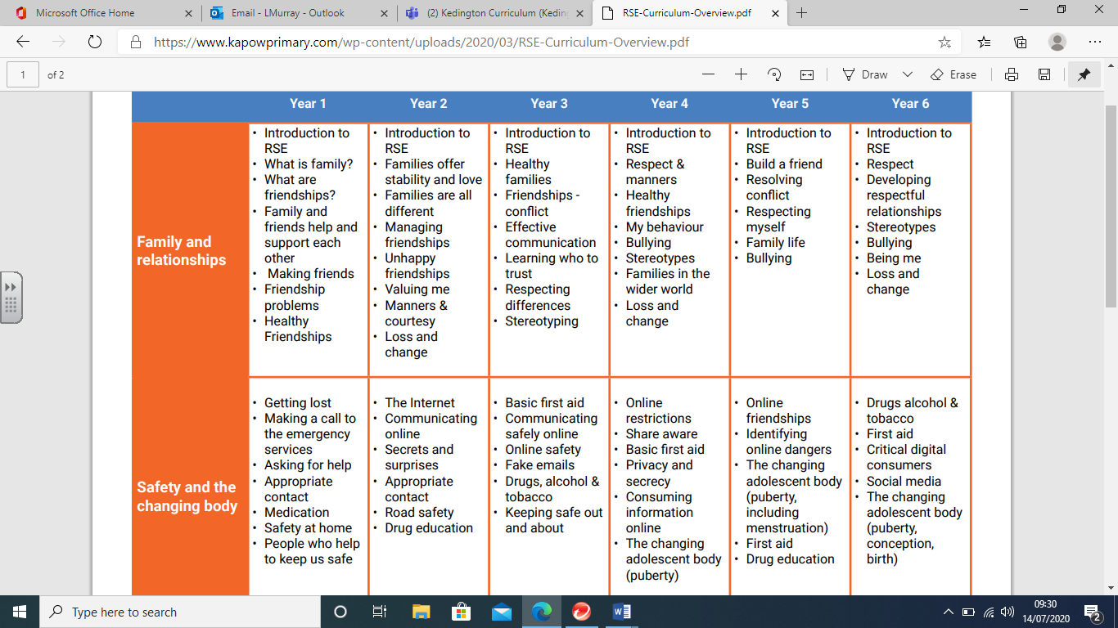

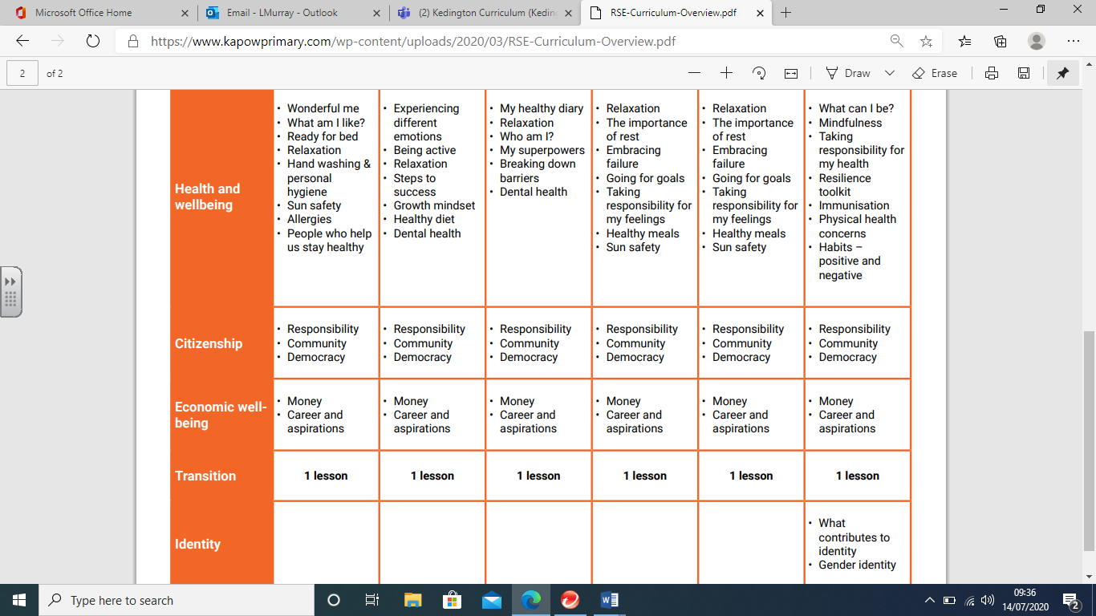

**Appendix 2: By the end of primary school children should know**

Relationships Education

|  |  |
| --- | --- |
| TOPIC | CHILDREN SHOULD KNOW |
| Families and people who care about me | * That families are important for children growing up because they can give love, security and stability * The characteristics of healthy family life, commitment to each other, including in times of difficulty, protection and care for children and other family members, the importance of spending time together and sharing each other’s lives * That others’ families, either in school or in the wider world, sometimes look different from their family, but that they should respect those differences and know that other children’s families are also characterised by love and care * That stable, caring relationships, which may be of different types, are at the heart of happy families, and are important for children’s security as they grow up * That marriage represents a formal and legally recognised commitment of two people to each other which is intended to be lifelong * How to recognise if family relationships are making them feel unhappy or unsafe, and how to seek help or advice from others if needed |
| Caring friendships | * How important friendships are in making us feel happy and secure, and how people choose and make friends * The characteristics of friendships, including mutual respect, truthfulness, trustworthiness, loyalty, kindness, generosity, trust, sharing interests and experiences and support with problems and difficulties * That healthy friendships are positive and welcoming towards others, and do not make others feel lonely or excluded * That most friendships have ups and downs, and that these can often be worked through so that the friendship is repaired or even strengthened, and that resorting to violence is never right * How to recognise who to trust and who not to trust, how to judge when a friendship is making them feel unhappy or uncomfortable, managing conflict, how to manage these situations and how to seek help or advice from others, if needed |
| Respectful  relationships | * The importance of respecting others, even when they are very different from them (for example, physically, in character, personality or backgrounds), or make different choices or have different preferences or beliefs * Practical steps they can take in a range of different contexts to improve or support respectful relationships * The conventions of courtesy and manners * The importance of self-respect and how this links to their own happiness * That in school and in wider society they can expect to be treated with respect by * others, and that in turn they should show due respect to others, including those in positions of authority * About different types of bullying (including cyberbullying), the impact of bullying, responsibilities of bystanders (primarily reporting bullying to an adult) and how to get help * What a stereotype is, and how stereotypes can be unfair, negative or destructive * The importance of permission-seeking and giving in relationships with friends, peers and adults |

|  |  |
| --- | --- |
| TOPIC | CHILDREN SHOULD KNOW |
| Online  Relationships | * That people sometimes behave differently online, including by pretending to be someone they are not * That the same principles apply to online relationships as to face-to face relationships, including the importance of respect for others online including when we are anonymous * The rules and principles for keeping safe online, how to recognise risks, harmful content and contact, and how to report them * How to critically consider their online friendships and sources of information including awareness of the risks associated with people they have never met * How information and data is shared and used online |
| Being Safe | * What sorts of boundaries are appropriate in friendships with peers and others (including in a digital context) * About the concept of privacy and the implications of it for both children and adults; including that it is not always right to keep secrets if they relate to being safe * That each person’s body belongs to them, and the differences between appropriate and inappropriate or unsafe physical, and other, contact * How to respond safely and appropriately to adults they may encounter (in all contexts, including online) whom they do not know * How to recognise and report feelings of being unsafe or feeling bad about any adult * How to ask for advice or help for themselves or others, and to keep trying until they are heard * How to report concerns or abuse, and the vocabulary and confidence needed to do so * Where to get advice e.g. family, school and/or other sources |

**Physical health and mental wellbeing (Statutory)**

|  |  |
| --- | --- |
| TOPIC | CHILDREN SHOULD KNOW |
| Mental wellbeing | * That mental wellbeing is a normal part of daily life, in the same way as physical health. * That there is a normal range of emotions (e.g. happiness, sadness, anger, fear, surprise, nervousness) and scale of emotions that all humans experience in relation to different experiences and situations. * How to recognise and talk about their emotions, including having a varied vocabulary of words to use when talking about their own and others’ feelings. * How to judge whether what they are feeling and how they are behaving is appropriate and proportionate. * The benefits of physical exercise, time outdoors, community participation, voluntary and service-based activity on mental wellbeing and happiness. * Simple self-care techniques, including the importance of rest, time spent with friends and family and the benefits of hobbies and interests. * Isolation and loneliness can affect children and that it is very important for children to discuss their feelings with an adult and seek support. * That bullying (including cyberbullying) has a negative and often lasting impact on mental wellbeing. * Where and how to seek support (including recognising the triggers for seeking support), including whom in school they should speak to if they are worried about their own or someone else’s mental wellbeing or ability to control their emotions (including issues arising online). * It is common for people to experience mental ill health. For many people who do, the problems can be resolved if the right support is made available, especially if accessed early enough. |
| Internet safety and harms | * That for most people the internet is an integral part of life and has many benefits. * About the benefits of rationing time spent online, the risks of excessive time spent on electronic devices and the impact of positive and negative content online on their own and others’ mental and physical wellbeing. * How to consider the effect of their online actions on others and know how to recognise and display respectful behaviour online and the importance of keeping personal information private. * Why social media, some computer games and online gaming, for example, are age restricted * That the internet can also be a negative place where online abuse, trolling, bullying and harassment can take place, which can have a negative impact on mental health. * How to be a discerning consumer of information online including understanding that information, including that from search engines, is ranked, selected and targeted. * Where and how to report concerns and get support with issues online. |

|  |  |
| --- | --- |
| TOPIC | CHILDREN SHOULD KNOW |
| Physical health and fitness | * The characteristics and mental and physical benefits of an active lifestyle. * The importance of building regular exercise into daily and weekly routines and how to achieve this; for example walking or cycling to school, a daily active mile or other forms of regular, vigorous exercise. * The risks associated with an inactive lifestyle (including obesity). * How and when to seek support including which adults to speak to in school if they are worried about their health. |
| Healthy eating | * What constitutes a healthy diet (including understanding calories and other nutritional content). * The principles of planning and preparing a range of healthy meals. * The characteristics of a poor diet and risks associated with unhealthy eating (including, for example, obesity and tooth decay) and other behaviours (e.g. the impact of alcohol on diet or health). |
| Drugs, alcohol and tobacco | * The facts about legal and illegal harmful substances and associated risks, including smoking, alcohol use and drug-taking. |
| Health and prevention | * How to recognise early signs of physical illness, such as weight loss, or unexplained changes to the body. * About safe and unsafe exposure to the sun, and how to reduce the risk of sun damage, including skin cancer. * The importance of sufficient good quality sleep for good health and that a lack of sleep can affect weight, mood and ability to learn. * About dental health and the benefits of good oral hygiene and dental flossing, including regular check-ups at the dentist. * About personal hygiene and germs including bacteria, viruses, how they are spread and treated, and the importance of handwashing. * The facts and science relating to allergies, immunisation and vaccination. |
| Basic first aid | * How to make a clear and efficient call to emergency services if necessary. * Concepts of basic first-aid, for example dealing with common injuries, including head injuries |
| Changing adolescent body | * Key facts about puberty and the changing adolescent body, particularly from age 9 through to age 11, including physical and emotional changes. * About menstrual wellbeing including the key facts about the menstrual cycle. |