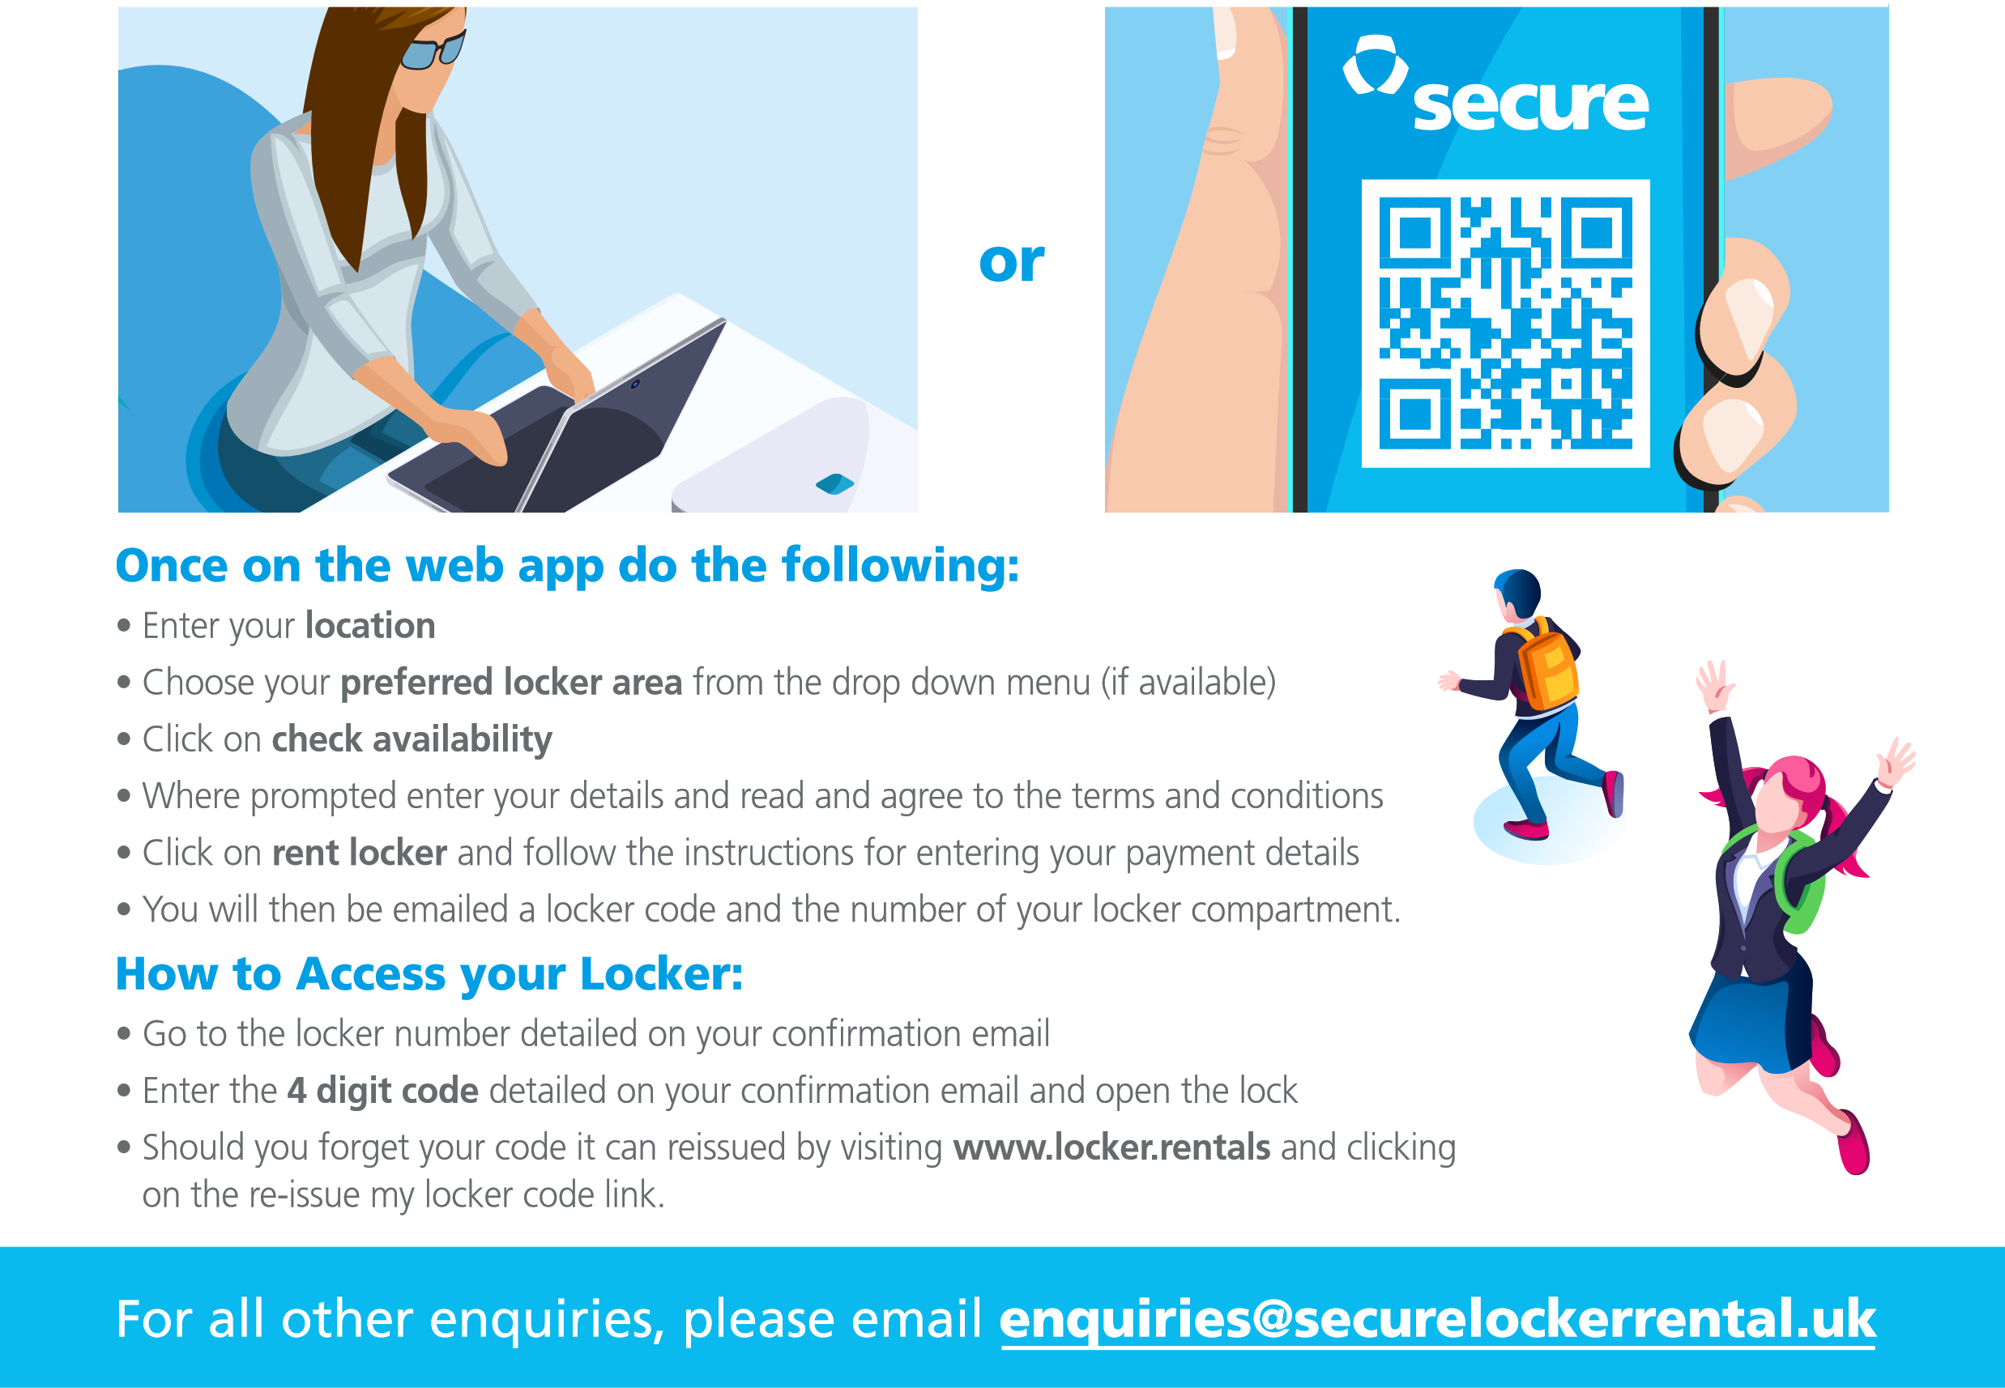Secure Locker Rental Limited, Suite A, 82 James Carter Road, Mildenhall, Suffolk IP28 7CE