Science Assessment Schedule and Revision Support

Science Assessment plan 25-26
Year | Autumn 1 | Autumn 2 | Spring 1 | Spring 2 | Summer 1 | Summer 2
7 | USP Baseline |  | Mid-year | Y7 Skills | USP Y7 milestone | End of Y7
8 | Y8 Skills |  | Mid-year |  | USP Y8 milestone | End of Y8
9 | USP end of KS3 | Y9 Autumn | USP mid-year |  | Y9 Summer | USP end of Y9
10 |  | Y10 Autumn | USP mid-year |  | Y10 Summer | Y10 PPE 1
11 | Y11 Skills | Y11 PPE 2 |  | Y11 PPE 3
12 | Suitability | Transition | Y12 Spring |  | Progress | Y12 Summer
13 | Y13 Autumn |  | Mocks |  | Y13 Summer

Why are assessments helpful?

An opportunity to identify knowledge and skills to develop for the next assessments.

An opportunity to see the progress you are making in the subject.
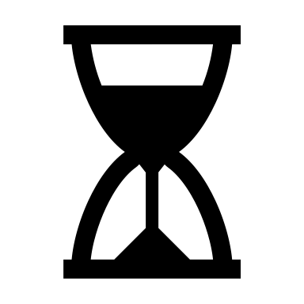
An opportunity to practice putting different pieces of knowledge together and apply it to less familiar questions.

An opportunity to practice answering questions in exam conditions: under similar pressure, time constraints and environment.
An opportunity to practice revising so you can adapt your revision strategy if it isn’t working

Support with revision
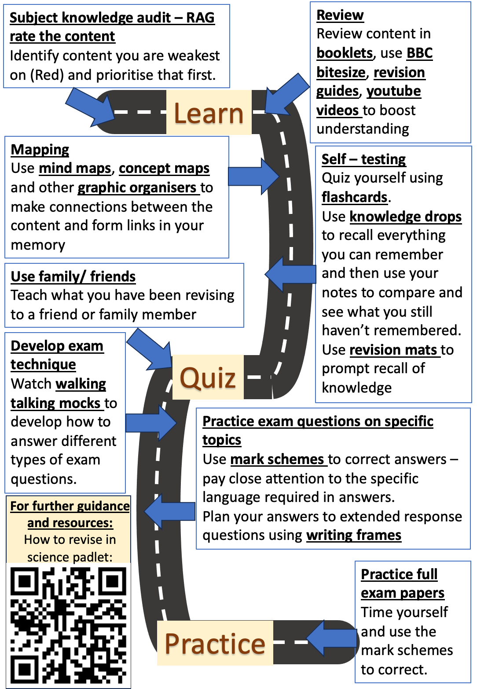
You can find resources to support with revision on our science resources padlet:
https://padlet.com/nbailey40/science_resources
On there you will find:
- A year group specific padlet - includes booklets from this year’s and previous, links to revision websites, revision mats and videos
- ‘How to revise in science’ platform https://padlet.com/nbailey40/sciencerevision - includes videos modelling revision techniques
What revision strategies are NOT effective?
- Re-reading/ re-writing notes
- Highlighting notes
- Writing flashcards
- Cramming
What revision strategies are effective?
- Self-testing using flashcards – sort into piles of what you do and don’t know and focus on the ones you don’t
- Creating mindmaps to connect ideas
- Blurting/ Knowledge drops and then filling in gaps using revision guides or knowledge organisers
- Using knowledge retrievers
- Completing past paper questions and using mark scheme to correct
- Dual coding gives multiple ways to remember
- Mnemonics
- Explain it to others
- Space your revision out in short sessions
Pomodoro technique: (25 min study – 5 min break) repeat x 4
12357 method to plan when your revision sessions will be in the 18 days leading up to an exam

How to use the booklets:
- Big question checklist at the front of booklet – allows quick audit of the content covered
- Knowledge questions at the back of booklet – allows self-testing to be carried out by covering up the answers – family and friends can also test them using these questions.

Homework
Carousel Learning is a platform we will be using for retrieval quizzes in lesson as well as setting quizzes as weekly homework and study packs to aid with assessments.
Y7-8: We will also set specific additional revision homework such as revision mats to help them prepare for these assessments.
Y9: We will set past paper questions at the end of each topic
Y10-11: We will also set past paper questions by topic each week on rotation between the three sciences

Feedback and reporting of assessment outcomes
Students will receive feedback on each assessment during one of their lessons with their lead class teacher.

The results of the assessments will also be communicated home through the scheduled progress checks. The results will be reported as a standardised score to enable progress to be better interpreted rather than it being skewed by varying difficulties of the assessments.

A standardised score of 100 will be the mean average for the cohort. For the milestone assessments the cohort is all students in that year group across the trust whereas the other assessments the cohort is all students in that year group at Samuel Ward Academy.

Recommended Revision Guides
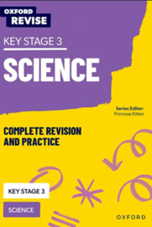
Year 7-8: Oxford Revise KS3 Science Year 10-11: Depends combined, or triple
Combined | Triple
1 x Combined Science Trilogy in either  higher or foundation  (if there is a chance your child could sit higher then I suggest getting the higher version as this will cover all the content where the foundation one won’t cover the ‘higher tier only’ content) | A separate one for each science (and no tier differences):  1 x Biology  1 x Chemistry  1 x Physics  Triple contains 1/3 more content than combined so it is important to have the triple guides and not combined.

Extra support with Year 11
Weekly homework - a useful way of getting more familiar with the exam questions and are then corrected in lesson so they know how to improve on these sorts of questions in future

Revision sessions every Tuesday P6 top floor B Block

Online science masterclasses: run by the trust science lead Mr Allen for students of all abilities – see your e-mails / contact lead teacher for details
Other recommended resources:
- CGP Required Practicals Course Booklets – a focus on questions around the required practicals
- CGP Revision Question Cards – an easy way to quiz your child on key content.
- CGP Knowledge Organisers + Knowledge Retrievers
- Collins Grade-Targeted Booster Workbooks – they do a variety of grade-focused practice

