English:
Reading
- A midsummer night’s dream
- I am not a label
- Boy in the tower
- Daffodils
This term we will be writing:
  - Third person stories set in another culture
  - Formal letters of application
  - Playscripts (Shakespeare retelling)
  - Biography
  - Poems that use word play
Science
Forces: Gravity, identify the effects of air resistance, water resistance and friction, that act between moving surfaces and to recognise that some mechanisms including levers, pulleys and gears allow a smaller force to have a greater effect.
Earth and Space: The movement of the Earth and other planets. The movement of the moon. The idea of the Earth’s rotation to explain day and night.

Art
Textiles and Collage - pupils will take inspiration from natural objects to create textile art. They will combine collage and apply techniques to create work that depicts textured surfaces. Pupils will use a variety of materials including items from nature.
-3D In this block, pupils will develop visual spatial skills as they look at the shape and form of 3D objects. They will use papier-mâché as well as develop skills to manipulate clay.

Spring Term
2025

Design Technology:
Textiles - pupils will consider the durability of fabrics. They will design and make a functional and hardwearing lunch bag.
Food and Nutrition - pupils will look to different countries to see what can be learnt from different cultures. The recipes chosen
showcase how certain foods can
contribute to good health and wellbeing.
Geography:
- Map Skills – Four and Six Figure Grid References– use the eight points of a compass, four and six-figure grid references, symbols and key (including the use of Ordnance Survey maps)
History:
Ancient Greece – We will finish our topic studying Greek life and their achievements and influence on the western world
Mayans: Studying a non European society that provides contrasts with British history – Maya c. AD 900

Year 5

Maths
Fractions and decimals
•Read, write, order and compare decimals •Round decimals to the nearest whole number •Represent, identify, name, write, order and compare fractions (including improper and mixed numbers) •Calculate fractions of amounts
Angles
Classify, compare and order angles •Measure a draw angles with a protractor •Understand and use angle facts to calculate missing angles
Fractions and Percentages
•Add, subtract fractions with denominators that are multiples of the same number •Multiply fractions (and mixed numbers) by a whole number •Explore percentage, decimal, fractions equivalence
Transformations
Coordinates in all four quadrants •Translation and reflection •Calculate intervals across zero as a context for negative numbers

RE:
Sikhism - Beliefs and moral values
Hinduism - Hindu Beliefs
Christianity - Salvation

P.E
- Fitness
- Cricket
- Tennis
- Gymnastics

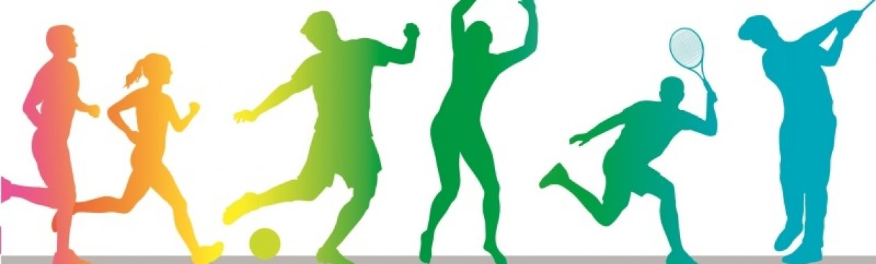
French:
- Friends and family
- Working together

Computing / iPads:
Internet Legends
Positive Digital Footprints, Spotting Fake Information Online and Refusing & Reporting.
Music:
Keyboard
Tuned focus: Musical notation
Singing
Music technology
Alter pitch and dynamic to create effects

PSHE:
Keeping Myself Safe block
Right and Respect block

