**Houldsworth Valley Primary Academy**

**Maths calculation policy**

**2024-2025**

**Introduction**

A Houldsworth Valley primary Academy we believe, at the centre of the mastery approach to the teaching of mathematics is the belief that all pupils have the potential to succeed. They should have access to the same curriculum content and, rather than being extended with new learning, they should deepen their conceptual understanding by tackling challenging and varied problems. Similarly, with calculation strategies, pupils must not simply rote learn procedures but demonstrate their understanding of these procedures through the use of concrete materials and pictorial representations. This document outlines the different calculation strategies that should be taught and used in Years 1 to 6, in line with the requirements of the 2014 Primary National Curriculum.

**Background**

The National Curriculum consists of suggested content for each year group, but schools have been given autonomy to introduce content earlier or later, with the expectation that by the end of each key stage the required content has been covered. For example, in Year 2, it is suggested that pupils should be able to ‘add and subtract onedigit and two-digit numbers to 20, including zero’ and a few years later, in Year 5, they should be able to ‘add and subtract whole numbers with more than four digits, including using formal written methods (columnar addition and subtraction)’. Specific objectives allows teachers to plan a coherent approach to the development of pupils’ calculation skills, and the expectation of using formal methods is rightly coupled with the explicit requirement for pupils to use multiple Representations, including concrete manipulatives and images or diagrams – a key component of the mastery approach.

**Purpose**

The purpose of this document is threefold. Firstly, in this introduction, it outlines the structures for calculations, which enable teachers to systematically plan problem contexts for calculations to ensure pupils are exposed to both standard and non-standard problems. Secondly, it makes teachers aware of the strategies that pupils are formally taught within each year group, which will support them to perform mental and written calculations. Finally, it supports teachers in identifying appropriate pictorial Representations and concrete materials to help develop understanding. The policy only details the strategies; teachers must plan opportunities for pupils to apply these, for example, when solving problems, or where opportunities emerge elsewhere in the curriculum.

**Developing number sense**

Developing number sense Fluency in arithmetic is underpinned by a good sense of number and an ability to understand numbers as both a concept (e.g. 7 is the value assigned to a set of seven objects) and as something resulting from a process (three beads and four more beads gives seven beads altogether or 3 + 4 = 7). Understanding that a number can be partitioned in many ways (e.g. 7 = 4 + 3; 5 + 2 = 7; 1 + 6 = 7) is key to being able to use numbers flexibly in calculating strategies. The part-whole model and, later, bar models, are particularly useful for developing ✓ ⎦ ones units is equal to equals / makes zero oh (the letter O) “The quality and variety of language that pupils hear and speak are key factors in developing their mathematical vocabulary and presenting a mathematical justification, argument or proof.” 2014 Maths Programme of Study © Ark Curriculum Plus 2023. This can be printed out and photocopied by Mathematics Mastery registered users only. 6 a relational understanding of number. Pupils who are fluent in number bonds (initially within ten and then within twenty) will be able to use the ‘Make ten’ strategy efficiently, enabling them to move away from laborious and unreliable counting strategies, such as ‘counting all’ and ‘counting on’. Increasing fluency in efficient strategies will allow pupils to develop flexible and interlinked approaches to addition and subtraction. At a later stage, applying multiplication and division facts, rather than relying on skip-counting, will continue to develop flexibility with number.

**Developing number sense in KS1 using ‘Number sense’**

The programme builds on our innate ability to process quantities visually with graphics that expose mathematical structures. With animations and exercises with visual scaffolding, and a wide range of practical activities, a deep understanding of number and quantity is developed. The programme is informed by research into the mathematical development of young children, by more than 10 years of classroom teaching, and by maths lesson observations in Shanghai. At the core of the programme are the Addition and Subtraction Fact Grids. These essential facts are the equivalent of times tables for addition and subtraction. Just as all multiplication and division calculations use root times table facts, all future addition and subtraction calculations use these root addition and subtraction facts. The core facts are taught alongside 12 calculation strategies. Learning and applying these strategies gives children a deep understanding of number and number relationships. Using these strategies children can then "use what they know to work out what they don't know". Explicit teaching of derived fact strategies is an effective route to fluency in addition and subtraction facts for all children, including lower attainers. The programme teaches every addition and subtraction fact systematically. Just as schools can tell you where they teach each grapheme-phoneme correspondence in phonics, the Number Sense Maths Fluency Programme systematically teaches the facts and strategies leaving nothing to chance.

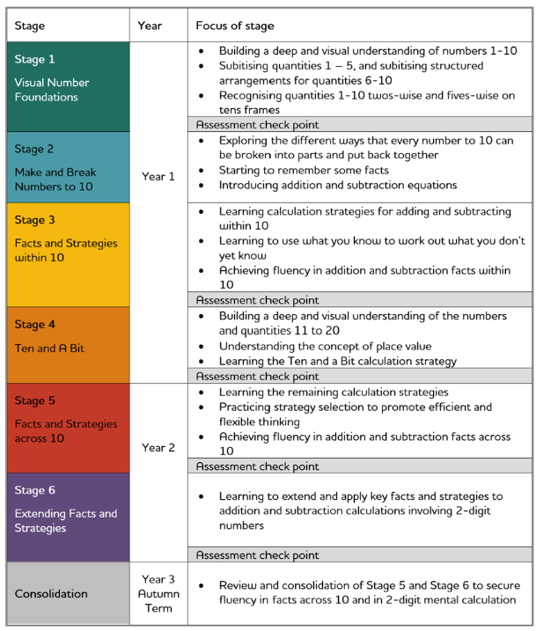

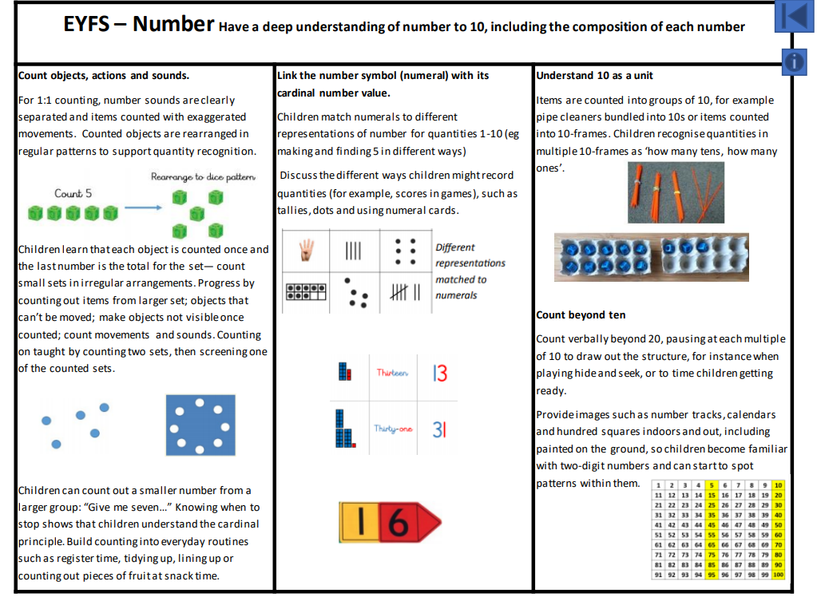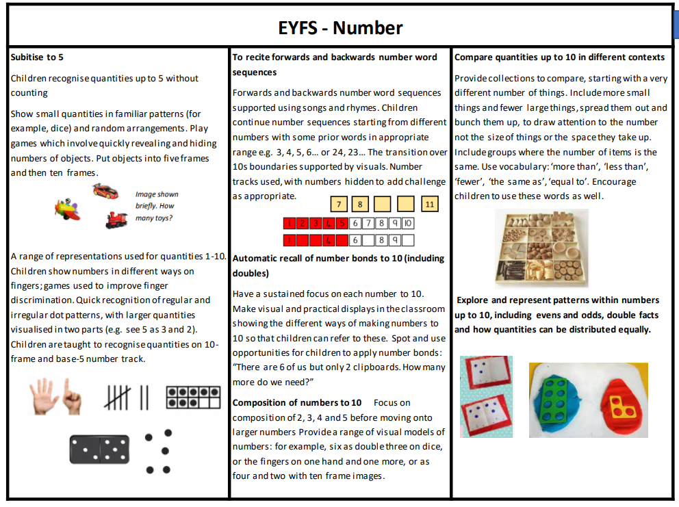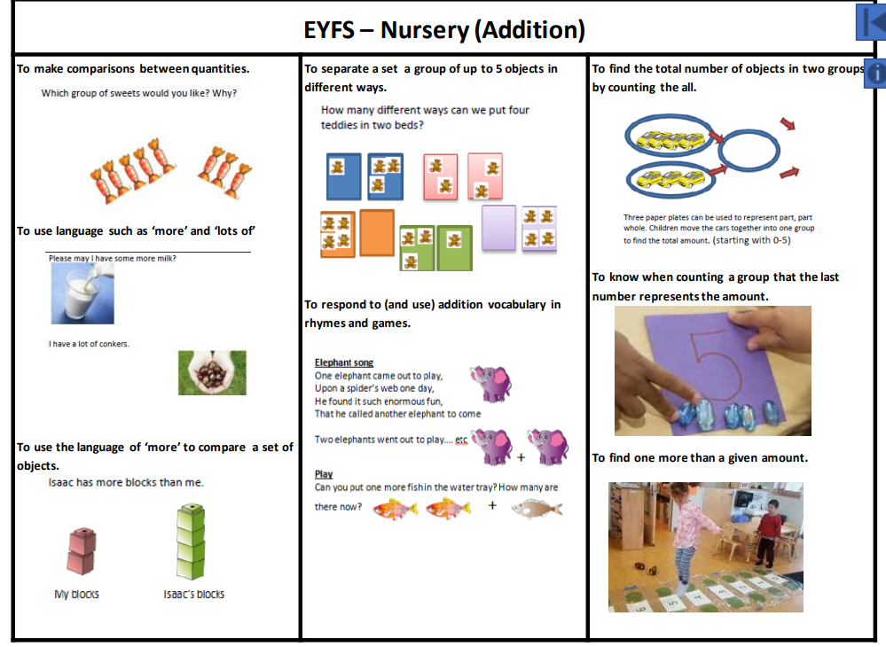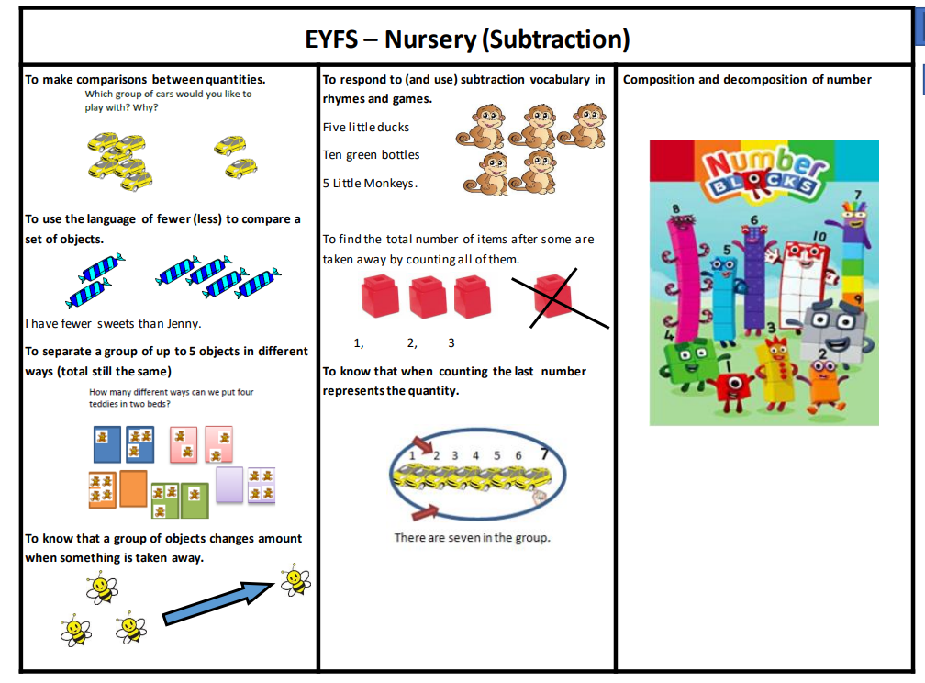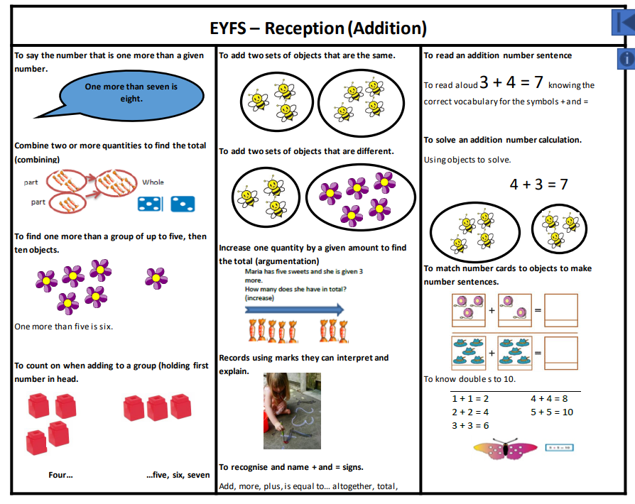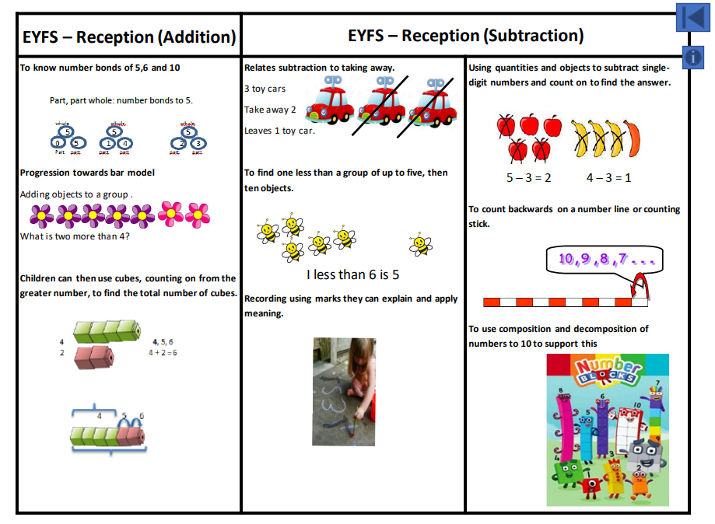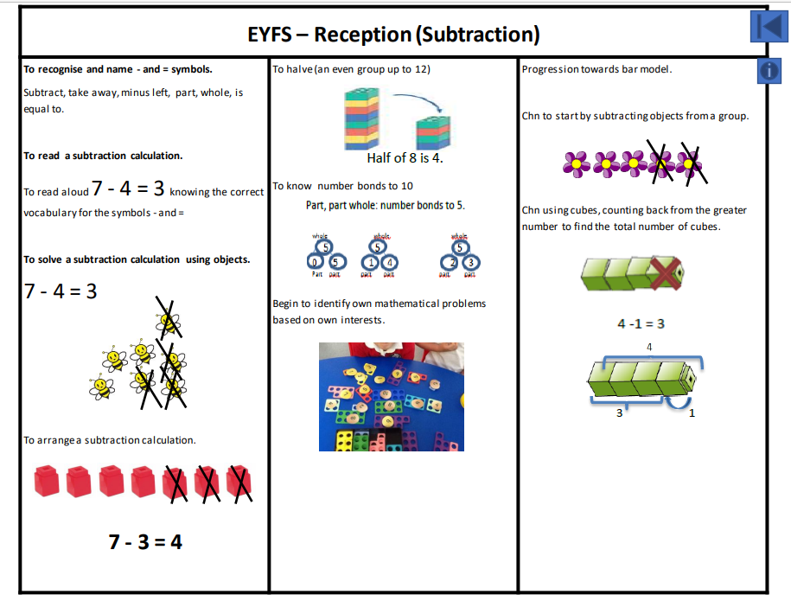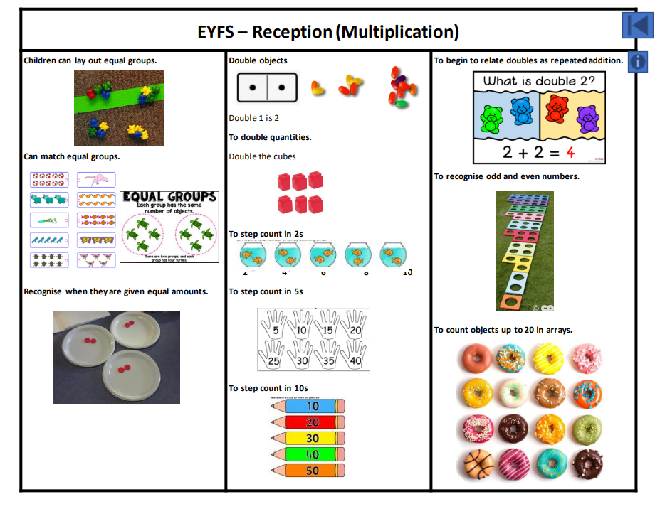

|  |  |
| --- | --- |
| **Year 1 addition** | **Year 2 addition** |
| Progression:  1. O + O where the answer is less than 10  2. O + O = 10  3. O + O crossing the tens boundary  4. O + O crossing 10 using number facts to bridge  5. teen numbers + O not crossing 20  6. teen numbers + O = 20  7. teen numbers + O crossing 20  8. TO + O (not crossing tens boundary)  9. TO + O (crossing tens boundary)  10. multiple of 10 + 10 (not crossing hundreds boundary)  11. 1 more than any given number to 100  12. O + O + O (not crossing tens)  13. O + O + O (regrouping) | Progression:  1. TO + O (not crossing tens)  2. TO + O (crossing tens)  3. multiple of 10 + multiple of 10  4. O + O + O (not crossing tens)  5. O + O + O (regrouping)  6. TO + multiple of 10 (all)  7. TO + TO (not crossing tens)  8. TO + TO (crossing tens)  9. TO + TO (crossing hundreds)  10. TO + TO (crossing tens and hundreds) |
| A close up of a math game  Description automatically generatedA black text on a white background  Description automatically generatedA green and red bar  Description automatically generatedA collage of a yellow object  Description automatically generated with medium confidenceA screenshot of a graph  Description automatically generatedA white text with black text  Description automatically generatedA diagram of yellow cubes and black and white numbers  Description automatically generatedA close up of a toy  Description automatically generatedA group of blocks with numbers and symbols  Description automatically generated with medium confidence |  |

|  |  |
| --- | --- |
| **Year 3 addition** | **Year 4 addition** |
| Progression:  1. HTO + TO (no carrying)  2. HTO + TO (one carry – first tens then hundreds)  3. HTO + HTO (one carry – first tens then hundreds)  4. TO + TO (two carries –tens and hundreds) 5. HTO + TO (two carries –tens and hundreds) 6. HTO + HTO (two carries –tens and hundreds) – into thousands | Progression:  1. ThHTO + HTO  2. ThHTO + ThHTO  3. O.t + O.t (in the context of measures and money)  4. O.th + O.th (in the context of measures and money) |
|  |  |

|  |  |
| --- | --- |
| **Year 5 and 6 addition** |  |
| Progression:  1. O.t + O.t  2. O.th + O.th  3. O + O.t  4. TO + O.th  1. Addition of numbers with any number of digits  2. Addition of two or more numbers with at least 4 digits and 3 decimal places  3. Addition of two or more numbers with at least 4 digits of various sizes and varied decimal places (e.g. 401.2 + 26.85 + 113)  Progression: | |
|  | |

|  |  |
| --- | --- |
| **Year 1 subtraction** | **Year 2 subtraction** |
| Progression:  1. O - O (where answer is less than 10)  2. Subtracting from 10  3. teen number - O (where answer is 10 or more)  4. teens - O (going back over tens boundary) 5. Subtraction facts from 20  6. Subtracting 10 from multiple of 10 | Progression:  1. TO - O (not crossing tens)  2. TO - O (crossing tens)  3. TO - multiples of 10 = less than 100  4. TO - TO (not crossing tens)  5. TO - TO (crossing tens) |
|  |  |

|  |  |
| --- | --- |
| **Year 3 subtraction** | **Year 4 subtraction** |
| Progression:  1. HTO - TO (no adjustments)  2. HTO - HTO (no adjustments)  3. Adjustment T to O  4. Adjustment H to T  5. HTO - TO (1 adjustments)  6. HTO - TO (2 adjustments)  7. HTO - HTO (2 adjustments) | Progression:   1. HTO - HTO (extending to noughts in the ones) 2 2. . ThHTO - ThHTO (extending to noughts in the ones) 3. 3. O.t - O.t (in the context of measures and money) 4. 4. O.th - O.th (in the context of measures and money) 5. 5. TO.th - TO.th (in the context of measures and money) |
|  |  |

|  |
| --- |
| **Year 5 and 6 subtraction** |
| Progression:  1. O.t + O.t  2. O.th + O.th  3. TO.th - TO.th  4. Refine year 5, increasingly larger numbers and complex decimal values  5. Difference between 2 negative integers  6. Difference between positive and negative integers |
|  |

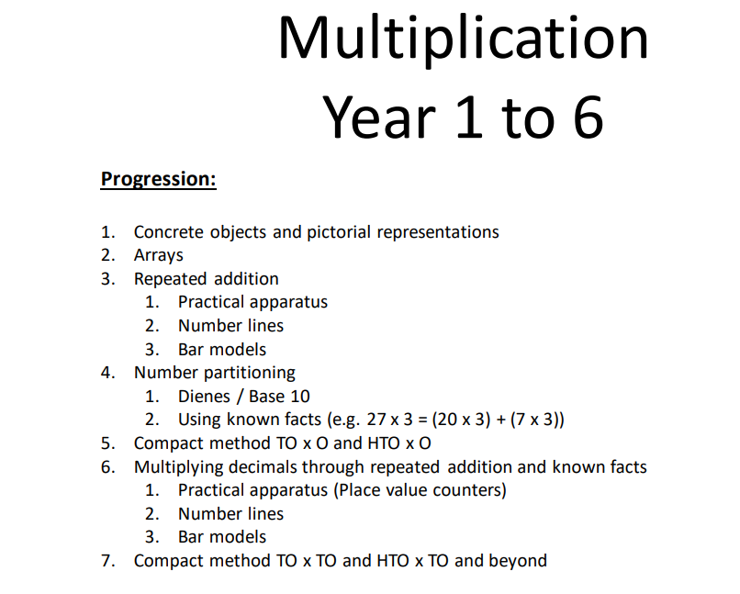

|  |  |
| --- | --- |
| **Year 1 multiplication** | **Year 2 multiplication** |
| Progression  : 1. Use repeated addition of equal groups using apparatus  2. Use repeated addition of equal groups using pictorial representations  3. Multiples of 2  4. Multiples of 5  5. Multiples of 10  6. Investigate patterns when counting in 2s, 5s and 10s. | Progression:  1. Multiplication as equal groups –building on Y1  2. 2 × table  3. 5 × table  4. 10 × table  5. Multiplying by 2, 5 and 10  6. Word problems |
|  |  |

|  |  |
| --- | --- |
| **Year 3 multiplication** | **Year 4 multiplication** |
| Progression:  1. 3× tables 2. 4× tables 3. 8× tables 4. Multiplying by 3, 4 and 8 5. Word problems 6. Multiples of 10 x ones 7. TO × O using base 10 8. TO × O expanded x column (no regrouping) 9. TO × O expanded x column (regrouping) 10. TO × O condensed recording | Progression:  1. 6× tables 2. 7× tables 3. 9× tables 4. Multiplying by 0 5. HTO × O (no regrouping) 6. HTO × O (regrouping) |
|  |  |

|  |
| --- |
| **Year 5 and 6 multiplication** |
| Progression: 1. Multiply whole numbers (including TO) by 10, 100 and 1 000 2. Multiply decimals by O 3. TO × TO using long multiplication  4. Whole numbers × O using short multiplication 5. TO × TO using long multiplication 6. HTO × TO using long multiplication |
|  |

|  |  |
| --- | --- |
| **Year 1 division** | **Year 2 division** |
| Progression  (Non statutory)  1. Division as sharing  2. Division as grouping - grouping a known quantity of pictorial representations  3. Using arrays to support concrete methods 4. Using multiples of 2,5,10 (alongside multiplication) | Progression:  1. Sharing apparatus into equal groups–building on Y1  2. Grouping a known quantity of pictorial representations –building on Y1  3. Introducing ÷ sign, writing number sentence  4. Dividing by 2, 5, 10  5. Word problems  6. Begin to link multiplication and division fact- inverse |
|  |  |

|  |  |
| --- | --- |
| **Year 3 division** | **Year 4 division** |
| Progression  1. Dividing by 3, 4 and 8 ( follow the below routine for each)  2. TO ÷ O (using pictorial images- no remainder, no carrying) e.g. 69 ÷ 3  3. TO ÷ O (using Place value counters - no remainder, carrying) e.g. 72 ÷ 3  4. TO ÷ O (using Place value counters -remainder, carrying) e.g. 47 ÷ 3  5. TO ÷ O (written method – following steps above) | Progression:  1. Dividing by 3, 4, 8, 6, 7, 8- continuing from year 3 and following on with tables knowledge ( follow the below routine for each) 2. Known facts for multiples of 10 ÷ O (e.g. 60 ÷ 3, 80 ÷ 4) 3. HTO ÷ O (using pictorial images- no remainder, no carrying) e.g. 396 ÷ 3 4. HTO ÷ O (using base ten- no remainder, no carrying) e.g. 484 ÷ 4 5. HTO ÷ O (using base ten- no remainder, carrying) e.g. 452 ÷ 4 6. HTO ÷ O (using base ten- remainder, carrying) e.g. 494 ÷ 4 7. HTO ÷ O (written method – following steps above) 8. Noughts in the quotient (final digit, final digit is nought and then remainder, middle digit is nought) e.g. 630 ÷ 3, 92 ÷3, 321 ÷ 3 |
|  |  |

|  |
| --- |
| **Year 5 and 6 division** |
| Progression   1. Multiply and divide whole numbers and those involving decimals by 10, 100 and 1000 (also in mental) 2. ThHTO ÷ O (written method- no remainder, no carrying) e.g. 6396 ÷ 3 3. ThHTO ÷ O (written method- no remainder, carrying) e.g. 7875 ÷ 7 4. ThHTO ÷ O (written method- remainder, carrying) e.g. 9462 ÷ 8 5. Placing the quotient e.g. 207 ÷ 3 6. Noughts in the quotient (final digit, final digit is nought and then remainder, middle digit is nought) e.g. 6630 ÷ 3, 9992 ÷3, 6321 ÷ 3   . ThHTO ÷ TO (written method- no remainder, no carrying) e.g. 2436 ÷ 12 2. ThHTO ÷ TO (written method- no remainder, carrying) e.g. 3198 ÷ 26 3. ThHTO ÷ TO (written method- remainder, carrying) e.g. 9427 ÷ 23 4. Interpreting remainders as fractions (or rounding if appropriate) 5. Missing box problems 6. Dividing numbers with up to two decimal places |
| v |

**Mathematics Mastery vocabulary list**

The vocabulary listed on the separate document is vocabulary that pupils are expected to use and understand on a daily basis within that year group, though the definitions are written for teacher reference and would not necessarily be shared with children as they stand. The vocabulary listed is cumulative and builds on the vocabulary previously introduced. Teachers should also consult with the Mathematics Mastery Primary Glossary. This is a working document and will be updated as required.

**Maths meetings**

At Houldsworth Valley, we recognise that a maths Meetings are a vital part of the Mathematics Mastery programme. Their purpose is to consolidate key areas of mathematics and develop fluency in recall of key knowledge. Maths meetings occur daily for approximately 15 minutes which aim to incorporate arithmetic and reasoning. A Maths Meeting should cover several curricular areas, broken down into short segments; each segment should take approximately 2 – 3 minutes. In KS1, the Number Sense programme (as previously mentioned) is used to ensure pupils have good fluency and a broad understanding of calculations strategies which are woven within the maths mastery curriculum.

