
Curriculum Information for Parents
At Houldsworth Valley we believe that ‘Anything’s Possible’
Our curriculum aims to support children who attend our school by:
• Increase the exposure the children have towards high level VOCABULARY and give opportunities to practise using these words to improve oracy.
• A curriculum that improves KNOWLEDGE of the world, building upon what the children know to create new links.
• Improve the RELATIONSHIPS that the children have with each other, building skills and abilities to work together.

Our curriculum is designed specifically for our children – giving them what they need to strive and achieve their best. At Houldsworth, we have considered what should drive our curriculum, drawing upon what our children need most in order to become educated citizens.
Strategic long-term plans have been created so that subject coverage is planned sequentially and with a clear rationale for making connections with prior learning, therefore learning is blended and refined. Blended means combining learning from different year groups under the same concept. For example, Plants in Year 1 and Year 2 is the concept, but elements from each year group may be combined. Our aim is to build upon children’s foundational knowledge and strengthen their cognitive connections within the long-term memory. Refined means reduced content, focusing on the essential knowledge therefore not overloading the working memory. We now interleave subjects. This means that relevant subjects are positioned to support and enhance learning so that pupils retrieve and transfer knowledge. For example, Stone Age learning is enhanced through the contextual study of prehistoric art. Our Long-term sequences for History, Geography and Science can be found on our Curriculum page.

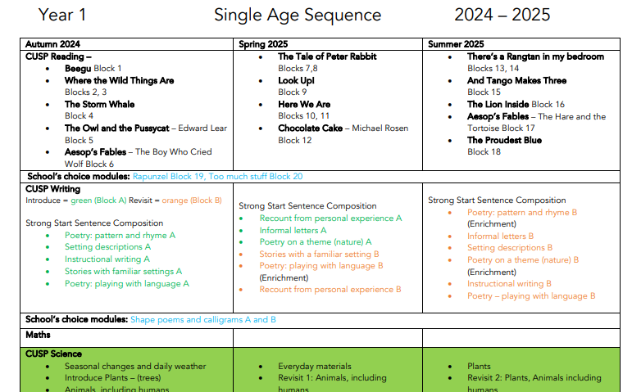

Vocabulary
During each unit we support children to decode, define, apply, link and analyse unfamiliar words to help develop their language acquisition (the learning or developing of a skill). The quality of parent/child interactions therefore is one of the biggest factors influencing vocabulary, so keep those rich discussions going at home. If you would like a list of key vocabulary (an example is below) for you to discuss and revise at home please ask your child’s class teacher and they’d be happy to share it with you.
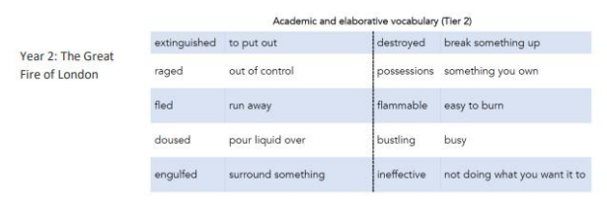
Vocabulary can be usefully divided into 3 tiers:
Tier 1 – high frequency in spoken language (table, slowly, write, horrible)
Tier 2 – high frequency in written texts (gregarious, beneficial, required, maintain)
Tier 3 – subject specific, academic language (osmosis, trigonometry, onomatopoeia).

Knowledge notes and knowledge organisers
These are present in children’s book at the beginning of a unit. Essential knowledge and vocabulary is communicated and kept in one place to avoid overloading children. Important vocabulary, such as Tier 3, is highlighted. These are present in children’s books during each lesson.
• Knowledge notes directly support teaching headlines and pupil tasks.
• Reduces the load on the working memory as all essential information is kept in one place.
• Vocabulary is clearly communicated and knowledge is supported by icons to improve acquisition.

