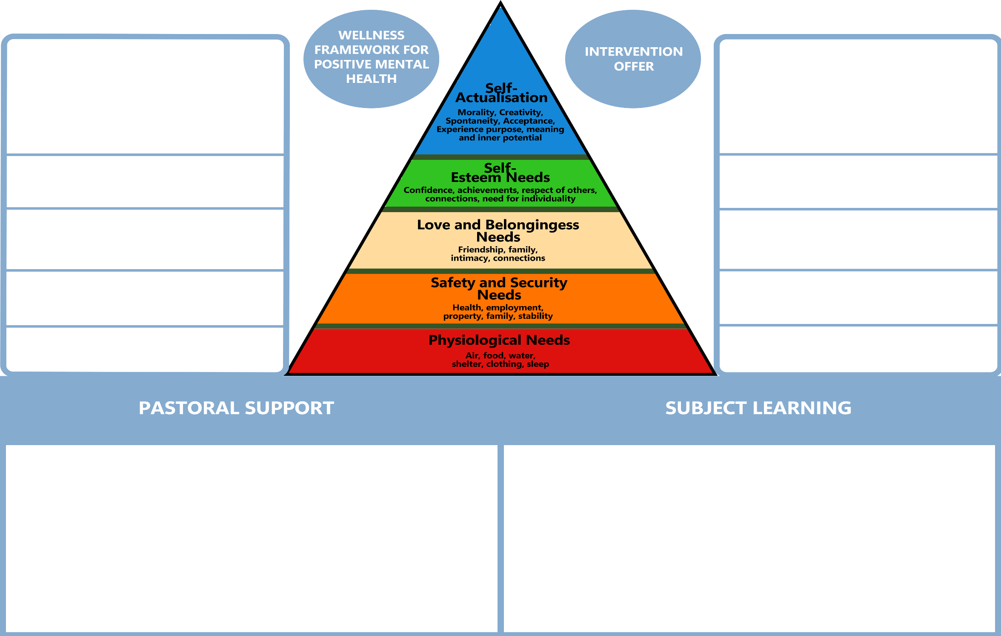

Read Write Inc

Fresh Start

Reading Plus

1:1/small group Maths (WRM)

Forest School

Horse Riding

Play Therapist

Music

Trauma Informed Schools UK Resilience Doughnut

Messy Play Sessions Mini Path

Lego Play Sessions ELSA

Therapeutic Expressive Art Talk About

Winston’s Wish Bereavement

English Maths Science PSHE IT Art PE

Food Technology (DT) Humanities RE Careers

Offsite – Vocational

**All of these are universal needs to enjoy positive mental health.**

Learning New Things

Making a positive contribution to others

Connecting with others

Mindfulness/time to pause and reflect

Physical health and safety

The curriculum at SPH is specifically designed to balance the social, emotional and mental health needs of our pupils and our ambition for them to do especially well in their personal development and academic learning.

The vast majority of our pupils arrive with extensive gaps in their personal and academic development, many having been out of education or in alternative offers for significant periods of time. Pupils arrive often having experienced multiple failed placements, with low self esteem, trauma experiences, low resilience, a mixture of additional educational needs and often resistant to academic learning.

We know that in order to accelerate progress we must ensure that our curriculum offer also addresses fundamental needs which may otherwise be missing in our pupils lives. We have used Maslow’s hierarchy of needs to explain our mix of class-based learning and interventions.

We have mapped Maslow’s hierarchy of needs to a Wellness framework that underpins current understanding of the 5 pillars for positive mental health.

We have then attached our classroom and intervention offers to show where each offer supports our overall curriculum intent.

Our ambition is always to be moving pupils closer to more classroom taught subject lessons, with a particular emphasis on improving reading skills and less reliance on interventions. This is reviewed on a regular and individual basis.