Monday 3rd June 2024

Dear parents and carers,
I hope you all had an excellent and restful half term, despite the rather changeable weather.
The final half term of the year is always a busy one, as new Y6 students come to visit, Y10s have their mock exams to prepare them for their final year, and Y11 finish their last few days at school and experience their leavers’ day and prom.

We are respectful
We are welcoming all students back today with our ‘re-set assemblies’ following the holidays, led by Mr Fisher and Mr Witter, where they will be thinking particularly about respect for the whole school environment. We have several areas of the school being updated in the summer holidays, including the second room in the Polaris unit.

We are resilient
Our friends at Youth for Christ are in school this week, leading assemblies on the importance of celebration. In tutor times, we will be thinking about how celebrations are important when we are trying to build our resilience.

Meet the staff
As we start to prepare for next year, we have finalised who will be looking after each year group in September 2024. Next, we will be finalising the tutors, and we will share these names with you soon. Y10 will move up to the care of Mr Barker and Miss Hill on Monday 24th June. Ms Lawson will be starting to work with Y7 from today, sharing this role with Mrs Turner, so that she can start to focus on transition for Y6.
Current Year | 6 | 7 | 8 | 9 | 10
Next Year | 7 | 8 | 9 | 10 | 11
Head of Year | Mrs Turner | Ms Lawson  (maternity cover for Miss Bond) | Mr Norman | Mrs Harridge | Mr Barker
Pastoral Officer | Mrs Honeyball | Mrs Robinson | Ms Howlett | Mr Cockerton | Miss Hill
Uniform
We are excited to announce that our new uniform supplier is up and running. Until the end of this term, they will be selling our current uniform stock at a reduced cost for current year 7 to 10 students. From the end of July, they will be selling our new uniform stock.
New Y7 students in September 2024 will be expected to wear the new uniform, but all other students can replace items as they grow out of them, or they wear out. I have attached the price list to this letter for you.
The key differences in the new uniform are:
- Blazer now has a school badge
- Blazer and trousers are a lighter weight material
- Tie is a full tie, not a clip on one
- Trousers can be purchased from any shop or from the school supplier
- Jumper has a school badge
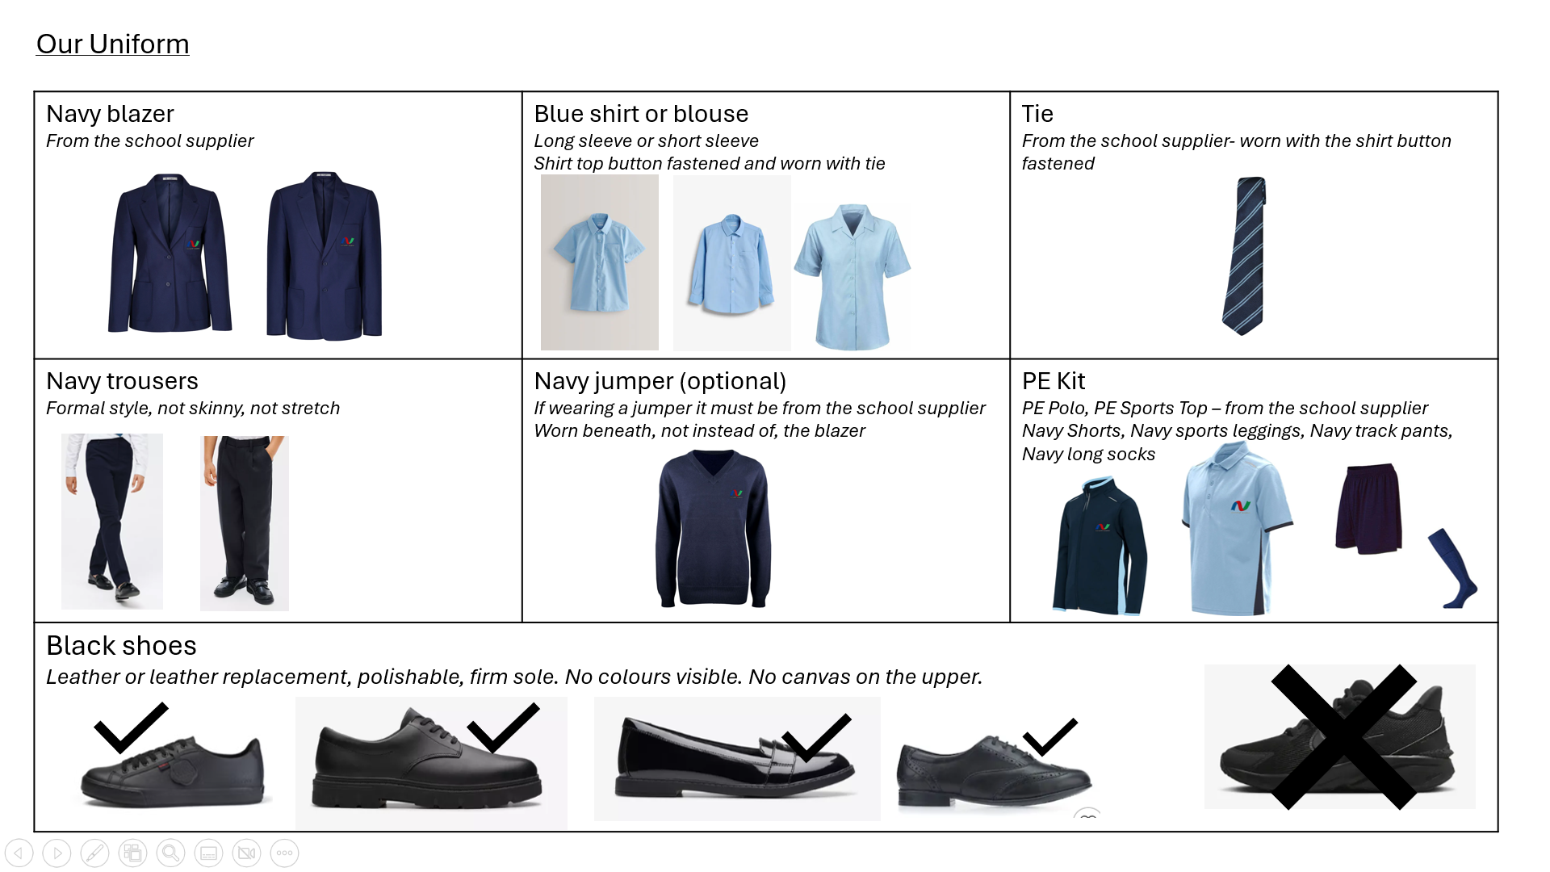
We would much prefer students to wear a sturdy school shoe and trainers with any canvas on the upper, bubbles or extra thick soles will not be permitted. Shoes must be entirely black. AF1s will be permitted.
Please note that all students are expected to wear their shirt tucked in, so please ensure both girls and boys have shirts and blouses that are long enough to tuck in comfortably.

Emails
In our parent survey, a few parents raised a concern that they have emailed the school and have had no reply. If this happens to you, please do forward the correspondence to me, and I will ensure you get the reply that you need. We aim to respond to emails within 2 school days.

As always, if you need anything at all, please don’t hesitate to get in touch.

Kind regards,

Mrs Horne
Deputy Headteacher

