Woodhall iPads – Supporting Home Learning

At Woodhall, we set homework using the iPads. As you can see below we have created specific folders in order for the children to find their homework quickly.

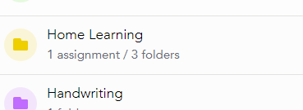

These are further organised inside this folder using the very helpful folder-within-a folder facility.

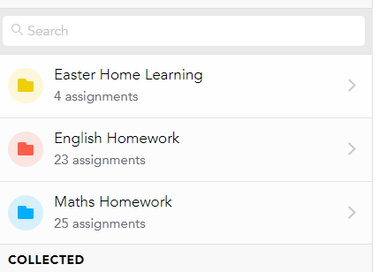

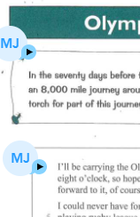We actively use voice notes to support with both our spelling and reading homework. Below you can see that the homework has been differentiated in three ways. There are two Y6 level comprehensions; the one marked VN has voice notes supporting the reading of the extract and the questions. There is also a separate Y4/Y5 extract for further scaffolding.

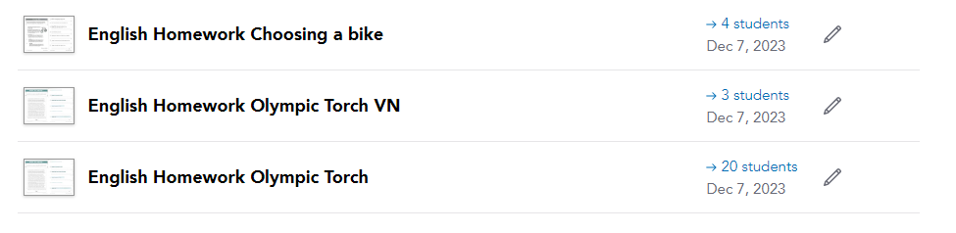

In Spelling, using the CUSP Home Learning for the Y6 Blocks, we add voicenotes to support with correcting common misconceptions and to add dictations to the sentence work.

In Maths, we alternate between arithmetic and reasoning homework. We have used the screen record option to create videos and worked examples to support the independence of the children when home learning. See link for further details: [Homework support.mp4](https://samuelwardco-my.sharepoint.com/:v:/g/personal/mjames_woodhallprimary_co_uk/EU4MoaMq2pVDjGKDU9bE_K4BNL3xYCZUFEWVi6Ob46fh8A?nav=eyJyZWZlcnJhbEluZm8iOnsicmVmZXJyYWxBcHAiOiJPbmVEcml2ZUZvckJ1c2luZXNzIiwicmVmZXJyYWxBcHBQbGF0Zm9ybSI6IldlYiIsInJlZmVycmFsTW9kZSI6InZpZXciLCJyZWZlcnJhbFZpZXciOiJNeUZpbGVzTGlua0NvcHkifX0&e=x8Q8bO)

