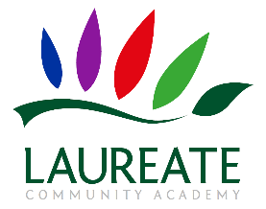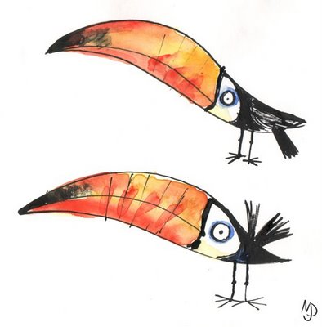[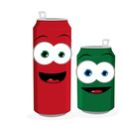](http://graphicleftovers.com/graphic/1971554-funny-beer-or-soda-cans)

Please bring in your canned foods to the playground or office by

**Friday 7th October 2022**

**Can you spare two cans?**

Once again, for Harvest Festival, we have offered to collect food for local charity Newmarket Open Door.

Can you spare two cans (or other non-perishable packs) of food this harvest?

?

?

?

?

?

?

# Newmarket Open Door Ltd

Unit 5, Craven Way,

Newmarket, Suffolk CB8 0BW

Tel: (01638) 561711

[foodbank@newmarketopendoor.org.uk](mailto:foodbank@newmarketopendoor.org.uk) [www.newmarketopendoor.org.uk](http://www.newmarketopendoor.org.uk)