

SEND Information Report
2025 – 2026
Issued September 2025


  Our School | Steeple Bumpstead Primary School is a one form entry mainstream school in a village on the Essex and Suffolk border. We value all children equally and provide access to a broad, balanced and relevant curriculum for all pupils. We aim to nurture the whole child, ensuring that all children, including those with SEND, are successful life-long learners. The well-being of children is paramount, which is why we want them to strive to reach their full potential and develop the resilience to face challenges both in and out of school.  September 2025 Information  SEND by Year Group  There are also many other children on our ‘Monitoring Register’, which is reviewed every 6 weeks.
  Number on Roll | 191
  Number on SEND Register | 33
  Number of Education Health Care Plans (EHPCs) | 9
  Reception | TBC
  Year 1 | 7 | Year 2 | 5
  Year 3 | 5 | Year 4 | 3
  Year 5 | 6 | Year 6 | 6
  Meet our SENDCo |   The SENDCo is Andrea Dodds and she is currently working towards her NPQSEN.  If you would like to contact Mrs Andrea Dodds, please call school on 01440 730220 or email office@steepleprimary.co.uk. Her working days are Thursday and Friday.
  Special Educational Needs | SEND is categorised into 4 broad areas in the SEN Code of Practice 2015:  At Steeple Bumpstead, we support children with a variety of special educational needs, and we pride ourselves on being a highly inclusive school with an ethos which encourages and celebrates diversity and difference.
   | Cognition and Learning
   | Communication and Interaction
   | Social, Emotional and Mental Health
   | Sensory and Physical  (hearing, visual or multisensory impairment)
  Identifying and Assessing Need | A child or young person has a special educational need if they have a learning difficulty or disability which calls for special educational provision. This provision means that which is additional to or different from that made generally available for children and young people of the same age.  A child or young person has a learning difficulty or disability if they:  - have significantly greater difficulty in learning than the majority of others the same age, or  - have a disability which prevents of hinders him or her from making use of educational facilities of a kind generally provided for others of the same age at school  (SEND Code of Practice, 2015)  Every teacher knows the needs and abilities of children in their class and our assessment and monitoring procedures ensure that every child’s progress and attainment is continually monitored.  When staff are concerned about a child, they will discuss this with parents before passing this onto the SENDCo. Before this happens, informal conversations are likely to have already taken place. Depending on the level of concern or presenting needs, the SENDCo may then observe the child in class and gather the views of both children and parents. For some children, we may use standardised assessments including PHaB, YARC, BPVS and Sandwell Maths to identify gaps in learning and/or inform future provision. In turn, these assessments are used to track progress.  We adopt a ‘graduated response’ to identifying children with SEND and additional provision is planned and delivered through the four-part ‘Assess, Plan, Do, Review’ cycle. Usually after an initial period of monitoring (usually a term), we will decide if a child needs to be placed on the SEND Register and a Personal Learning Plan (PLP) will be written with around 3 targets and additional support they are receiving. Class Teachers share these with parents, and they are reviewed three times yearly (December, April and July).  Some children may require more support than is ordinarily available in school. In this instance, we may seek the support of outside agencies in ensuring that we are offering the best support we can.  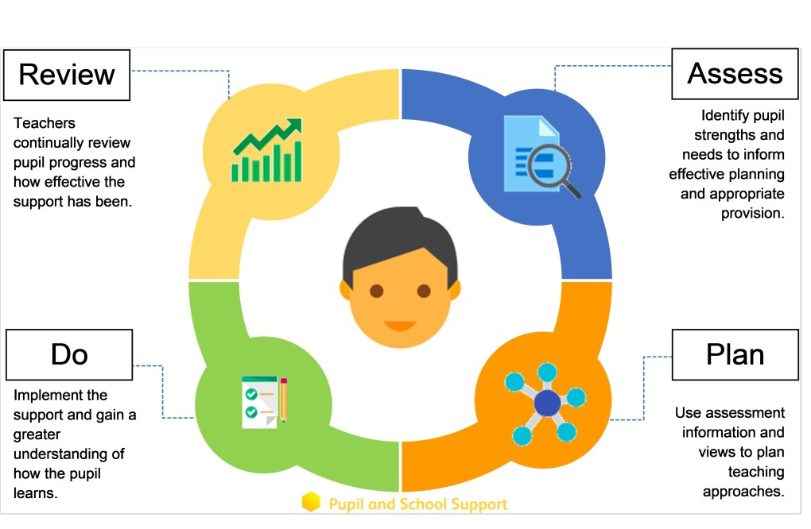
  Our approach to teaching children with SEND | We are an inclusive school. Wherever possible children are taught alongside their peers in flexible teaching groups.  Teachers adapt their high-quality teaching to cater for their pupils’ needs and plan individual timetables where necessary. When appropriate, staff are deployed to give children additional interventions in small groups outside the classroom, or to provide one-to-one support.  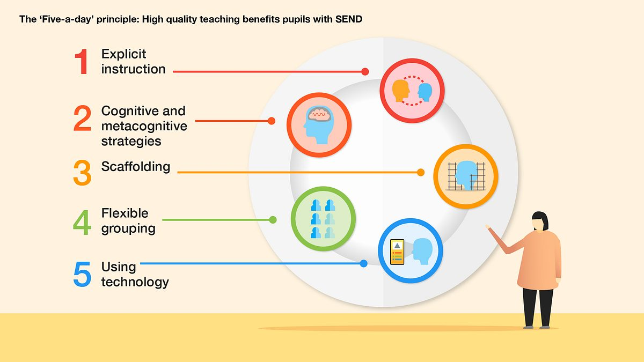  We use the EEF guidance ‘Five-a-day’ and embed the key principles into all our lessons.  We use the SEND Handbook produced by the Unity Schools Partnership to complement our teaching. This handbook is reviewed at least annually and contains a wealth of information and support that helps teachers to further adapt and enhance their provision for those with additional needs.
  Adapting the Curriculum | We use a range of strategies across our lessons to ensure we offer an inclusive approach to learning and allow all children to access the classroom environment. Our trust-wide curriculum CUSP (Curriculum Unity Schools Partnership) is an evidence-informed approach that presents curriculum in cumulative and coherent manner that is rightly challenging, but accessible for all.  Our provision to support children with additional needs comprises of 3 aspects:  Adjustments – the ‘Teacher Tweaks’ that staff make through everyday Quality First Teaching (e.g. visual prompts, Now and Next structures etc.)  Resources/Support – the physical or human resources (e.g. pencil grips, adult scribe, voice record etc.)  Intervention – specific and additional teaching (e.g. individual or small group activities rehearsing a particular skill)  (Adapted from SEND Intervention, Judith Carter, 2022)  Common day-to-day adaptations may include:
   |  | 
  Visual Timetables | Now and Next boards | Word banks or vocabulary lists
   |  | 
  Ear defenders | Timers | Pre or Post Teaching
   |  | 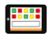
  Explicit and clear instructions | Opportunities for self-reflection and assessment | Assistive Technology
   |  | 
  Writing slope | Pencil grip | Fiddle toy
   |  | 
  Peer Marking | Individual support from an adult | Coloured overlays
  Communicating with Parents and Carers | At Steeple Bumpstead we work closely with parents and carers and recognise that they have much to contribute to our support for children with SEND. We communicate in a range of different ways, including:  - An open-door policy with Class Teachers, SLT and pastoral staff available at the start and end of each day  - Drop-in sessions and workshops for parents  - Parents Evening twice yearly. The SENDCo is always available at these events.  - Monthly Newsletter  - Class Dojo and school website  - Annual Reports (summer term)  - Termly PLPs (Personalised Learning Plans)  - Annual Reviews for those with EHCPs
  Pupil Views | Pupil’s views are very important to us; they have a right to be involved in decisions about their education and they are made aware of the support that surrounds them in school.  Where appropriate, children are fully involved and their views feed directly into all policies, procedures and daily teaching of children with SEND.  In a manner appropriate to their level of need, pupils are given opportunities to:
   | 
  Tell us how they think they are doing | Attend meetings and help decide the support needed | Represent their peers when giving views in School Council and Eco School
  Evaluating Provision | We regularly review our provision for children with SEND and this is done in a range of different ways including:  - Review progress in SLT meetings and discussing next steps  - Discuss and share ideas in staff meetings to ensure up to date research and policies are in place  - Reviewing children’s individual progress at regular intervals  - Monitoring classroom practice by SENDCo and subject leaders  Our provision is also reviewed by external processes including:  - Annual SEND Review led by Trust Directors of SEND  - Strategic Planning Meetings held with Inclusion Partner (Essex County)  - Ofsted inspections (last inspected in July 2022)
  Staff Training | At Steeple Bumpstead, we believe in professional development and aim to ensure all our staff have the understanding they need to enable them to support your child.  When a new member of staff joins the school, we ensure they understand the systems within school, and they are given information about the children they are working with.  The senior leadership team are constantly monitoring needs within the school and, where an area of concern is highlighted, whole school training may be organised to ensure all staff understand specific learning difficulties and appropriate teaching or support strategies that could be used.  Some staff have completed training in the following areas:
   |  | 
  Trauma Perceptive Practice | PACE  (Playfulness, Acceptance, Curiosity and Empathy) | DESTY
   | 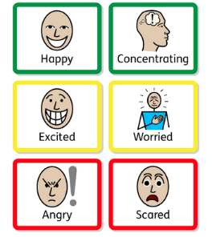 | 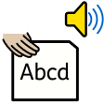
  Speech and Language | Zones of Regulation | Sounds Write Phonics
   |  | 
  Specific Learning Difficulties | Explicit Vocabulary Instruction | ELSA  (Emotional Literacy Support)
   |  | 
  De-escalation Theory | Sensory Needs | Reading strategies for struggling readers
  Transition Support | Nursery to Reception  We hold an information session in the summer term for our new reception starters, providing parents with the opportunity to meet key members of staff and to ask any questions they may have.  ‘Stay and Play’ sessions are held in the second half of the summer term in preparation for their September start. For some children with SEND, we offer additional opportunities to spend time with us to help this transition further.  We liaise closely with local early years settings and rely on their expert knowledge of the children to secure they have the best possible start to school.  End of Year Transition  When children move up a year, we provide information booklets which include photos of the teacher, support staff and key curriculum information. Children on the SEND Register create their own One Page Profile which helps build initial connections.  We hold ‘Transition Days’ during the summer term allowing the children to go up to their new classroom and meet their teacher.  For some children, we provide an ‘Enhanced Transition’ to help reduce any anxiety and to ensure that the transition is successful and positive.  Class teachers and TAs meet with each other during the summer term to discuss the needs of the children and share Individual Learning Plans and other key documentation.  Secondary Transition  Taking their lead in this process, we liaise closely with local secondary schools to ensure that the transition from primary school to the secondary school is as smooth as possible. We highlight those children in Year 6 who would benefit from further ‘enhanced transition’ early and ensure we pass on all relevant documentation in a timely manner.  Mid-Year New Starters  When we are aware that children joining us from other settings have identified special educational needs, we arrange a meeting with the family to enable us to gain a greater understanding on the support we need to put in place.
  Outside Agencies | We also seek advice and equipment from external agencies and work closely with a range of professionals to provide support for children with SEND:  - Inclusion Partner (Essex County)  - Occupational Therapy (OT)  - Speech and Language Therapy (SALT)  - School Nursing Team  - Educational Psychology (EP)  - Primary Mental Health Worker  We also draw upon the experience and expertise of colleagues across Unity Schools Partnership, including that of the trust’s Directors of SEND.  We will ask your permission before we arrange for any outside agencies to come in and work with your child. Once the feedback has been received we will of course share any advice given.
  Clubs and Educational Visits | Our extra-curricular activities and school visits are available to all our children, including our before-and after-school clubs.  All children are encouraged to take part in sports day, school competitions, school assemblies and performances, workshops, etc.  All children are encouraged to apply for roles of responsibility in school e.g. school council, monitor etc.  No child is ever excluded from taking part in these activities because of their SEN or disability.
  If You Have Concerns... | In the first instance, any concerns should be raised with the Class Teacher.:  You can contact them via Class Dojo to make a face-to-face appointment or to request a telephone call.  If concerns or issues are still not resolved, then our SENDCo Mrs A Dodds should be contacted.  In the event of a complaint, please follow the Unity Schools Partnership complaints procedure https://www.unitysp.co.uk/documents/complaints-policy-and-procedure/.
  EYFS | Mrs L Milson  Mrs S Grey
  Year 1 | Mrs L Laxton  Mrs L Lambert
  Year 2 | Miss H Moss  Mrs C Kimber
  Year 3 | Mrs B Shoard  Mr L Howden
  Year 4 | Ms R Jowitt  Mrs S Grey
  Year 5 | Mrs S Shaw  Mrs H Berry
  Year 6 | Mrs F Parsons
  Suffolk Local Offer and Further Information | The Suffolk Local Authority Local Offer can be found at https://www.suffolklocaloffer.org.uk/  The Unity School Partnership SEND Policy can be found at https://www.unitysp.co.uk/documents/send/  Further support and information can be found:
  Suffolk SENDIASS | https://suffolksendiass.co.uk/
  British Dyslexia Association | www.dyslexia.org.uk
  British Deaf Association | www.bda.org.uk
  National Autistic Society | https://www.autism.org.uk/
  Downs Syndrome Association | www.downs-syndrome.org.uk
  Afasic (Speech and Language needs) | www.afasic.org.uk
  Action for Children | https://parents.actionforchildren.org.uk/
  Family Action | https://family-action.org.uk/
  Mencap | https://www.mencap.org.uk/help-and-advice/social-care/childrens-social-care/support-parents-and-carers-children-and-young

