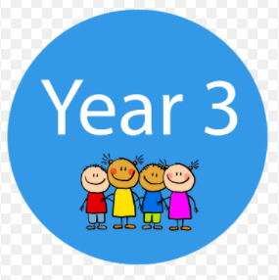


Year 3 Spring Term Newsletter 2023

Dear Parents and Carers,

Happy New Year to one and all! We hope you managed to have the best Christmas and New Year and things weren’t too scuppered by colds, flu and Covid etc. We are all very appreciative of the lovely Christmas presents you gave to us and we thank you very much for being so thoughtful. The children have had a good first couple of days back and it has been great to see them back in school.
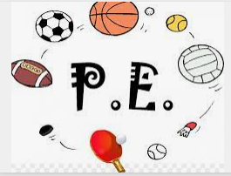

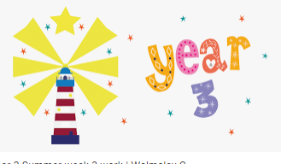
This first half term there is a change to PE, which will still be on Tuesdays, but also with Mr Deurs on Thursdays – Mr White has already messaged this information on Class Dojo. The children will come into school on those days in their kits. Warm, winter kits are thoroughly recommended due to the cold temperatures, because the children may at times be having their lessons outside. It would be helpful to wear shorts and a T-shirt underneath a jogging suit or equivalent, because then, when we are inside, they can take off a layer and won’t over-heat. Thank you for already being organised with this. Long hair needs to be tied back and the amended guidelines for the wearing of ear-rings is that earrings must either not be worn on a PE day, or can be worn if the child can independently take them out before the lesson or can tape them up themselves using tape provided from home. We thank you for your support with this. More information about the second half of this term will be posted on Dojo nearer the time.

Curriculum

This term we shall be revisiting rocks and fossils and then learning about forces and magnets and light in Science. In Geography we will be learning about the UK by looking at its regions, counties, cities and topography and we will also be researching some of the UK’s significant human and physical landmarks. We shall be learning about the Bronze Age, Iron Age and begin to look at the impact of the Romans in Britain in History and programming, digital literacy and databases in Computing. The children will be using textiles, collage and 3D materials in Art and working on lots of busy and exciting things in Design and Technology which Mr. White tends to update you on each week. We will also have weekly RE lessons with Mrs. Nicholls on a Wednesday, French with Madame Buckley on Tuesdays, music lessons once per week and of course PE twice a week. PSHE will also be a weekly fixture.

In English we shall be writing an animal-themed narrative using the third-person perspective, a non-chronological report about the UK, an instructional text, a narrative from the first-person perspective linked to our UK study in Geography and we will also be working on performance poetry including poems from other cultures. Spelling lessons will continue to take place three times a week, with homework given out on Wednesdays to be returned by Monday morning. This completed homework is then marked together in class and used as the basis for that first lesson of the weekly cycle. Handwriting lessons take place twice per week with interventions given to those children who need extra support. Bingo, Snap, Kim’s game, dictation, Hang-man and other games found on-line are different ways of helping with spellings you might want to use.
In Maths we shall be learning how to multiply and divide 2 digit numbers by 1 digit numbers and our other units will focus on length and measure including perimeters, mass and capacity and fractions. The children will practise and be assessed on their knowledge of the 2, 3, 4, 5, 8 and 10 times tables two to three times per week. Please ensure your child is regularly practising their times tables as they will face a National assessment on all of the times tables near the end of Year 4. Many children are making good and noticeable progress with their multiplications, which is really great to see. Remember to use Hit the Button https://www.topmarks.co.uk/maths-games/hit-the-button or use the TT Rockstars site as well as just reciting them whenever you have a spare few minutes!


Reading

Children will continue to have five reading lessons per week in which we focus on a class book and other supporting texts. This term we will be reading Sam Wu is Not Afraid of the Dark and Operation Gadgetman. The children will be sitting another termly reading check to assess their reading age. This tests their reading fluency as well as their comprehension levels. The children will still continue to progress through the reading colours (if still relevant) or will become/continue as Y and/or S readers. This progression will be guided by assessments, reading checks, 1-1 reading and through our daily reading lessons. Children who need extra support with their reading will read more regularly with Mrs. M and/or the class teacher.

Remember!!! Free Access to Curriculum Visions – awesome information books and much more!
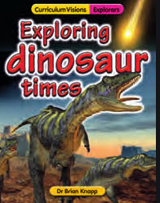

There are 100s of online books, activities and videos you can access with your child for free. Please use the log-in details below, but please be mindful that this access is only for children at Steeple Bumpstead Primary School. Enjoy!

https://curriculumvisions.com/login/login.php
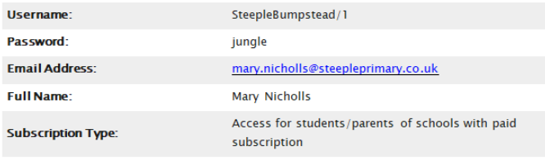

Remember if you need to contact us, then please do so via the office email/phone number or catch us at the door at the end of the day.

Best wishes and thank you for your continued support,
The Year Three Team

Mrs. Belinda Shoard - Class Teacher (Monday, Tuesday and Wednesday)
Mr. Stuart White - Class Teacher (Thursday and Friday)
Mrs. Mathieson (Mrs. M.) - Teaching Assistant (Monday to Friday mornings)

