

Behaviour Policy

Author of document | J Thuell
Position | Deputy Headteacher (Pastoral)
Date adopted by County  High School | Sep 2025
Signed by Headteacher | 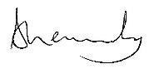
Signed by Chair of  Governors | 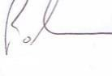
Review date | Sep 2026

This policy outlines the expectations of the standard of behaviour expected by all students attending
County High School and applies to all students attending the school.

Principles
County High School aims to provide an education that is broad and balanced so that every student can maximise their potential. Here each student will be able to develop their self confidence in a learning culture based on mutual respect. We want our students to go on to become honest, resilient, happy young people who make a positive contribution to their community and become truly global citizens.
We believe that all students and staff at County High School have the right to be treated with respect and courtesy. They also have the right to work and study in an effective well-ordered learning environment where standards of behaviour and discipline are high and where excellent levels of learning can be achieved.
A well-disciplined environment creates effective conditions for learning and promotes high standards for all.

Purpose
To ensure an ethos of high expectations
To provide clear boundaries to support learning and progression.
To state clearly the standards of behaviour expected and how these will be achieved through consistent approaches to managing student behaviour.
To create a positive approach to discipline that will prepare students for life-long learning and the world of work.
To support school leaders to ensure correct decisions are made when implementing sanctions or rewards for student behaviour.
To secure the involvement of parents/carers in students learning and personal development.
To promote equal opportunities and value individuals regardless of gender, race or disability.

Expectations
The ethos of the school is created by the way our students present and conduct themselves. With the support of teachers and parents, will realise how important it is to be seen as sensible and mature young individuals aiming to achieve the best for themselves and the school.
A full list of our expectations the behaviour for learning expectations is displayed in every room in the school. See Appendix A.
This means that everyone should: act according to the stated Aims and Values of the school whilst in school, on school trips and visits and on the journey to and from school.
We will not tolerate:
- violent or threatening behaviour
- inappropriate language (including sexist or misogynistic language) or swearing
- refusal to follow instructions and defiance
- racism or any other form of prejudice
- deliberate dangerous behaviours
- disruption to other people’s learning
- Sexual violence, sexual harassment and harmful sexual behaviour

PROCEDURE
Encouraging positive Behaviour
The expectations of the school are clearly outlined in the student planner and the home / school agreement which is signed at the start of each academic year by the parent, student and tutor.
Expectations will be clearly explained, regularly discussed and reflected upon in tutor time (Appendix
A)
We will always seek to identify and reward good work and good behaviour. This should be supported by frequent use of verbal praise and positive written comments on pieces of work and the awarding of achievement points; sending letters home; the issuing of certificates and other awards. This is clearly expressed to students in the Classroom Behaviour for Learning routine (Appendix B)

Managing Classroom Behaviour
Behaviour in the classroom is supported by the ‘Behaviour for Learning’ system whereby expectations are reinforced. Students whose behaviour is disturbing the learning of others will be given a warning to change their behaviours before a sanction of an after-school detention is given. Further behavioural issues will result in the student being removed from that lesson with an extended after school detention being given. This process is made clear for students through the display of and reference to Classroom Behaviour for Learning routine (Appendix B). School will ensure that even before a classroom warning is issued that the member of staff knows the additional needs of young people in the classroom and that these needs are being met. It is essential that members of staff know and recognise the additional needs of students; the policy is to be followed consistently for all students.
Extreme disturbance of learning or behaviour incidents will not receive a warning. If a student’s behaviour contravenes our zero-tolerance code they will be immediately removed from that lesson and placed in the supervised Reflection Room in the first instance. Suspensions may be used if appropriate following further investigation. (See Section ‘Suspensions’)
Following an instance of negative behaviour in a class or a series of incidents within one particular lesson, consideration will be given to how the student can move forward successfully. There are a number of strategies that may be utilised in these circumstances but this may include being placed with another teacher within the faculty, a restorative meeting with student and member of staff, facilitated by another suitable member of staff identified by the leadership team of the school; a subject or year team report card may be used to identify lesson to lesson successes and monitor a re-establishment of expectations.
The Department for Education sets out the power that schools have to set detentions (seen here in the document DfE Behaviour in Schools Feb 2024). County High School will give notice of one day where a detention is issued (the detention would take place on the following school day): parents/carers will be expected to make appropriate travel arrangements and are responsible for their child’s movements at the end of the extended day following a detention. The school will endeavour to support families by supervising their child for a longer period of time if they are not able to collect at the assigned detention end point. Sanctions open to schools are limited but are an important part of establishing expectations. Repeated failure to accept school sanctions will lead to escalation of the sanction, for instance: repeatedly failing to attend an after-school detention.
Sanctions available to the leadership of the school, short of suspension, include:
- Reflection Room for a fixed period.
- Isolation with in the Isolation Room of another Unity SP Trust school (offsite) for a fixed period.
- Loss of privilege of attending school trips (the Head Teacher will make the final decision based on review of incidents).

Communication with parents
The school will seek to work collaboratively to find solutions with parents in regards to behaviour incidents. All positive and negative incidents will be recorded on Go4Schools and parents will be notified via this system.

Aggression, Intimidation and Violence
Aggressive, intimidating or violent behaviour is unacceptable and will not be tolerated at County High School. An incident does not need to result in physical harm for it to instigate serious sanctions. Each incident will be investigated and where necessary the perpetrator(s) will be sanctioned and counselled.
Where the incident is minor this could result in an internal suspension in the Reflection Room. The Reflection Room is a staffed provision to which students who have caused significant issues in lessons or in the on call / parking room can be removed by the member of SLT / on call. A successful day is required in the Reflection Room in order to return to the school community whereby expectations are met with the support of the staff supervising the room. If expectations are not met, the day in the Reflection Room must be repeated the following day.
Where there is violence, or where there is an attack by a student on another, suspension may be used. The length of suspension will vary according to the severity of the incident: second and/or subsequent offences will attract a longer period of suspension. The suspension could be an internal suspension or fixed term suspension depending on the severity of the incident. Repeat offenders could face permanent exclusion. In extreme cases the student may face permanent exclusion for a first offence.
Verbal, physical threats or intimidation against staff will be investigated and may result in suspension. Depending on the severity of the situation verbal, physical threats or intimidation against staff may result in permanent exclusion.
Physical violence towards staff may result in permanent exclusion.
The school retains the right to report incidents to the Police.
Where a fixed term suspension has been issued, the student and their parent/carer must attend a readmission meeting following the suspension to discuss support and interventions to avoid future suspensions. The student will spend their first day back following a suspension in the Reflection Room to ensure they are ready to return to the school community.
A successful day is required in the Reflection Room in order to return to the school community whereby expectations are met with the support of the staff supervising the room. If expectations are not met, the day in the Reflection Room must be repeated the following day.

Sexual violence, sexual harassment including online sexual harassment and harmful sexual behaviour
Sexual violence and sexual abuse can happen anywhere, and all staff working at County High School maintain an attitude of ‘it could happen here’. County High School will respond appropriately to all reports and concerns, including those outside the school or college, and or online.
At County High School we make it clear that there is a zero-tolerance approach to sexual violence, sexual harassment and harmful sexual behaviour and it is never acceptable, and it will not be tolerated. It will never be passed off as “banter”, “just having a laugh”, “part of growing up” or “boys being boys”.
We will always challenge physical behaviour (potentially criminal in nature), such as grabbing bottoms, breasts and genitalia, pulling down trousers, flicking bras and lifting up skirts. These acts will never be dismissed or tolerated as such behaviours risk normalising them.
We will not allow a culture of unacceptable behaviour, an unsafe environment and in worst case scenarios a culture that normalises abuse leading to children accepting it as normal and not coming forward to report it.
Suspension may be used as a sanction. The length of suspension will vary according to the severity of the incident: second and/or subsequent offences will attract a longer period of suspension. The suspension could be an internal suspension or fixed term suspension depending on the severity of the incident. Repeat offenders could face permanent exclusion. In extreme cases the student may face permanent exclusion for a first offence.

Racism and discrimination
At County High School we make it clear that there is a zero-tolerance approach to racism and discrimination of any kind. We will always challenge discriminatory language and behaviours and will not allow a culture of unacceptable behaviour that normalises discrimination.
Suspension may be used as a sanction. The length of suspension will vary according to the severity of the incident: second and/or subsequent offences will attract a longer period of suspension. The suspension could be an internal suspension or fixed term suspension depending on the severity of the incident. Repeat offenders could face permanent exclusion. In extreme cases the student may face permanent exclusion for a first offence.
Follow-up intervention targeted at educating the student surrounding their use of language or behaviour may be necessary to ensure the student understands why their actions are offensive. This work will be carried out by our Pastoral Support Team and may include restorative work and education packages to alter negative behaviours.

Weapons and Dangerous Items
Possession of a weapon on school premises is a criminal offence and creates a culture of violence and fear which is not tolerated at County High School. Students are not allowed to bring knives, similar weapons and other dangerous items to school. Such actions will result in a risk of permanent exclusion and any instances will be reported to the police.

Theft
Theft may result in suspension if the offence is considered severe. The length of the suspension will vary according to the severity of the incident: second and/or subsequent offences may attract a longer period of suspension. Persistent offenders and very serious incidents may face permanent exclusion. In addition, the cost of those items that have been stolen will be recovered from the student involved. The Police will normally be informed in all cases where a theft has occurred.
Illegal Substances, Alcohol, Solvent Abuse, Use of E-Cigarettes and Smoking.
(See County High School’s Drug Incident Policy and search policy)

Setting off the Fire Alarm
Setting off the fire alarm or damaging fire protection equipment is a criminal offence that puts the health and safety of students and staff at risk and the police will be informed. Any student who intentionally sets off the fire alarm may be suspended from school for a fixed period. Further offences may attract a longer period of suspension. In the case of persistent offenders’ permanent exclusion will be considered.

Swearing
Swearing is regarded as verbal abuse and is unacceptable.
The following sanctions apply:
- Swearing overheard in conversation with another student will result in a warning.
- Using extremely offensive language in conversation may result in a removal from lessons.
- Swearing at a member of staff will result in at least an internal suspension. Second and/or subsequent offences will result in external suspension. Persistent offenders will face permanent exclusion.

Damage to the School Fabric or Furniture
If the damage is the result of wilful behaviour parents/carers will be informed and the cost of repair/replacement will be shared between those involved. Deliberate or malicious damage will result in the full cost of replacement or repair and, depending on the incident, further sanctions including suspension may result. Serious offences may result in permanent exclusion.

Behaviour on Trips, Home-School Transport, walking / cycling to school and outside school
Students on school trips and visits, and on the daily home-school buses, are governed by the school’s behaviour policy. It is expected that students behave well on trips and visits and on the daily buses. Poor behaviour on buses can be extremely dangerous and is completely unacceptable. Likewise, rudeness to drivers and other adults will not be tolerated and may result in suspension. Students who misbehave on the daily buses may be reported to Suffolk County Council who is able to ban them from further travel on the buses concerned. Students on trips could be sent home, at their parents’ expense, if their behaviour risks the health and safety of others.
Students will be sanctioned if they bring the school into disrepute on the way to and from school. Depending on the severity of the behaviour this could result in suspension.
School may also discipline students for misbehaviour at any time, whether or not the conditions above apply, that could have repercussions for the orderly running of the school or poses a threat to another pupil or member of the public or could adversely affect the reputation of the school.

Mobile Phones and other Electrical Devices
County High School is a phone free site for students. Students are not permitted to have a mobile phone on them at school. All mobile phones will be collected by staff in morning line ups across all year groups and stored securely – prior to line up and handing in of their device, students must adopt a “not seen or heard” approach to their phone in school. All mobile phones will be returned at the end of the school day.
Arrangements have been made for students to hand in their device to Student Services if they are late to school or have a scheduled appointment, trip or fixture meaning they will need to collect their phone prior to the end of the school day.
Any student with a medical exemption meaning they need their phone with them due to a medical reason (such as monitoring Type 1 diabetes) will be given a medical pass and permitted to keep their phone with them.
Parents of students who do not possess a mobile phone or who will not be bringing their mobile phone to school need to inform the school in writing in order that a phone pass will be issued.
Any student not handing in a phone daily will be asked for their pass – failure to produce one will result in a bag search by SLT. If staff suspect that a student may have a phone in their possession, a bag search will take place.
If a mobile phone is found in the possession of a student without a medical pass it will be confiscated and stored in the school safe for a period of 2 weeks.
Incidents of bullying using mobile phones or other electronic devices will be dealt with according to the County High School Anti Bullying Policy.
Smart watches are not permitted on the school site (other than those students with a medical exemption)
Smart watches will be confiscated and returned to the student at the end of the school day on the first event;
any subsequent confiscations would require collection of the device by a parent/carer.

Truancy
Please see Attendance Policy
Defiance
Defiance to staff and failure to follow instructions will not be tolerated and may lead to suspension. This could be an internal suspension or a fixed term external suspension. Continued defiance may result in a longer period of suspension. In extreme cases, such as defiance of the Headteacher, students could face permanent exclusion.

Dress Code/Uniform
All staff will reinforce the dress code as this an integral part of our values at County High School. Failure to adhere to the dress code will result in parents/carers being made aware of the issue by email, telephone or Go4Schools. Parents are expected to inform the Tutor if they have sent a student to school wearing clothing that infringes the Dress Code. Shoes are provided (where sizing is in stock) unless there is a genuine medical problem, accompanied by medical evidence of the need to wear alternative footwear.
Student will not be allowed to attend lessons in non-uniform clothing or wearing items that are not allowed, listed on the uniform guidance available on the school website.

Students in breach of the school’s Uniform Guidance and Expectations will be supervised in the Reflection Room until the issue can be resolved. The school will endeavour to support the resolution of the issue by lending spare items where available or by contacting parents to bring in items to resolve the clothing issue, or to purchase lost items we hold in stock in school (for instance: purchasing a new tie via Parentmail in order that one can be issued from stock). If a student is wearing a banned item and is unable to remove this, parents will be contacted to explore options that will ensure the student can return to lessons as soon as possible following the breach being rectified.
Where students attend school with the inappropriate footwear and do not correct this by borrowing school shoes from the school stock, they will be supervised in the Reflection Room.
Items not in line with the school uniform policy (including jewellery and clothing such as hoodies) will be confiscated and returned to the student at the end of the academic term.
Persistent failure to adhere to the schools’ uniform expectations will result in suspension from school and, in line with the Department for Education guidance, could ultimately lead to permanent exclusion.

Behaviour Support System
Staff will be timetabled to spend lessons supervising students who have been sent to the Reflection Room when internally suspended. This is a serious matter and can only be sanctioned by a member of the senior leadership team (SLT) or when a student has been involved in a serious incident.
The Pastoral Team will ensure the involvement of parents and carers. During an internal suspension parents/ carers are notified by telephone/Go4Schools. During this time the student support team will use a variety of strategies to ensure that barriers to learning are removed and that students do not continue to breach the school’s expectations. These strategies will include:
- Restorative justice
- Mentoring
- Mediation
- Referrals to external agencies

Persistent Inappropriate Behaviour
Students who repeatedly fail to follow our Behaviour for Learning expectations will be placed on a Report Card and assigned a Learning Mentor, after due consideration has been made with regard to any additional needs of young people in the classroom and school has ensured that these needs are being met. The report card will initially last for two weeks. At the end of the two weeks a review meeting will be held with the parents to review the student’s progress. Ordinarily a student will not remain on a report card for more than six weeks.
The student will be set achievable targets to support an improvement in their behaviour.
The card must be signed at the end of each lesson by the subject teacher. Students will collect their card from their Head of Year and report back at the end of each day to review their progress.
If a student continues to fail to meet the school’s behaviour expectations, they may be placed on a Suffolk Pastoral Support Programme / Form (SPSF) as a strategy to work closely together to support the student if all parties are committed to engaging fully with the process. An SPSF runs for a period of no more than 16 weeks. Parents/Carers will be informed and expected to attend fortnightly meetings with their child’s Head of Year to review progress and amend targets if needed. The initial meeting will be with the Deputy Headteacher. Outside agencies will be contacted for additional support if applicable.
If the student continues to not follow the schools’ expectations, then the parents will be requested to give permission for their child to be discussed at the In Year Fair Access Protocol (IYFAP) meeting to access further support and / or a managed move to another school because they are in danger of being permanently excluded for persistent breaches of the school’s behaviour policy. Consideration must and will be made for young people with additional needs, and school knows and recognises these additional needs, however the policy is to be followed consistently for all students.
Students who persistently breach the school’s behaviour expectations and if allowing them to remain in school would seriously harm the education or welfare of the student or others in the school are at risk of a permanent exclusion.

Trauma Informed Approach
County High School embraces a trauma informed school approach, one that is able to support young people who suffer with trauma or mental health problems and whose troubled behaviour acts as a barrier to learning. Public health studies have shown that when children who have suffered several painful life experiences, and are not helped, there is a very high chance of them going on to suffer severe mental and physical ill-health. We strive to build effective relationships with these young people and their families that heal minds, brains and bodies.
At County High School we believe this is vital as research shows that rising numbers of young people are presenting with mental health difficulties in schools. Many young people have a high ACE score (meaning multiple Adverse Childhood Experiences) known to leave young people at risk of mental and physical ill-health later in life and even early death.
Reasonable adjustments
Under the DFE guidance ‘Behaviour in schools: advice for Head Teachers and School Staff Feb 2024’; schools should consistently and fairly promote high standards of behaviour for all students and provide additional support where needed to ensure students can achieve and learn as well as possible. A school should not assume that because a student has SEND, it must have affected their behaviour on a particular occasion – this is a question of judgement for the school on the facts of the situation. Schools should consider whether a student’s SEND has contributed to the misbehaviour and if so, whether it is appropriate and lawful to sanction the student. In considering this, schools should refer to the Equality Act 2010 and school’s guidance.
Educational institutions have a legal duty under the Equality Act to make reasonable adjustments for disabled students. A reasonable adjustment refers to changes made to ensure students have equal access to learning and participation opportunities. These adjustments aim to remove disadvantages caused by a student's additional need and allow them to benefit from the school's offerings in the same way as students without an additional need.
Reasonable adjustments for students will be made on a case-by-case basis after consultation with the student, parents/carers and the team around the child in the school and may include the issue of a card to allow removal from lessons; toilet pass; additional interventions from pastoral or SEND team; bespoke timetable; off-site/alternative provision; counselling referral; well-being hub referral or other intervention as appropriate.

Suspensions
Dfe guidance on suspensions (August 2024) acknowledges that good behaviour in schools is essential to ensure
that all pupils benefit from the opportunities provided by education. The government recognises that school exclusions, managed moves and off-site direction are essential behaviour management tools for headteachers
and can be used to establish high standards of behaviour in schools and maintain the safety of school
communities. For the vast majority of pupils, suspensions and permanent exclusions may not be necessary, as
other strategies can manage their behaviour. If these approaches towards behaviour management have been
exhausted, then suspensions and permanent exclusions will sometimes be necessary as a last resort.
This is to ensure that other pupils and teaching staff can work in safety and are respected.
Other behaviour management strategies at CHS can be:
- Internal suspensions - whereby students remain in school and are provided with the work but are isolated from the rest of the student body in the Reflection room.
- Off-site directions – whereby students are supervised off site in one of the Trust’s Reflection Rooms for a specified number of days, with work provided by CHS. Parents are responsible for supporting with transport, however the school will support with this where possible.
The Head Teacher of the person deputising has the power to suspend a student:
- Fixed term suspensions - where the student is formally suspended for between 1 and 5 days. Following fixed term suspension, a student will be required to be isolated internally, and achieve a positive outcome in the Isolation Room before being re-joining the rest of the student body.
- Permanent exclusions.
All serious breaches of school policy should be investigated thoroughly under the leadership of the Deputy Headteacher. Witness statements should always be taken including a statement from the alleged perpetrator. The Deputy Headteacher will then make a decision based on the evidence available what action should be taken, making recommendations to the Headteacher. The Governing body accepts that senior leaders will make such decisions based on the principle of a balance of probability when conclusive proof is not available.
Where a student is given a fixed term suspension of six school days or longer, the school is obliged to provide suitable alternative provision. A parent/carer is always contacted by telephone in the first instance.
A written record of the actions taken must be kept together with copies of written records made by other members of staff, including any interview with the student concerned. A report on the number, type and nature of suspensions is given to the Governing Body at their meetings, every half term. Following fixed-term suspension, the student and parent/carer will meet with a member of the senior leadership team. The suspension must be completed and the student must be placed on report for a minimum of 2 weeks and a SPSF may be opened.
In the case of a permanent exclusion the school will send work home for the student to complete. From the sixth day the Local Authority is responsible for ensuring that full time education is provided.

Guidance on the use of Permanent Exclusion – Specific Breaches of Policy
Only the Headteacher can decide to permanently exclude a student. A decision can be taken only:
- in response to serious breaches of the school’s discipline (Behaviour, Anti Bullying or Drug) policies
- If allowing the student to remain in school would seriously harm the education or welfare of the pupil or others in the school.
There may be occasions when in the judgment of the Headteacher it is appropriate to exclude a student permanently, for a single one-off breach of the policy. These will include:
- serious actual or threatened violence against another student or member of staff
- sexual abuse or assault
- supplying an illegal drug (for payment or not), or any other substance knowing it is to be misused
- carrying an offensive weapon.

Irrevocable Breakdown in the school/student relationship
In claiming this has occurred the Headteacher is stating that, in their opinion, allowing the student to remain in school would seriously harm the education or welfare of the student or others in the school and that the student is behaving in open defiance of the school’s behaviour policy.
In most cases, before permanently excluding a pupil, a range of alternative strategies should have been tried, and normally, governors will expect that all other practical interventions have been exhausted prior to a student being suspended, and in all cases that all relevant legislation and guidance has been given due regard.
Governors will also require, in each case, the Headteacher to support the decision to exclude a student with:
- Relevant documentary and witness evidence, regarding the breach or breaches of policy that lead to suspension.
- All written witness statements must be attributed, signed and dated.
- A clear record of interventions and strategies that failed prior to the suspension – and where no interventions have been employed, clear evidence of why suspension is necessary.
- A clear indication that current guidance and legislation has been complied with.

Use of Reasonable Force
In some circumstances, staff may use reasonable force to prevent students from:
- Causing disorder
- Hurting themselves or others
- Damaging property

The use of reasonable force must:
- Always be used as a last resort
- Be applied using the minimum amount of force for the amount of time possible
- Be used in a way that maintains the safety and dignity of all concerned
- Never be used as a form of punishment
- Be reported to parents

Behaviour for Learning Rewards
Celebrating achievement in school
· Top 5 Stars of the Week on Achievement board, screens, student news and in accolade
· Tutors will update weekly Achievement Point board
· Discussions in tutor time on progress
· Assemblies
· Presentations
· Students wearing pin badges they have earnt
· Stripe Awards
· Headteachers commendation for subject performance
· Headteachers commendation for attendance

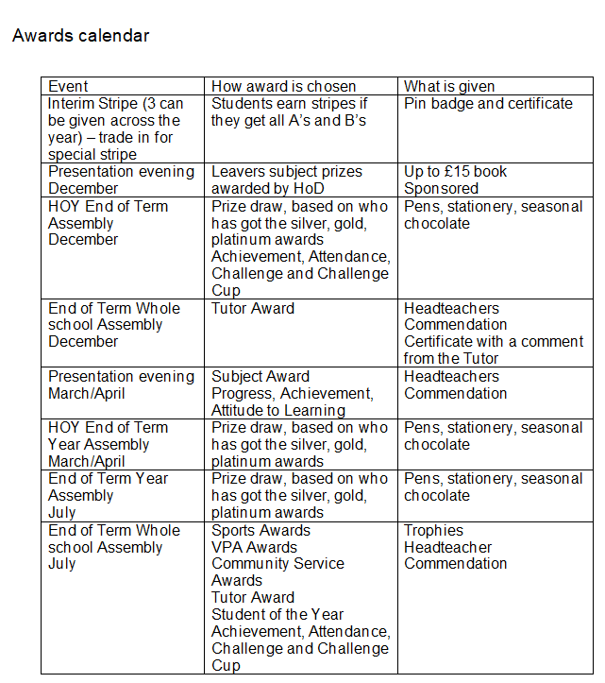

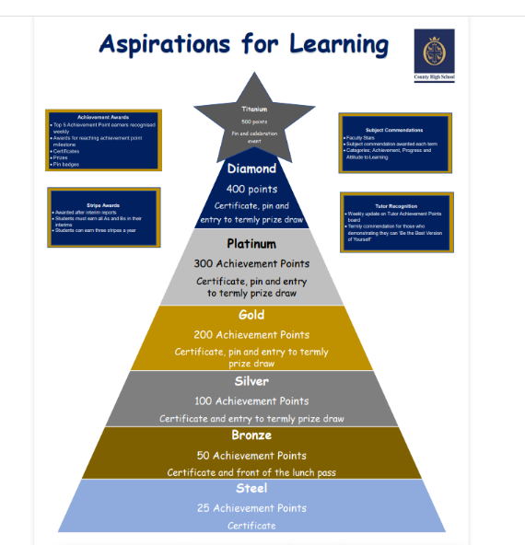

APPENDIX A expectations:

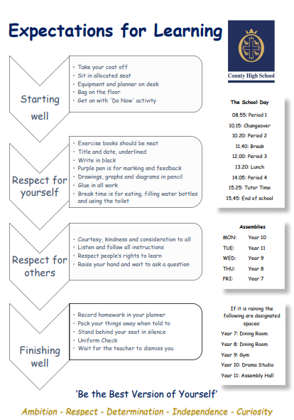

Appendix B – Classroom Behaviour for Learning routine

Classroom Behaviour for learning routines

Clear Expectations
To ensure that all students are able to make good progress and learn in a calm environment free from disruption, we have high expectations of the standards of behaviour for all our students.

Teachers will give you clear and explicit instructions so everybody knows what they are expected to do, and how they are expected to do it. It is important to listen to these instructions so you know what is expected of you.

Warning
Students who do not meet the expectations that have been set out will be given a ‘Warning’. This warning serves as a reminder that you will need to change your behaviour.
D1 Sanction
Students who do not improve their behaviour following a Warning will be given a D1 Sanction. This will be recorded on Go4Schools by the teacher and will include an after-school detention for 30 minutes the next day.
D2 Removal
Students who continue to disrupt the learning of other students following a D1 Sanction will be removed from the classroom and taken to an On Call room.
They will attend an after-school detention for 60 minutes the next day.


Classroom Behaviour for learning routines

Clear Aspirations
At County Upper School you can be the best version of yourself.
Achievements will be celebrated. Achievement Points recognise your positive attitude to learning. Once you gain a set number of Achievement Points over the year (25,50,100,150, etc.) you will earn Achievement Certificates.

Recognition
Teachers will recognise and acknowledge that you are working at expectations.
A1 Achievement
Students who demonstrate excellent attitude to learning, classwork or homework will be awarded an A1 Achievement. This will be recorded on Go4Schools by the teacher as an Achievement Point.
A2 Praise
Students who demonstrate exceptional attitude to learning, behaviour, effort or achievement will be awarded an A2 ‘Praise’. This will be recorded on Go4Schools by the teacher and a Subject Praise Card will be sent home.

Appendix C: Definitions Sexual violence
Rape: A person (A) commits an offence of rape if: he intentionally penetrates the vagina, anus or mouth of another person (B) with his penis, B does not consent to the penetration and A is not totally positive that B consents.
Assault by Penetration: A person (A) commits an offence if: s/he intentionally penetrates the vagina or anus of another person (B) with a part of her/his body or anything else, the penetration is sexual, B does not consent to the penetration and A is not totally positive that B consents.
Sexual Assault: A person (A) commits an offence of sexual assault if: s/he intentionally touches another person (B), the touching is sexual, B does not consent to the touching and A is not totally positive that B consents. (Schools should be aware that sexual assault covers a very wide range of behaviour so a single act of kissing someone without consent or touching someone’s bottom/breasts/genitalia without consent, can still constitute sexual assault.)
Causing someone to engage in sexual activity without consent: A person (A) commits an offence if: s/he intentionally causes another person (B) to engage in an activity, the activity is sexual, B does not consent to engaging in the activity, and A is not totally positive that B consents. (This could include forcing someone to strip, touch themselves sexually, or to engage in sexual activity with a third party.)
What is consent? Consent is about having the freedom and capacity to choose. Consent to sexual activity may be given to one sort of sexual activity but not another, e.g.to vaginal but not anal sex or penetration with conditions, such as wearing a condom. Consent can be withdrawn at any time during sexual activity and each time activity occurs. Someone consents to vaginal, anal or oral penetration only if s/he agrees by choice to that penetration and has the freedom and capacity to make that choice.

Sexual consent
- a child under the age of 13 can never consent to any sexual activity;
- the age of consent is 16;
- sexual intercourse without consent is rape.

Sexual harassment
When referring to sexual harassment at County High School - we mean ‘unwanted conduct of a sexual nature’ that can occur online and offline and both inside and outside of school/college. When we reference sexual harassment, we do so in the context of child-on-child sexual harassment. Sexual harassment is likely to: violate a child’s dignity, and/or make them feel intimidated, degraded or humiliated and/or create a hostile, offensive or sexualised environment.
Whilst not intended to be an exhaustive list, sexual harassment can include:
- sexual comments, such as: telling sexual stories, making lewd comments, making sexual remarks about clothes and appearance and calling someone sexualised names;
- sexual “jokes” or taunting;
- physical behaviour, such as: deliberately brushing against someone, interfering with someone’s clothes (schools and colleges should be considering when any of this crosses a line into sexual violence - it is important to talk to and consider the experience of the victim) and displaying pictures, photos or drawings of a sexual nature; and
- online sexual harassment. This may be standalone, or part of a wider pattern of sexual harassment and/or sexual violence.
It may include:
Sharing nudes and semi-nudes: taking and sharing nude photographs of U18s is a criminal offence;
Sharing of unwanted explicit content;
upskirting (is a criminal offence);
sexualised online bullying;
unwanted sexual comments and messages, including, on social media;
sexual exploitation; coercion and threats.
It is important that schools and colleges consider sexual harassment in broad terms. Sexual harassment (as set out above) creates a culture that, if not challenged, can normalise inappropriate behaviours and provide an environment that may lead to sexual violence.

Harmful sexual behaviour
Children’s sexual behaviour exists on a wide continuum, from normal and developmentally expected to inappropriate, problematic, abusive and violent. Problematic, abusive and violent sexual behaviour is developmentally inappropriate and may cause developmental damage. A useful umbrella term is “harmful sexual behaviour” (HSB). The term has been widely adopted in child protection and is used in this advice. HSB can occur online and/or face to face and can also occur simultaneously between the two. HSB should be considered in a child protection context.
When considering HSB, ages and the stages of development of the children are critical factors. Sexual behaviour between children can be considered harmful if one of the children is much older, particularly if there is more than two years’ difference or if one of the children is pre-pubescent and the other is not. However, a younger child can abuse an older child, particularly if they have power over them, for example, if the older child is disabled or smaller in stature.

