Admissions Arrangements 2024-25



|  |  |
| --- | --- |
| **Policy Title** | Admissions Arrangements 2024-  25 |
| **Policy Created / Amended** | December 2022 |
| **Policy Ratified** |  |
| **Policy review cycle** | 1 Year |
| **Policy Review Date** | September 2023 |

# ADMISSIONS POLICY FOR BSE COUNTY HIGH SCHOOL 2024-25

**Introduction**

Parents should note that for there is no automatic right or guarantee of a place at any school It is essential that application forms are completed and returned by 31st October.

# Published Admission Number

The Published Admission Number (PAN) for 2024-25 is 180.

# Procedures for Admission

Although the Academy will decide its own admissions, the local authority co-ordinates all Normal Year of Entry Admissions in its area, and will communicate all admission decisions to parents on behalf of the Academy Trust. In- year applications should be made directly to the Academy.

Procedures for applying to BSE County High School are explained in the publication Admission to Schools in Suffolk on Suffolk County Council’s website [www.suffolk.gov.uk/admissions.](http://www.suffolk.gov.uk/admissions) Parents should make themselves familiar with this information and take particular note of the definitions provided, dates and deadlines, which apply to County High admissions arrangements unless stated otherwise in this document.

Applications should be made online at [www.suffolk.gov.uk/admissions](http://www.suffolk.gov.uk/admissions). If you are unable to apply online, you should complete the paper application(CAF1) which can be downloaded from Suffolk County Council’s website or you can request a copy by calling 0345-600-0981 Your application must be submitted or reach Suffolk County Council by the closing date of 31 October.

**No completed CAF1 forms will be accepted at the school**. There is the ADM1 form for in year applications online and these forms should be sent to the school for processing.

As required by the Regulations of 2006 the school will give top priority to applications on behalf of Looked after Children (children in care) and Previously Looked after Children (children who were looked after, but ceased to be so because they were adopted or became subject to a child arrangements order or special guardianship order, immediately following having been in care, including those who appear [to the admission authority] to have been in state care outside of England and ceased to be in state care as a result of being adopted).

# Definitions Sibling

By sibling we mean children living at the same address who have one or both natural parents

in common, children living at the same address who are related by a parent’s marriage, children living at the same address whose parents are living as partners at this address. We do not include

‘cousins’ within our definition of sibling.

# Admissions Criteria

Pupils with an Education, Health and Care Plan (EHC Plan) that name the Academy will be admitted.

Looked after Children or previously looked after children be admitted as the top priority. ***Children adopted from state care outside of England*** A child is regarded as having been in state care outside of England if they were in the care of or were accommodated by a public authority, a religious organisation, or any other provider of care whose sole or main purpose is to benefit society and ceased to be in state care as a result of being adopted.’

We will admit pupils using the oversubscription criteria listed below in descending order:

1. Children in care (looked after children) and children who were previously in care (children who were looked after, but ceased to be so because they were adopted or became subject to a child arrangements order or special guardianship order, immediately following having been in care, including those who appear [to the admission authority] to have been in state care outside of England and ceased to be in state care as a result of being adopted).

# Exceptional Medical Need / Medical Need

Exceptional medical circumstances supported by written medical evidence may override all but the first criterion. Any such applications must be received by the closing date in the coordinated scheme and will be considered by the Admissions Committee of the school. The extent and circumstances which medical need would override those above would relate to situations in which e.g. a hospital consultant has stated in writing that attendance at County High was an essential in terms of meeting the medical needs of the child. The evidence should come, however, from at least one registered health professional and should set out the particular reasons why County High is the most suitable school.

1. (a) children of staff of the academy who have been employed at the academy for two or more years at the time at which the application for admission was made and/or

(b) children of staff who are recruited to fill a vacant post for which there is a skill shortage.

1. Children with a brother or sister (sibling) attending County High at the time of application with a reasonable expectation they will be attending at the start of the new school year. Attendance at County High School will include attendance at the Sixth Form.
2. Distance as outlined in the section labelled ‘Tie Breaker’ below.

The academy reserves the right to refuse entry to applicants who have been permanently excluded from two or more schools. This applies within two years of the second exclusion.

# Tie-Breaker

In the event of oversubscription, those living nearest the school will be given priority. We measure by a straight line (‘as the crow flies’). All straight-line distances are calculated electronically by Suffolk County Council using data provided jointly by the Post Office and Ordnance Survey. The data plots the co-ordinates of each property and provides the address-point between which the straight-line distance is measured and reported to three decimal places. Where there is more than one home within a single building (for example apartments) we will measure to a single point within that building irrespective of where those homes are located.

In the unlikely event that two or more applicants competing for a single place at the school live the same distance from the school, the place will be offered to one applicant on the basis of lots drawn by a person who is independent of the School.

# Shared Living Arrangements

Where a child lives part of the week with one parent and part with another member of the family, the ‘home address’ will be considered to be the address where the child is ‘ordinarily resident’. By ordinarily resident we mean the place where your child usually lives. We consider this to be where they sleep overnight. We may need proof of this address. If you use another address to give the impression that your child lives at a different address to where they are ordinarily resident, such as a second home or a grandparent’s address - so that you have a higher priority for a place at that school - we consider this to be a fraudulent application. Where a child lives at two or more addresses, each for part of the week, the address at which the child is ordinarily resident will be considered to be the address that the child lives at for most of the week (excluding weekends and school holidays). Separate evidence in writing from each parent must be provided to confirm the child’s living arrangements at the time of application.

In cases where the child spends an equal proportion of the school week at two or more different addresses, evidence of which is to be considered the main contact address will be required to support the application. Agreement in writing by the parents will be required to state which address is to be used as the ordinarily resident address. This address will then be used when processing all school preferences expressed. It is not acceptable to use one address for one school preference and another address for another school preference.

If we are aware of a parental dispute affecting the application, we may not be able to deal with the application and you may need to seek independent legal advice in order to resolve the matter.

**Admission of children outside their normal age group**

It is expected that children will normally be educated within their chronological year group. However, we will make decisions on the basis of the circumstances of each case and in the best interests of the child concerned in line with the School Admissions Code.

You can make a request to the school in writing. This will need to include, where relevant, any supporting evidence. We will make a decision on the request, taking into account the views of

the headteacher. We will write to you with the outcome including the reasons for the decision. If the request is refused, you we be given the details of how to complain to the school.

A CAF1 application form must be sent to Suffolk County Council along with the decision letter from the school and other relevant evidence by the national closing date. Even if the request is agreed there is no guarantee there will be a place available.

# Multiple Births

If the final place available at the Academy is offered to a twin, triplet or other multiple birth and the remaining siblings would ordinarily be refused, the academy will offer places to the remaining sibling(s).

# Waiting Lists and in year admissions

The Academy will automatically maintain a waiting list in the event that oversubscription occurs until the 31st January after the September in the normal year of admissions (Year 7). Pupils will be ranked in order against the oversubscription criteria.

The Academy will not keep any other waiting list. Pupils will be admitted to the Academy in year when and if a space becomes available and parents should keep in contact with the school for assistance with their applications.

# Guardianship

The school reserves the right to carry out necessary checks as to the legal guardianship of an adult making an application for admission for a child whether as an in-year admission or as part of the general intake where it considers it necessary to do so. It is recognised that this can relate to safeguarding issues and is therefore of the highest priority to the school.

# RIGHT TO APPEAL

**When an applicant is unsuccessful there is an automatic right of appeal to an Independent Appeal Panel.** Information regarding how to do this will be sent in the letter outlining the reasons for refusal.

Appendix 1

# Distance to School Map for Bury St Edmunds County High School

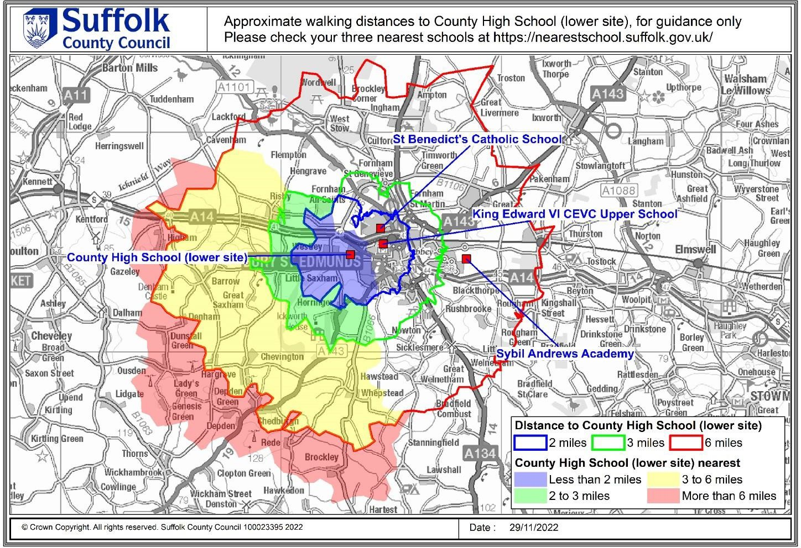

For further information, this map identifies the areas for which County High School would be the closest school. School travel eligibility is based on a child attending their nearest suitable school that would have had a place available for them. You should consult Suffolk County Council’s [Nearest School Checker](https://nearestschool.suffolk.gov.uk/) to accurately find your child’s nearest school.