**CONCERNED ABOUT A CHILD?**

**REFER – SEE IT, HEAR IT, REPORT IT**

**to our safeguarding team (wearing Red Lanyards)**

**Safeguarding**

**Governor**

**Deputy**

**Safeguarding**

**Lead**

**Designated**

**Safeguarding**

**Lead**

**Alternate Safeguarding**

**Leads**

**Leads**

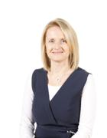

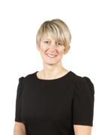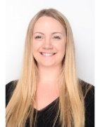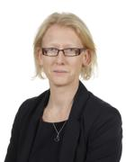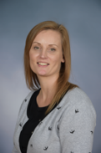

**Mrs R Kerr**

**Deputy Head**

**Mrs G Ellis**

**Trust Governor**

**Miss H George**

**Office Administrator**

**Mrs T Kittle**

**Executive Head**

**Mrs F-C Thompson**

**Head Teacher**

**Miss Egan**

**Thrive Practitioner**

**Miss R Dunmore**

**Deputy Head**

**What to do** if a child makes an **allegation or disclosure** of abuse against an adult or other child or young person, **it is important that you:**

* **Do** stay calm and listen carefully.
* **Do** reassure them that they have done the right thing in telling you.
* **Do** **not** investigate or ask leading questions.
* **Do** let them know that you will need to tell someone else.
* **Do not** promise to keep what they have told you a secret.
* **Do** inform your DSL as soon as possible.
* **Do** use the concern form (kept in staffroom) to make a written record of the allegation, disclosure or incident which you must sign, date and record your position.
* **Do not** include your opinion without stating it is your opinion.
* **Do refer without delay**

**TELEPHONE NUMBERS:**

**Children’s Services:** Customer First Free phone: **0808 800 4005**

Local Area Designated Officer: **0300 123 2044**

[LADOCentral@suffolk.gcsx.gov.uk](mailto:LADOCentral@suffolk.gcsx.gov.uk)

**Suffolk Police:** Main Switchboard No: **01473 613500 or 101**

**IN AN EMERGENCY DIAL 999**