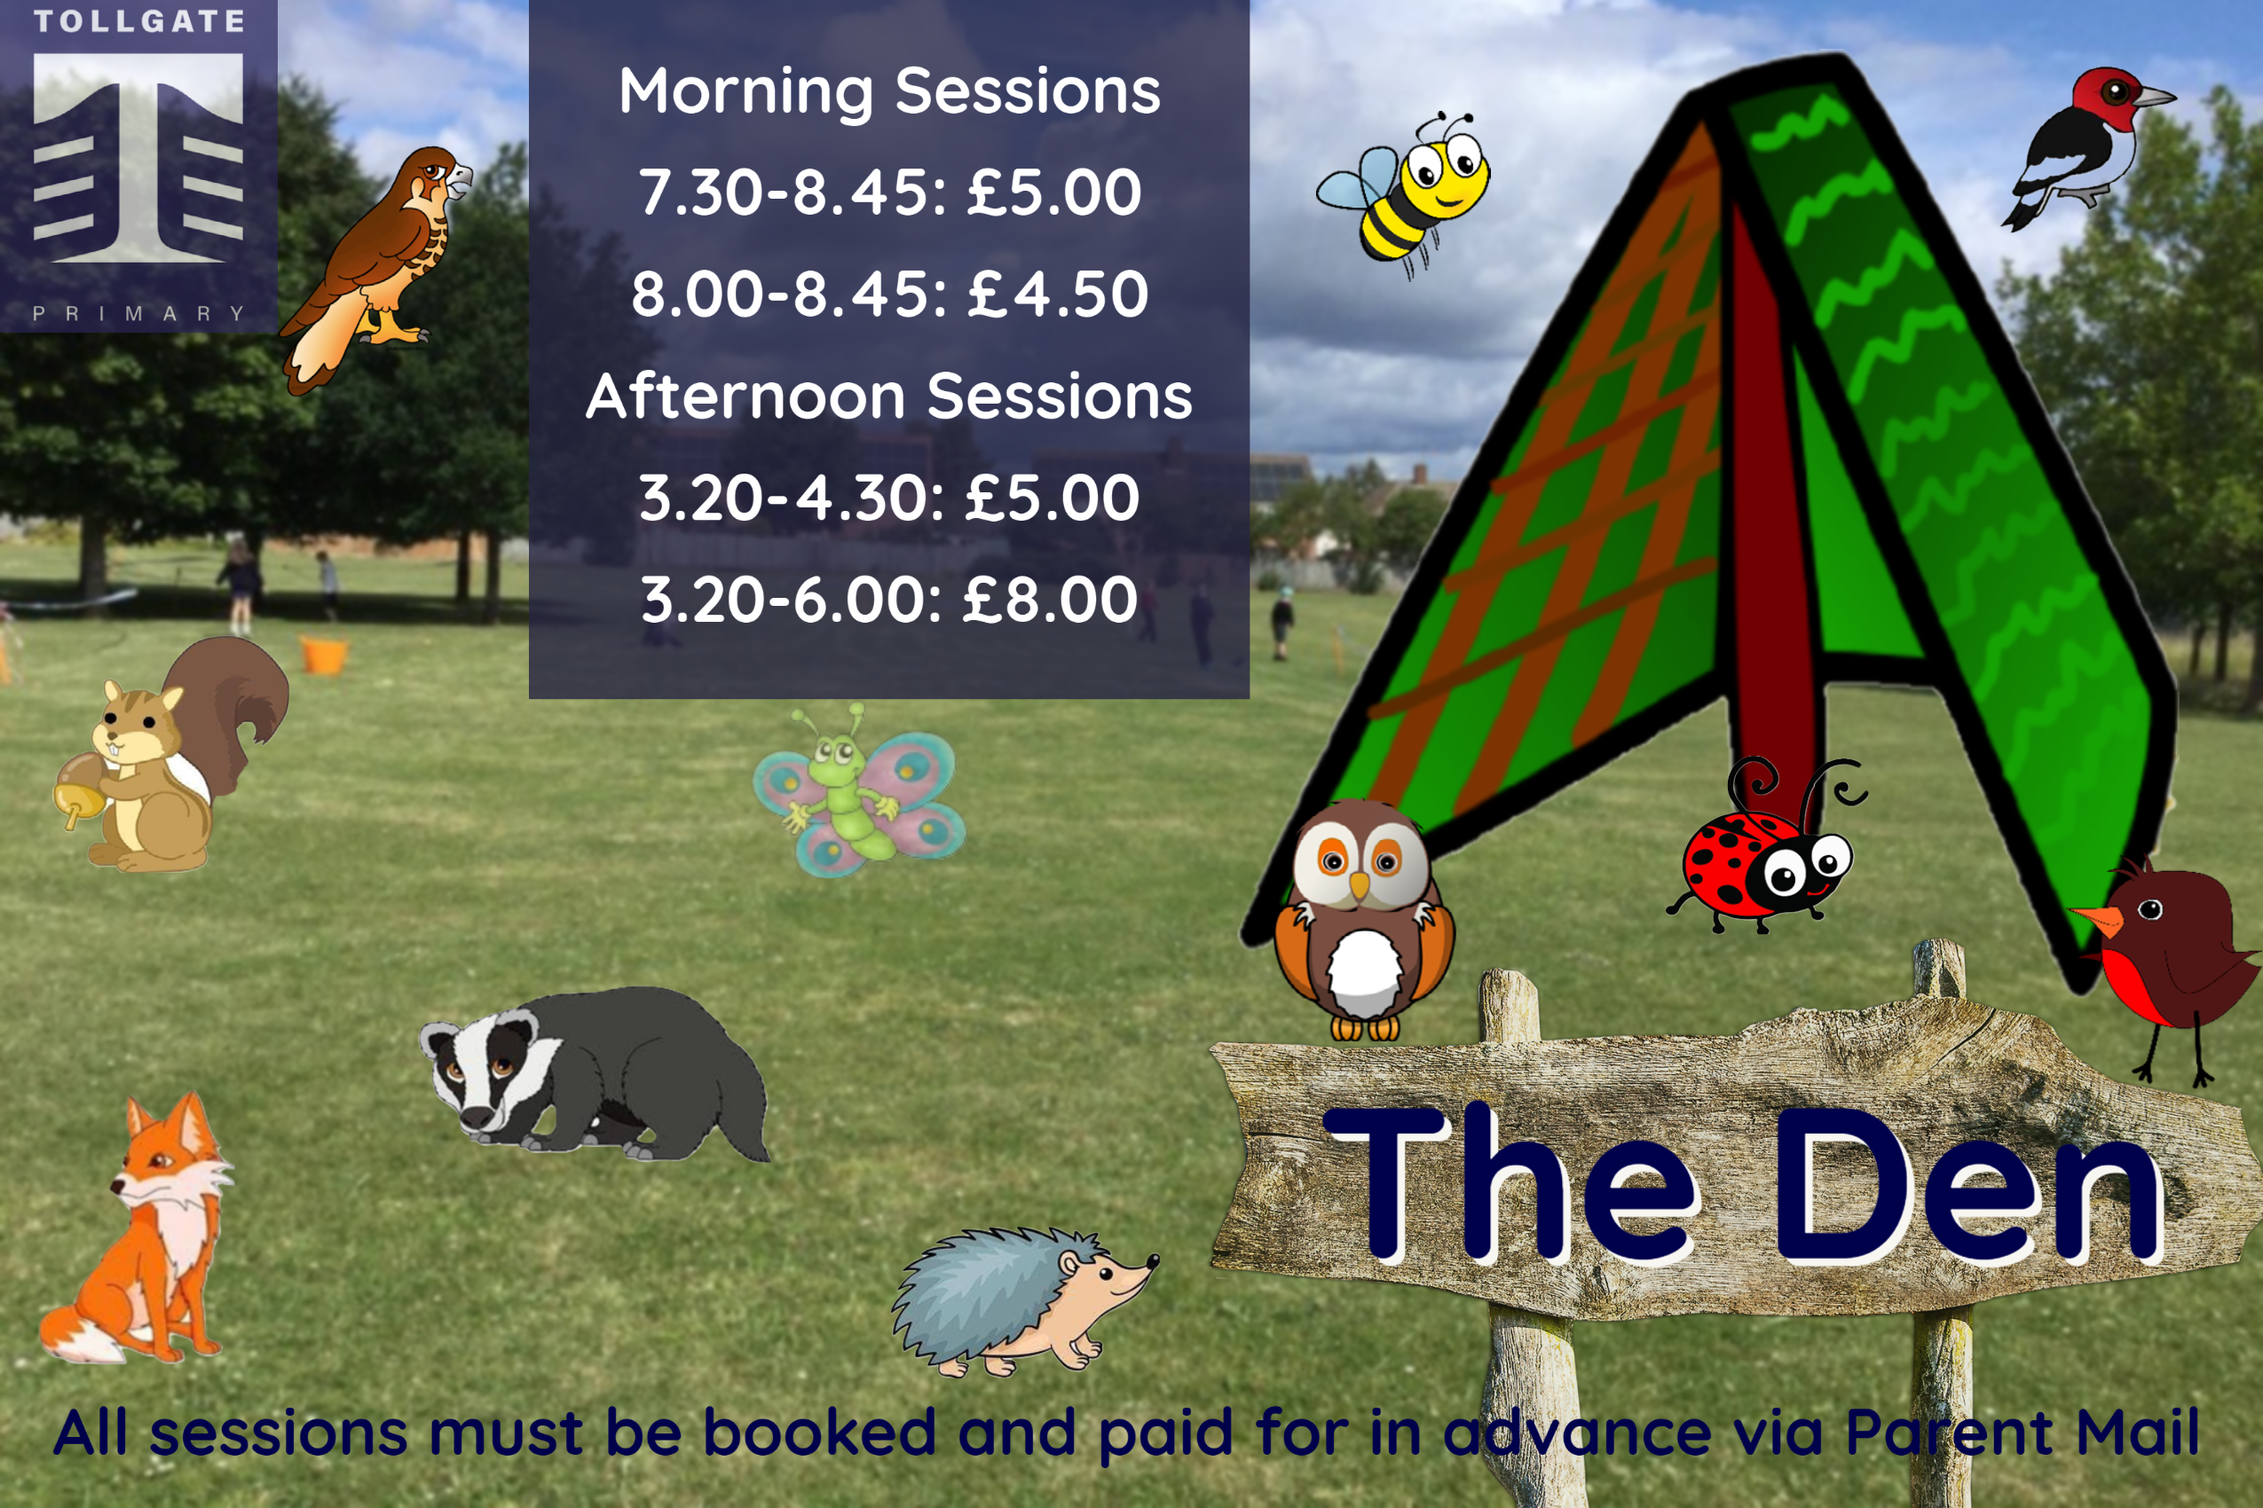

**All session must be booked and paid for in advance via Arbor under Den AM and Den PM with 24 hours notice**

**01284 777190**

Morning Sessions

7.30 – 8.45 : £6.00

8.00 – 8:45 : £5.50

Afternoon Sessions

3.30 – 4.30 : £6.00

3.30 – 6.00 : £9.00