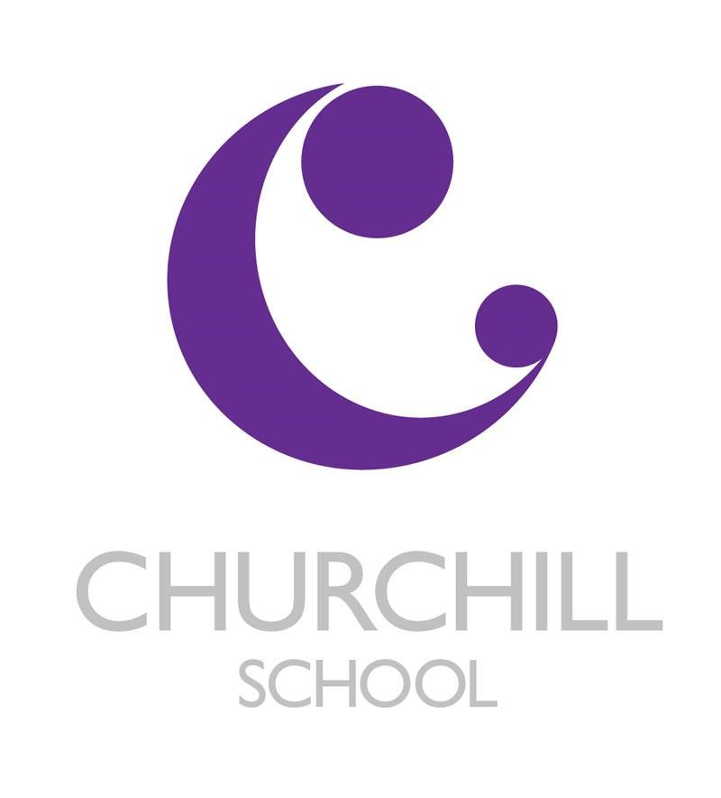

RSHE - Relationships and Sex
Education (RSE) and Health Education Policy -

Introduction

This policy covers Churchill School’s approach to Relationships and Sex Education (RSE) and Health Education. The information in this policy complies with the DfE’s statutory guidance to deliver RSE in all year groups from September 2021. This policy will be reviewed regularly to ensure that is it in line with the current government guidance and legislation and to ensure our RSHE curriculum continues to meet the needs of all our pupils.

The purpose and aims of RSHE in our school.

The aim of RSHE is to give children and young people the information they need to help them to develop healthy, positive relationships and lead healthy lives as well as preparing them for adult life and becoming a valued member of the wider community.

The vision for safe and effective RSHE

RSE is taught within the subject relationships, sex, and health education (RSHE). Biological aspects of RSE are taught within the science curriculum, and other aspects are included in Religious Education (RE) and Life Skills. There are several cross curricular links for RSHE. As a school, the RSE aspect of RSHE curriculum focuses on giving young people the information they need to help them develop healthy, nurturing relationships of all kinds including:
- Families
- Respectful relationships, including friendships.
- Online and media
- Being safe
- Intimate and sexual relationships, including sexual health.

These areas of learning are taught within the context of family life taking care to ensure that there is no stigmatisation of children based on their home circumstances (families can include single parent families, LGBT parents, families headed by grandparents, adoptive parents, foster parents/carers amongst other structures) along with reflecting sensitively that some children may have a different structure of support around them (for example: looked after children or young carers).
Roles and responsibilities
Governors will:
- Ensure all pupils make progress in achieving the expected educational outcomes.
- Ensure the curriculum is well led, effectively managed, and well planned.
- Evaluate the quality of provision through regular and effective self-evaluation.
- Ensure teaching is delivered in ways that are accessible to all pupils with SEND.
- Provide clear information for parents on subject content and their rights to request that their children are withdrawn.
- Ensure the subjects are resourced, staffed, and timetabled in a way that ensures the school can fulfil its legal obligations.

The Head teacher will:
- Oversee the overall implementation of this policy.
- Ensure staff are suitably trained to deliver the subjects.
- Review requests from parents to withdraw their children from the subjects.
- Report to the governing board on the effectiveness of this policy.
RSHE subject leader will:
- Ensure that parents are fully informed of this policy.
- Discuss requests for withdrawal with parents.
- Organise alternative education for pupils, where necessary, that is appropriate and purposeful.
- Work with the Senior Leadership Team and curriculum leaders to evaluate the quality of provision.
- Create a high-quality and age-appropriate curriculum in line with statutory requirements.

Class teachers will:
- Use a variety of teaching methods and resources to provide an engaging curriculum that meets the needs of all pupils.
- Ensure they do not express personal views or beliefs when delivering the programme.
- Model positive attitudes to relationships, health, and sex education.
- Respond to any safeguarding concerns in line with the Safeguarding and Child Protection policy.
- Act in accordance with planning, monitoring and assessment requirements for the subjects.
- Consult with the SENCO to identify and respond to individual needs of pupils with SEND.

Parents/carers will:
- Support school staff to shape the curriculum for relationships, health, and sex education.
- Communicate openly and constructively with school staff regarding relationships, health, and sex education.
- Attend, or contribute to, any consultation or information sessions regarding the delivery of relationships, health, and sex education.

Statuary guidance including right to withdraw.

As a secondary Special school we must provide RSE to all students as per section 34 of the Children and Social work act 2017. The Relationships Education, Relationships and Sex Education and Health Education (England) Regulations 2019 made under sections 34 and 35 of the Children and Social Work Act 2017 make Relationships Education compulsory for all pupils receiving primary education and Relationships and Sex Education (RSE) compulsory for all pupils receiving secondary education. The regulations also make Health Education compulsory in Academies.

Curriculum design

Churchill School use jigsaw to design the RSHE curriculum. RSE forms part of the Relationships, Sex and Health Education (RSHE) curriculum in our school. The RSHE programme is led by the RSHE subject leader. RSHE lessons are taught by class teachers, supported by the RSHE subject leader. Teaching staff receive training in the delivery of the RSHE curriculum through dedicated staff meetings, led by the RSHE subject leader. All classes will have regular weekly or fortnightly timetabled RSHE lessons and will be delivered in an age appropriate and sensitive manner. RSHE is delivered by the class teacher to mixed-gender year groups in KS3 and 4 and mixed year groups in KS2. Occasionally, appropriate, and suitably experienced and/or knowledgeable visitors from outside school may be invited to contribute to deliver RSHE in school for example school nurses. All visitors will be familiar with and understand the school’s RSHE policy and be expected to work within it. Some content may be delivered through other subjects including:
- ICT
- Life Skills
- Science
- PE
- Careers
An overview of our RSHE scheme of work is included within the appendices of this policy for reference, this is the curriculum pathway.

Teaching and learning strategies

All teachers at Churchill understand that children of the same age may be developmentally at various stages, leading to differing types of questions or behaviours. Teachers will consider what is appropriate and inappropriate in a whole class setting and which areas are better addressed with groups or individuals e.g., the teaching of menstruation is vital for the girls but may vary from year to year due to pupil numbers. We aim to provide an environment and atmosphere for RSHE where pupils feel relaxed, safe, unintimidated, and focused; and where they trust the knowledge, ability, and skills of staff in school. To ensure high quality RSHE lessons are taught, teachers will:

- Use resources and teaching methods which have been approved by the RSHE subject leader.
- Adhere to the school’s agreed curriculum content which is age and stage appropriate.
- Teach RSHE through a spiral curriculum which revisits previous learning and builds knowledge and understanding in gradual steps.
- Teach in a sequence of lessons which build knowledge and understanding at a gentle pace.
- Make provision for supporting pupils who may struggle to adhere to the ground rules or deal with the content of the lessons (this may include arranging for additional staff to support in the lesson or be on standby).
- Ensure that lessons are well planned, prepared and that all staff that are present are clear about the level of content that will be covered – age and stage appropriate.
- Provide adequate lesson time for discussion, to answer questions, deal with misconceptions and ensure that the pupils have properly understood the content.
- Provide regular opportunities for pupils to ask questions in written form to avoid risk of embarrassment or judgement. This will also provide the teacher with time to assess whether the question fits within the age & stage requirements and decide how/whether the question should be answered.
- Use personalisation techniques to allow students to explore an issue without relating it to personal experience.
- Agree a set of ground rules based on a school-wide template to provide clarity and create a safe learning environment, at the beginning of SRE lessons including rules such as:
- No personal questions
- Respect everyone’s ideas and contributions.
- It is okay to pass a questions or activity if it feels too private.
- Laughing or giggling is okay.
- No put downs.
A wide range of teaching methods and activities are used in RSHE lessons including but not limited to:
- PowerPoint presentations
- Videos
- Case studies
- Think, Pair, Share
- Class discussions
- Card sorts including diamond 9 card sorts.
- Drawing, collage, or comics
- Explain to an alien.
- Giving advice to others or someone younger
- Mind maps
These activities will support students assess their learning and identify progress they have made as well as giving them the opportunity to apply skills they have been learning in different contexts.

Safeguarding

Teachers are aware that effective RSHE, which brings an understanding of what is and what is not appropriate in a relationship, can lead to a disclosure of a child protection issue. Teachers will take these matters seriously and speak to a child away from the class as a matter of priority. Teachers will draw their concerns to the attention of the designated safeguarding lead within the school. This will then be dealt with in line with the safeguarding policy. We occasionally engage the expertise of other appropriate external partners to work with use to provide advice and support to children about RSHE education. Such visits should be arranged through the RSHE co-ordinator and with the approval of the Headteacher. These sessions are in addition to, and intended to complement, our existing RSHE provision. Where external partners are involved, teachers will have discussed and shared the planning and content of the session with visitors in advance. A class teacher will always be present and responsible for classroom management. Visitors supporting the delivery of RSHE will follow the agreed ground rules and protocols set out above regarding any safeguarding or child protection concerns.

The roles of parents/parental right to withdrawal

Parents/carers play a key role in the development of their child’s understanding of relationships and health. Parents are the first educators of their children and have the most considerable influence in enabling their children to grow and mature and to form healthy relationships. All parents/carers will be:
- Given every opportunity to understand the purpose and content of RSHE including relationships and sex education.
- Encouraged to participate in the development of RSHE at Churchill.
- Able to discuss any concerns with school including their RSHE teacher and RSHE co-ordinator.
Rights to be excused from sex education.
In primary education from September 2021:
- Parents will not be able to withdraw their children from any aspect of Relationships Education or Health Education (which includes learning about the changing adolescent body and puberty).
- Parents will be able to withdraw their children from any aspects of Sex Education other than those which are part of the science curriculum. (Note that sex education will not be statutory in primary schools, however the new statutory guidance makes clear that schools should still provide a programme of age-appropriate sex education).
- For primary aged pupils the Head teacher must grant requests to withdraw a pupil from sex education, other than where it is part of the science curriculum (although the guidance makes clear that good practice is ‘likely to include the head teacher discussing with parents the benefits of receiving this important education and any detrimental effects that withdrawal might have on the child’).
- Where pupils are withdrawn from sex education, schools should document the process and will have to ‘ensure that the pupil receives appropriate, purposeful education during the period of withdrawal.’
In secondary education from September 2021:
- Parents will not be able to withdraw their child from any aspect of Relationships Education or Health Education.
- Parents will be able to withdraw their child (following discussion with the school) from any or all aspects of Sex Education, other than those which are part of the science curriculum, up to and until three terms before the age of 16.
- After that point, the guidance states that ‘if the child wishes to receive sex education rather than be withdrawn, the school should make arrangements to provide the child with sex education during one of those terms.’
- Where pupils are withdrawn from sex education, schools should document the process and will have to ‘ensure that the pupil receives appropriate, purposeful education during the period of withdrawal.’
- More details can be found on the gov.uk website here https://www.gov.uk/government/publications/relationships-education-relationships-and-sex-education-rse-and-health-education/introduction-to-requirements

Curriculum Intent for RSHE

The Jigsaw programme focuses on 6 themes for each key stage.

Key Stage 2

The RSHE programme is designed to support students to develop the skills and attitudes they need to make positive decisions outside of the classroom. The six key areas taught in each year are:
- Being me in my world
- Celebrating difference
- Dreams and goals
- Healthy me
- Relationships
- Changing me
As part of this subject, students will have opportunities to understand, concepts that they may find difficult to understand, such as developing and maintaining relationships and understanding personal space and gain a better understanding of others and how their actions can impact those around them. At Key Stage 2, the RSHE curriculum enables pupils to develop the skills needed to become more independent and learn more about the wider world so they can make positive choices in the community.
Key Stage 3
The RSHE programme is designed to support students to develop the skills and attitudes they need to make positive decisions outside of the classroom. The six key areas taught in each year are:
- Being me in my world
- Celebrating difference
- Dreams and goals
- Healthy me
- Relationships
- Changing me

As part of this subject, students will have opportunities to understand, concepts that they may find difficult to understand, such as developing and maintaining relationships and understanding personal space and gain a better understanding of others and how their actions can impact those around them.
At key stage 3, students build on the knowledge and understanding, skills, attributes, and values they have acquired and developed during Key Stage 2. Pupils will learn and develop the skills which will equip them for the opportunities and challenges of life. Students learn to manage diverse relationships, their online lives, and the increasing influence of peers and the media.

Key Stage 4

The RSHE programme is designed to support students to develop the skills and attitudes they need to make positive decisions outside of the classroom. The six key areas taught in each year are:

- Being me in my world
- Celebrating difference
- Dreams and goals
- Healthy me
- Relationships
- Changing me

As part of this subject, students will have opportunities to understand, concepts that they may find difficult to understand, such as developing and maintaining relationships and understanding personal space and gain a better understanding of others and how their actions can impact those around them.
At key stage 4, students deepen knowledge and understanding, extend and apply skills, and further explore attitudes, values, and attributes they learnt during key stage 3.

Drugs

As part of the RSHE curriculum students will be taught about the misuse and abuse of drugs, and the negative impact this can have on you physically and mentally. See below when the topic is taught. The physiological and physical effects of drugs, drug poisoning and drug classification is first taught in year 9 in the Healthy Me topic. This information is then covered in more detail in year 10, along with the misuse of prescription drugs, again in the Healthy me topic. The teaching of drugs throughout the RSHE curriculum is in line with the Churchill Special Free School’s Drugs Policy.

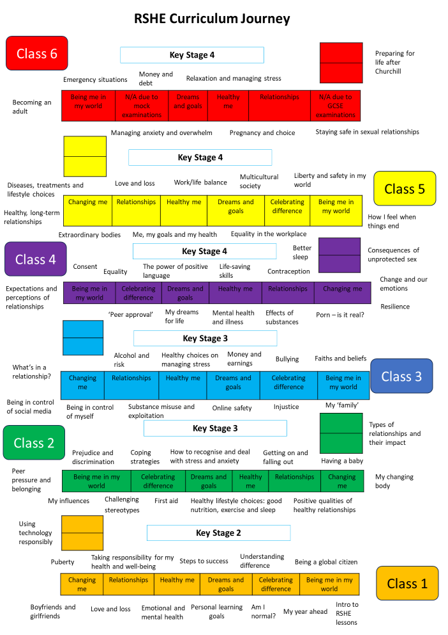

Review

This policy will be reviewed in line with the school’s policy review programme.
Author  Mr C Komodromos | Date  Autumn Term 2025 | Frequency of Review  Yearly

