

Friday 23rd January, 2026

Dear Parents and Carers,

It is officially one week to go until our Coupals and Place Farm Have Got Talent at the Haverhill Arts Centre on Friday 30th January. Thank you to those parents who have purchased tickets via Arbor for the event.

I wanted to remind parents of children in Year Six that parents’ evening will take place on Monday 2nd February (3:40-7:30pm) and Tuesday 3rd February (3:30-5:30pm). This is taking place earlier than it is for the rest of the school so that you can be made aware of how your child is progressing towards their End of Key Stage SATs assessments and what further support they are receiving in school towards these. You will be able to book an appointment with either Mr Brogan or Mrs Bamforth-White from 3pm today – Friday 23rd January. Please note that booking will be closed on Arbor at 10am on Monday 2nd February.

Next week proves to be an exciting week at Coupals as we participate in the CUSP Art Festival! I am sure the children will be eagerly looking forward to participating in exciting Art concepts through out the course of the week.

Please can I remind parents to park with care when they drop off and collect their child/children at the beginning and end of the school day. There have been several incidents this week where cars have been parking on the zig zags and have been parking on the corner of Shetland Road. Please can I remind parents to be considerate when parking. We appreciate your support with this.

I would like to draw parents’ attention to NSPCC Number Day on Friday 6th February. Please see the information below around how we are going to engage with this day at Coupals.

Please can I ask parents and carers should they have a query or would like to speak to a Senior Leader to ensure that they email the admin email address on admin@coupalsacademy.co.uk to arrange an appointment.

Have a restful weekend,

Tom Wade
Head of School

Could you make a difference to our schools?
Join the Coupals and Place Farm Local Governing Body
We’re looking for enthusiastic, community-minded people who want to help shape the future of our two schools. As a School Governor, you’ll play a vital role in supporting our leadership team and ensuring we provide the very best education for every child.
Why Become a Governor?
🌟 Make a meaningful impact on children’s education
- 💡 Use your skills and experience to support school improvement
- 🎓 Gain valuable insight into how schools operate
- 🤝 Be part of a committed team working for the success of both schools
This is an interesting, varied, and highly rewarding role — perfect for anyone who wants to give back and help our schools continue to thrive. Full training and ongoing support are provided.
Interested?
To find out more about this voluntary role or arrange an informal conversation, please contact:
Sue Kehr, Chair of Governors
📧 skehr@samuelward.co.uk

CALENDAR

January
Friday 30th January- Place Farm and Coupals Have got Talent at the Arts Centre
February
Monday 2nd and Tuesday 3rd February -Year Six Parents’ Evening
Friday 6th February – NSPCC Number Day
Half- term – Monday 16th February – Friday 20th February
Thursday 26th February – EYFS Share assembly
March
Tuesday 10th March - Spring term Disco!
Wednesday 11th March – Year 1 Share assembly 8:50-9:30am
Thursday 12th March – World Book Day (Coupals WBD)
Friday 20th March – Red Nose Day!
Thursday 26th March – Year 2 Share assembly 8:50-9:30am
Friday 27th March – last day of spring term

April
Monday 13th April – Start of summer term
Thursday 23rd April – Year 3 Share assembly 8:50-9:30am
Monday 27th and Tuesday 28th April – EYFS-Y5 Parents’ Evening
May
Thursday 7th May – Year 4 Share assembly 8:50-9:30am
Monday 11th – Thursday 14th May – Year Six SATs Week
Monday 18th – Thursday 21st May – Sports Days this week!
Half term – Monday 25th May – Friday 29th May
June
Thursday 4th June – Year 5 Share assembly 8:50-9:30am
Monday 8th – 12th June – Phonics Screening Week for Y1 pupils
Monday 1st June – Friday 12th June – Y4 Multiplication Times Tables Check
Wednesday 17th June – Thursday 18th June – Y5 Residential – Kip on a Ship!
Friday 19th June – Vancols - Class Photos
Friday 26th June – PD Day- school closed to pupils
July
Monday 6th – Wednesday 8th July- Y6 Residential to Mersea
Friday 10th July- Reports to go home with pupils
Tuesday 14th July – Year Six Graduation
Wednesday 15th- Friday 17th July- Transition Days!
Friday 17th July – last day of summer term
Monday 20th July – PD Day – school closed to pupils

Celebration Assembly!

Please see attached the photo of the pupils who achieved certificates in assembly this week. We are incredibly proud of all of the pupils for demonstrating the DRIVE Values in all that they do! Thank you to parents who were in attendance of the assembly to share in the children’s successes this week.
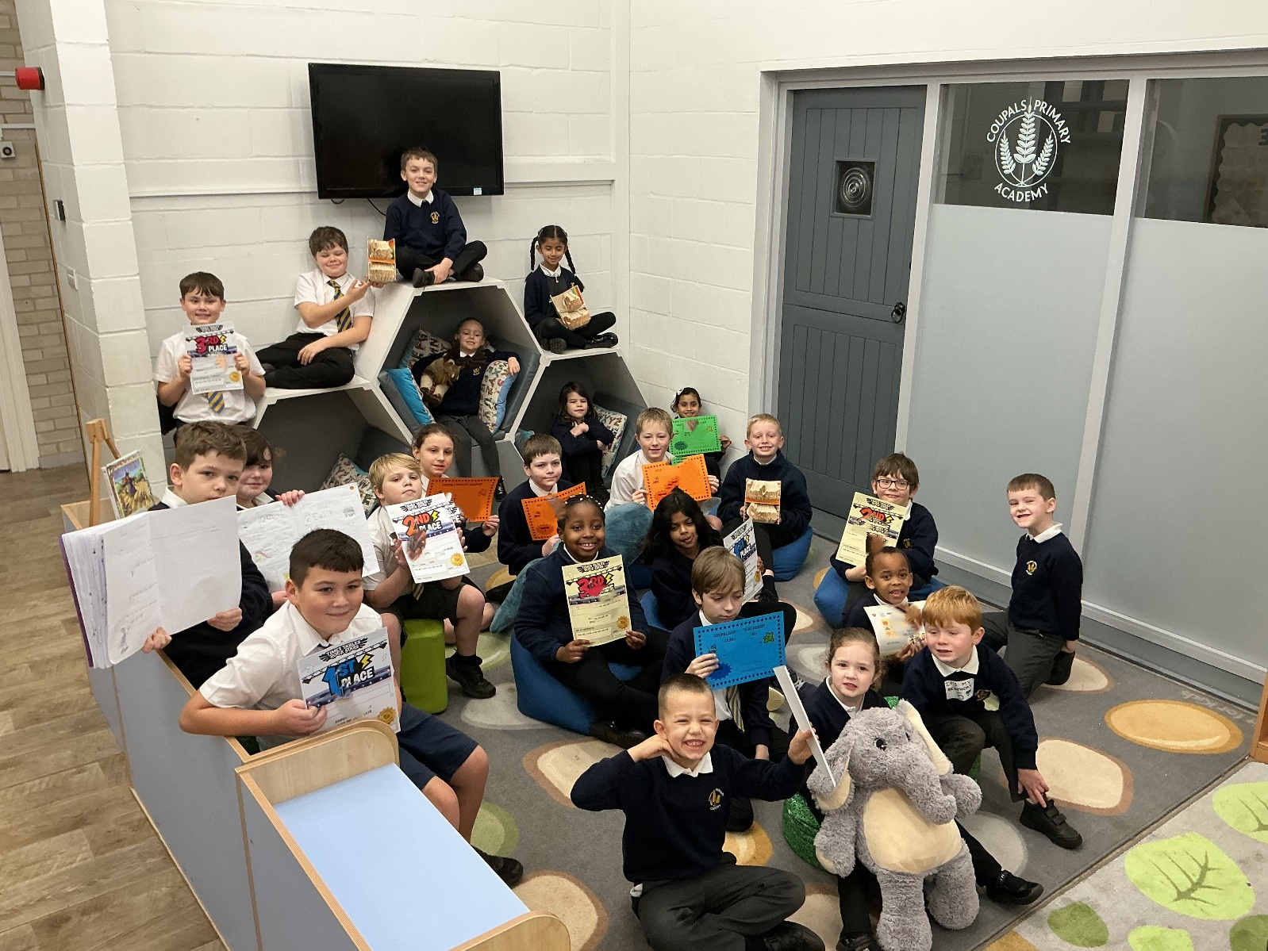

Well done to 6LB (98%), 0BP (97.9%) and 1LP (95.8%) who were awarded the animals to spend time in their classes this week for super attendance!

Year 3
Year 3 have been extremely busy since returning after the Christmas holidays! We have started reading a new class book, Sam Wu is NOT Afraid of the Dark, which we have thoroughly enjoyed and has sparked lots of excitement and discussion in the classroom. In maths, we have been working hard on our multiplication and division skills, linking our knowledge of commutative and inverse operations while embedding our understanding of the 3, 4 and 8 times tables. The children have felt immensely proud of themselves as they have shown great determination and effort in building their fluency with these facts. During our afternoon lessons, we have begun a new geography unit learning about the United Kingdom, explored friction in science, and created beautiful concentric artwork in art. It has been a fantastic start to the term, and we are very proud of all the children’s hard work and enthusiasm.

Maths Club
In our Year 6 Maths Club, we have been practicing the arithmetic and reasoning skills needed for the Year 6 curriculum. The children have been working extremely hard to embed their knowledge of long division, as well as problem solving from SATs based questions.

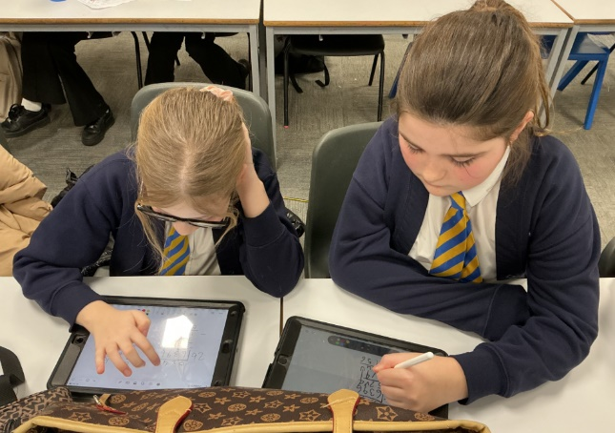
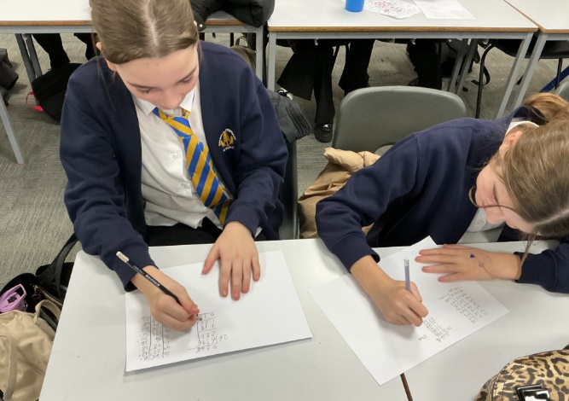
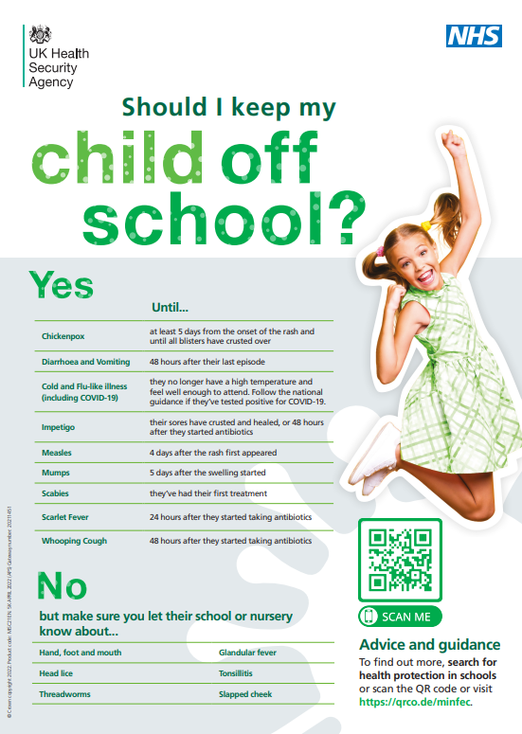



REPORTING YOUR CHILD’S ABSENCE

Quick Guide for Parents

Can my child go to school?
Yes  - Mild cold  - Runny nose  - Slight cough  - Sore Throat  - Fever  ✔️ You may use your usual at home care to help them feel better.  ✔️ If their temperature improves and they seem well enough to join in, they can attend. | No  - Vomiting or diarrhoea  ❌ Keep them home for 48 hours after the last episode.  - Contagious illnesses (e.g., chickenpox, impetigo)  ❌ Follow NHS guidance for return times.

How to report an absence

Please contact the school before morning registration.
- Call the school office
- Leave a voicemail if calling early
- Email the admin inbox

What to tell us
- Child’s full name
- Class/teacher
- Reason for absence
- Expected return date

Daily updates

If your child is off for more than one day, please update the school each morning unless we have agreed otherwise.

Medical evidence

For longer or repeated absences, we may request:
- Appointment card
- Prescription label
- Hospital note
This helps us record the absence correctly and ensure that we can support you and your child.


Dear Parents and Carers,
As a school, we will be celebrating NSPCC Number Day on Friday 6th February 2026.

It’s the perfect way to celebrate Maths and raise awareness of this wonderful charity.

The children do not need to bring a donation in for this.

The theme for this year is 'Dress up as digits' so the children can come in wearing something numbered such as a football shirt or something you can count e.g. spots or stripes – be creative! This is an option so the children can choose if they want to do this or not.

During their Maths lesson on the day, the children will take part in lots of fun activities and games linked to NSPCC Number Day.

There will also be an exciting TTRS competition for children in Years 2-6 to take part in! It is called ‘NSPCC Rocks’ and will start at 7:30am and finish at 7:30pm on Friday 6th February 2026. They can play up to a limit of one hour in any game mode.



I am sure we will all enjoy celebrating NSPCC Number Day

Many thanks for your support with this,

Miss Lister (Senior Maths Lead for Coupals and Place Farm)









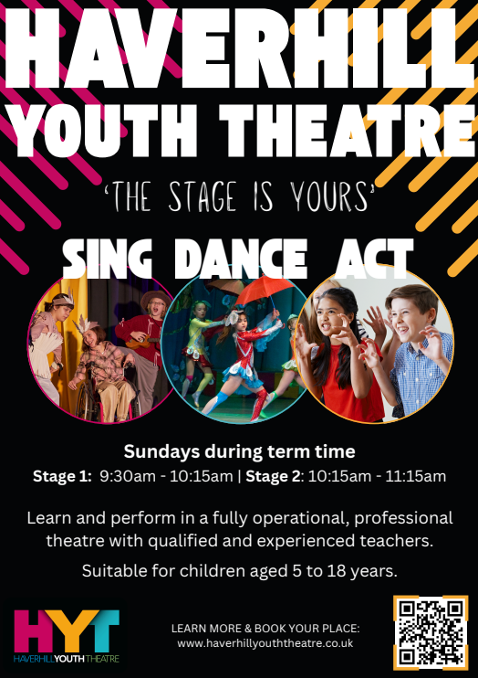


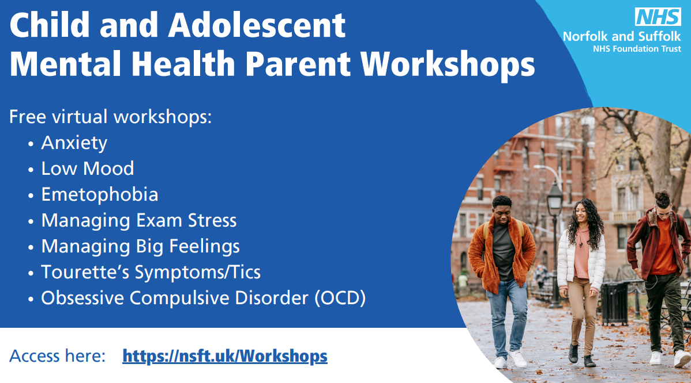
SEND Parent Padlet:
https://padlet.com/lkidd11/parenting-padlet-hgdrprcnhjl3ene5
Please use this link to have an explore of our new SEND Parent Padlet, which contains lots of information resources and links to provide you with support and advice. There are links to local groups, SEND resources and parenting tips.



School uniform expectations
