

SEND Information Report
2025 – 2026
Issued September 2025

  Our School | Coupals Primary Academy is a two-form entry mainstream school in Haverhill, with our core DRIVE values being determination, readiness, integrity, versality and empathy. We value all children equally and aim to create an inspiring, stimulating and safe environment that enables all children to achieve their full potential. Our aim is to develop children into confident and resilient learners, for them to develop a love of learning and to encourage them to explore opportunities to step outside of their comfort zone whilst not neglecting the need to develop wider life skills that they can use to underpin their future development.  September 2025 Information  SEND by Year Group  We also have children on our ‘Monitoring Register’.
  Number on roll | 280
  Number on SEND register | 40
  Number of Education, Health and Care Plans (EHCPs) | 10
  Nursery | 1 | Year 3 | 6
  Reception | 1 | Year 4 | 5
  Year 1 | 4 | Year 5 | 10
  Year 2 | 4 | Year 6 | 9
  Meet our SENDCo |   The SENDCO is Lucy Kidd. She began her teaching journey in 2005 and is currently completing the NPQSEN qualification.  If you would like to contact Mrs Kidd, please call 01440 763933 or email admin@coupalsacademy.co.uk  .
  Special Educational Needs | SEND is categorised into four broad areas in the SEN Code of Practice 2015:  At Coupals, we support children with a variety of differing special educational needs and we pride ourselves on being a highly inclusive school with an ethos which encourages and celebrates diversity and difference. We are a Trust Lead School.
   | Cognition and Learning
   | Communication and Interaction
   | Social, Emotional and Mental Health
   | Sensory and Physical
  Identifying and Assessing Need | A child or young person has a special educational need if they have a learning difficulty or disability which calls for special educational provision. This provision means that which is additional to or different from that made generally available for children and young people of the same age.  A child or young person has a learning difficulty or disability if they:  - have significantly greater difficulty in learning than the majority of others the same age, or  - have a disability which prevents of hinders him or her from making use of educational facilities of a kind generally provided for others of the same age at school  (SEND Code of Practice, 2015)  Every teacher knows the needs and abilities of children in their class and our assessment and monitoring procedures ensure that every child’s progress and attainment is continually monitored. When staff have a concern about a child, they follow the Graduated Response, including discussing the concern with the parents/ carers and completing a ‘SEND Cause for Concern form’. Depending on the level of concern or presenting needs, the SENDCo may then observe the child in class and gather the views of both children and parents. For some children, we may use standardised assessments including YARC, WRAT-5, BPVS and Sandwell Maths to identify gaps in learning and/or inform future provision. In turn, these assessments are used to track progress.  The ‘Graduated Response’ process to identifying children with SEND means that additional provision is planned and delivered through the four-part ‘Assess, Plan, Do, Review’ cycle. After an initial period of monitoring (usually a term), we will decide if a child needs to be placed on the SEND Register and a Pupil Support Plan will be written with three to four targets and additional support they are receiving. Class teachers share these with parents/carers, and they are reviewed three times yearly.  Some children may require more support than is ordinarily available and we may ask outside agencies to support us in ensuring that we are offering the best support we can.  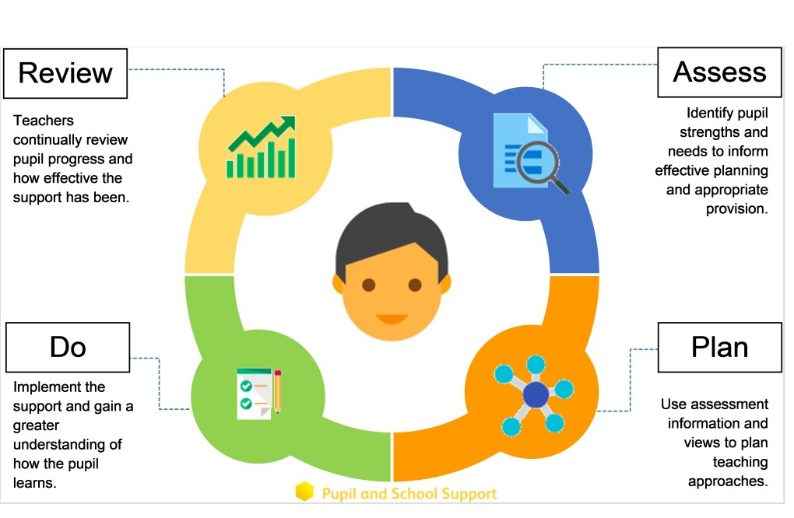
  Our approach to teaching children with SEND | We are an inclusive school. Wherever possible children are taught alongside their peers in flexible teaching groups.  Teachers adapt their high-quality teaching to cater for their pupils’ needs and plan individual timetables where necessary. When appropriate, staff are deployed to give children additional interventions in small groups outside the classroom.  We use the EEF guidance ‘Five-a-day’ and embed the key principles into all our lessons.  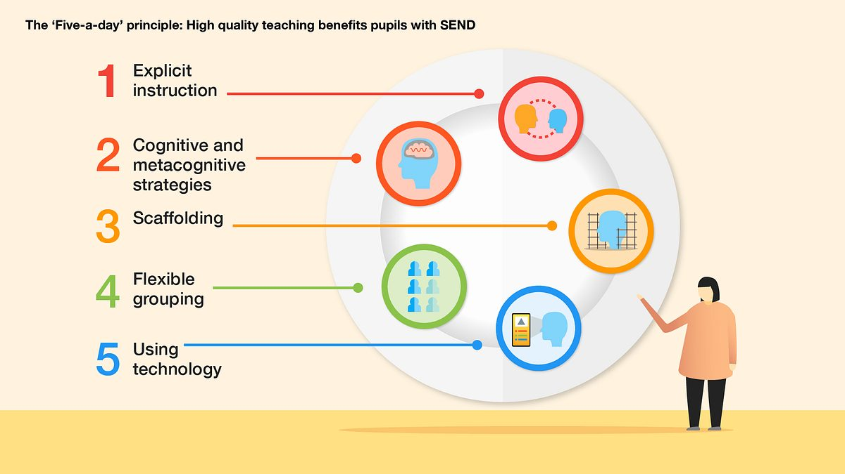  We use the SEND Handbook produced by the Unity Schools Partnership to complement our teaching. This handbook is reviewed at least annually and contains a wealth of information and support that helps teachers to further adapt and enhance their provision for those with additional needs. Staff also have access to our ‘SEND Information and Resources’ Padlet and our ‘Learning Made Easier’ strategy booklet.  We have our Nook intervention in the afternoon, which is designed to support children with EHCPs, EHCNAs or specialist teacher involvement, along with our Looked After Children. This focuses on self-esteem, social communication and social skills, while also working on the children’s individual targets.
  Curriculum adaptations | We use a range of strategies across our lessons to ensure we offer an inclusive approach to learning and allow all children to access the classroom environment. Our trust-wide curriculum CUSP (Curriculum Unity Schools Partnership) is an evidence-informed approach that presents curriculum in cumulative and coherent manner that is rightly challenging, but accessible for all.  Our provision to support children with additional needs comprises of three aspects:  - Adjustments – the ‘Teacher Tweaks’ that staff make through everyday Quality First Teaching (e.g. visual prompts, Now and Next structures etc.)  - Resources/Support – the physical or human resources (e.g. pencil grips, adult scribe, voice recorders etc.)  - Intervention – specific and additional teaching (e.g. individual or small group activities rehearsing a particular skill)  (Adapted from SEND Intervention, Judith Carter, 2022)  Common day-to-day adaptations may include:  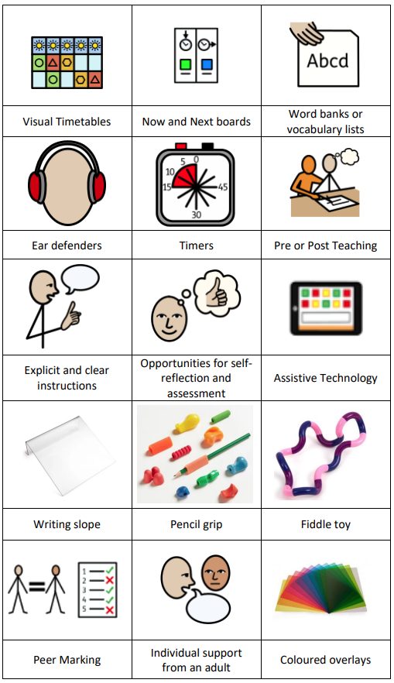
  Communicating with Parents and Carers | At Coupals we work closely with parents and carers and recognise that they have much to contribute to our support for children with SEND. We communicate in a range of different ways, including:  - Class teachers, Senior Leadership and pastoral staff available on the playground at the start and end of each day  - Parents’ Evening twice yearly. The SENDCo is always available at these events.  - Class Dojo, school website, Facebook and X (formerly known as Twitter)  - Annual Reports (summer term)  - Annual Reviews for those with EHCPs
Pupil Views | Pupil’s views are very important; they have a right to be involved in decisions about their education and they are made aware of the support that surrounds them in school.  Where appropriate, children are fully involved and their views feed directly into all policies, procedures and daily teaching of children with SEND.  In a manner appropriate to their level of need, pupils are given regular opportunities to:
   |  | 
  Self-assess how they are doing | Represent their peers when giving views in School Council meetings and similar | Attend meetings and help decide the support needed
  Evaluating Provision | We regularly review our provision for children with SEND and this is done in a range of different ways including:  - Review progress in SLT meetings and discussing next steps  - Discuss and share ideas in staff meetings to ensure up to date research and policies are in place  - Reviewing children’s individual progress at regular intervals  - Monitoring classroom practice by SENDCo and subject leaders  Our provision is also reviewed by external processes including:  - Annual SEND Review led by Trust Directors of SEND  - Termly visit by SES (Specialist Education Service)  - Teaching and Learning Reviews led by external advisers  - Ofsted inspections (last inspected in January 2023)
  Staff Training | At Coupals, we believe in professional development and aim to ensure all our staff have the understanding they need to enable them to support your child.  When a new member of staff joins the school, we ensure they understand the systems within school and they are given information about the children they are working with.  The senior leadership team within school are constantly moderating needs within the school and, where an area of concern is highlighted, whole school training may be organised to ensure all staff understand specific learning difficulties and appropriate teaching or support strategies that could be used.  If your child needs specialist support from an outside agency, such as the Speech and Language Service (SALT), Educational Psychologist (EP), Occupational Therapist (OT) or school nurse, we will always discuss this with you first.  Some of our staff have completed training in the following areas:
   |  |  | 
  Trauma Informed Practice | Lego Therapy | Reading for those who struggle | Bucket time (Attention Autism)
   |  | 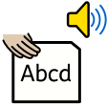 | 
  Dyslexia strategies | Makaton | Sounds-Write Phonics | Team Teach
   |  |  | 
  Specific Learning Difficulties | Thrive | ELSA (Emotional Literacy Support) | Speech and Language
  Transition Support | Nursery starters  We hold ‘Stay and Play’ sessions for the children, initially where parents / carers stay, and then when the children stay without parents/carers, in order to support their transition to Nursery.  Nursery to Reception  We hold a parent and carer session in the summer term for our new reception starters, providing parents with the opportunity to meet with the class teacher and SENDCo.  We hold ‘Stay and Play’ sessions in the second half of the summer term in preparation for the September start.  We liaise closely with local early years settings and rely on their expert knowledge of the children to secure they have the best possible start to school.  End of Year transition  The last few days of the summer term are ‘move up days’, where the children complete their lessons in their new classrooms with their new teachers. This reduces anxiety over the summer holidays, and allows the children to get to know their new teacher.  Some children may require extra transition visits to their new classroom or additional time with their new teacher to help reduce their anxiety and ensure that the transition is successful and positive.  Class teachers meet with each other during the summer term to discuss the needs of the children and share Pupil Support Plans and relevant information about the children.  Secondary Transition  We liaise very closely with our partner schools to ensure that the transition from primary school to the secondary school is as smooth as possible. We highlight those children in Year 6 who would benefit from further ‘enhanced transition’ and ensure we pass on all relevant documentation in a timely manner.  Mid-Year new starters  When we are aware that pupils joining us from other settings have identified special educational needs, we arrange a phone call and/or meeting with the family to enable us to gain a greater understanding on the support we need to put in place.
  Outside Agencies | We also seek advice and equipment from external agencies and work closely with a range of professionals to provide support for children with SEND:  - Specialist Education Services (SES)  - Occupational Therapy (OT)  - Physiotherapy (PT)  - Speech and Language Therapy (SALT)  - School Nursing Team  - Educational Psychology (EP)  - Primary Mental Health Support Team  We also draw upon the experience and expertise of colleagues across Unity Schools Partnership, including that of the Trust’s Directors of SEND. We will ask your permission before we arrange for any outside agencies to come in and work with your child. Once the feedback has been received, we will of course share any advice given.
  Clubs and Trips | Our extra-curricular activities and school visits are available to all our children, including our before-and after-school clubs.  All children are encouraged to take part in sports day, school competitions, school assemblies and performances, workshops, etc.  All children are encouraged to apply for roles of responsibility in school e.g. school parliament, Head Boy/Girl etc.  No child is ever excluded from taking part in these activities because of their SEN or disability.
  If you have concerns… | In the first instance, any SEND concerns should be raised with the Class Teacher. You can contact them via Class Dojo to make a face-to-face appointment or to request a telephone call.  If concerns or issues are still not resolved, then our SENDCo Mrs Kidd should be contacted.  In the event of a complaint, please follow the Unity Schools Partnership complaints procedure: https://www.unitysp.co.uk/documents/complaints-policy-and-procedure/
  Suffolk Local Offer and further information | The Suffolk Local Authority Local Offer can be found at: https://www.suffolklocaloffer.org.uk/
  Suffolk SENDIASS | Home - Suffolk SENDIASS
  British Dyslexia Association | British Dyslexia Association
  British Deaf Association | British Deaf Association – The BDA stands for Deaf Equality, Access and Freedom of Choice.
  National Autistic Society | National Autistic Society
  Action for Children | Action For Children | Children's charity | For safe and happy childhoods
  Family Action | Family Action: Supporting families at every age and stage of life
  Parenting Padlet | https://padlet.com/lkidd16_1/parenting-padlet-hgdrprcnhjl3ene5
  Feedback | Child: “This is the greatest day of my life!”  Parent: “Thank you for all your support – I hope you know how much it is appreciated.”

