**Year 5 Rounders**

On Tuesday morning a selection of our Year 5 pupils headed for Westfield to take part in a small competition between the two schools.

It took Coupals a couple of games to get into the swing of things losing their first game

Coupals 4 -7 Eagles, this was then followed by another defeat Coupals 2 ½ - 7 DunnoYets

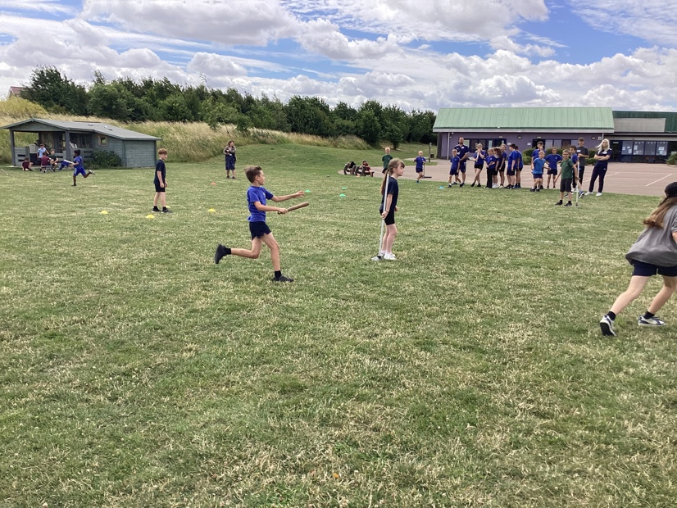

After the first two games the children really took on board the feedback given from the two games as well as what they observed themselves. This resulted in three victories in our last three games.

Coupals 8 – 1 ½ Starlings, Coupals 6 – 2 Kingfishers, Coupals 8 ½ - 3 ½ Goats.

The final three victories gave Coupals an overall record of Won 3 and Lost 2 finishing in joint 2nd place. A fantastic morning out and excellent opportunity for the children who all really enjoyed themselves.

