



Friday 31st March, 2023

Dear Parents/Carers,

I cannot quite believe that the spring term has come to a swift conclusion. I am sure that you will agree that this half-term has quite simply zipped by.

I can honestly say that I am extremely proud of your children. They have worked incredibly hard and should be proud of all that they have achieved this half-term. Next term is a big term for our Year Six cohort as they are ready to embark on their final term in Primary Education and their Year Six SATs. It also proves to be a busy term with lots to look forward to including, the Year Six residential, Year Two Skills Escalator Days, a Year Four trip to Samuel Ward to see the Curiosity Cube and so much more.

It was wonderful to welcome Year One parents to our Year One Curriculum meeting on Wednesday. Thank you to those parents who attended to find out what is in store for their child’s learning journey in the summer term. For those unable to attend, Mrs Parsons will post the slides on to Class Dojo to give you an insight in to what is coming in the summer term.

Today we say a fond farewell and thank you to Miss Jordan and Mrs Jones. We wish them every success in their futures. We shall miss them both a great deal and we know that the children who have been in their care have been very lucky to have been taught by them both. We also will be welcoming our new Assistant Head teacher – Mrs Guiler and Year One teacher, Miss Robinson. We are delighted that they will be joining our Coupals family.

Have a wonderful and restful Easter break and thank you for all of your support this term,

Tom Wade

Head of School

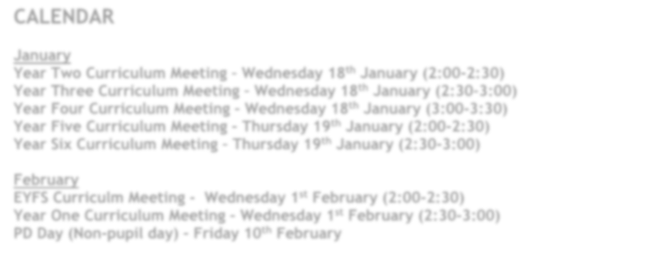

# CALENDAR

**March**

**Final day of the Spring term – Friday 31st March**

**April**

**PD Day – Non-pupil day – Monday 17th April**

**First day of the Summer term – Tuesday 18th April**

**School photographs – Wednesday 19th April**

**May**

**Tuesday 2nd May- Friends Pop Up Shop – Friends Event – details to follow**

**Wednesday 3rd May – Year Four Curiosity Cube trip to Samuel Ward**

**Friday 5th May – Purple Day and Friends Pop up Shop – details to follow**

**Monday 8th May – Bank holiday to celebrate the King’s Coronation**

**Tuesday 9th May – Friday 12th May – Year Six SATs Week**

**Friday 26th May – Year Two Skills Escalator Day – details to follow**

Easter Experience

On Monday, Year Four were lucky enough to be invited to St Mary’s Church in Haverhill for an Easter Experience. They took part in different activities to learn about Holy Week and the events that lead to Jesus’ crucifixion. Everyone had a lovely time and represented the school fantastically. The event organisers even commented on what a credit these children are to the school, well done Year Four!

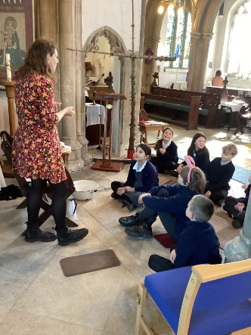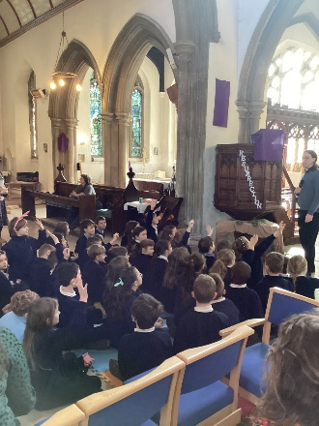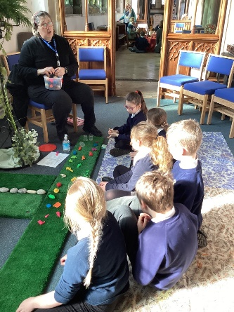

**Year Five**

This week, in year Five, we have been very busy with lots of new and exciting learning.

In writing, we have been looking at poetic devices which the children have been apply their own poems. Zambezi and Nile have really enjoyed using word play and wiring their poems to amuse. In maths, we have been looking at co-ordinates and transformations the children have really enjoyed this unit. The children have also been working really hard on their arithmetic practise and problem solving.

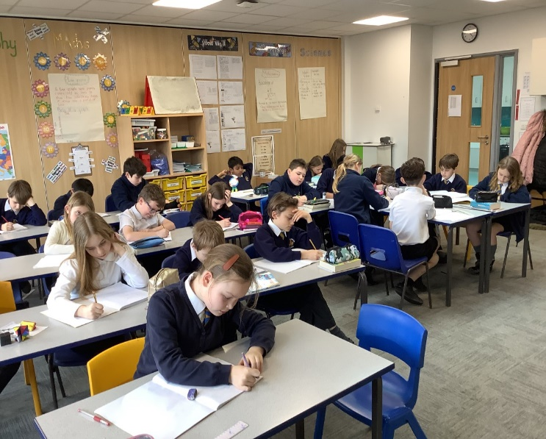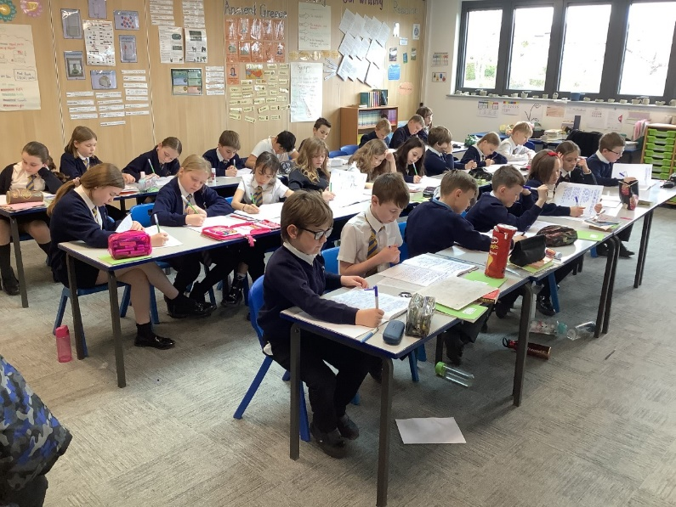

Year Six

Year Six have been shown the light this week in their science lessons! Learning about electrical components and properties of circuits came easily to our students who thoroughly enjoyed brightening up their classrooms. Not to be outshone, Year Six also celebrated a fantastic week in mathematics progress, delivering our highest yet average score for our weekly arithmetic tests!

The Easter break will be a well-deserved rest for our senior students.

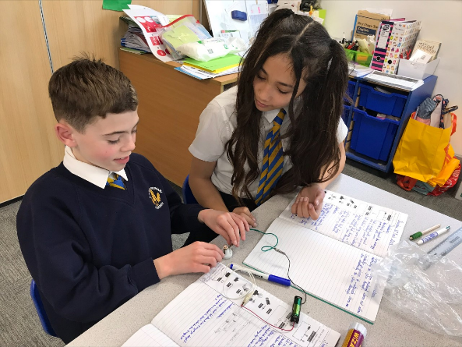 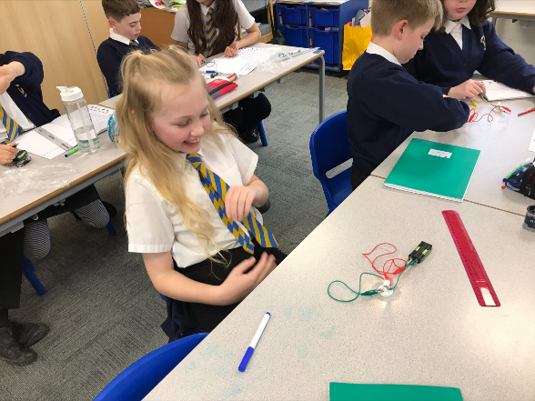

**Menu for the Spring/Summer term**

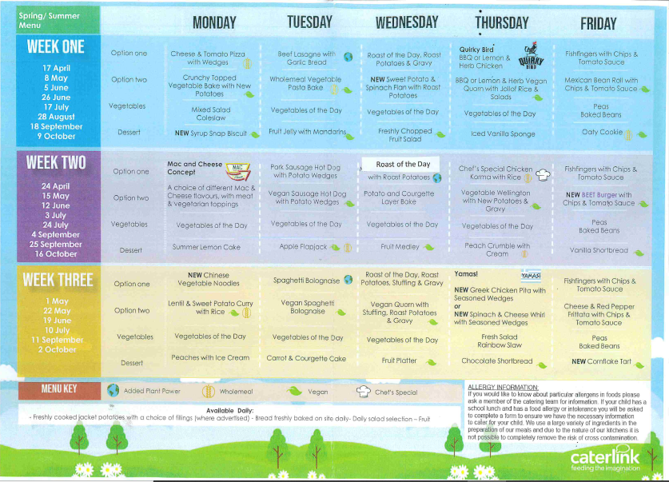

**October Holiday Consultations**

**Please look out for the email from the Trust, updating on the October 2 week holiday consultations.**

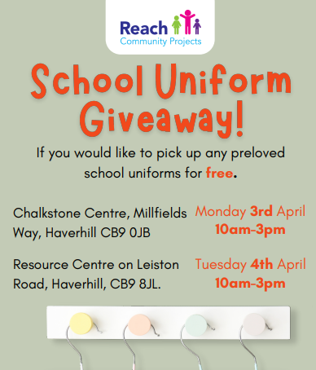



**The March/April Issue of Families Suffolk Magazine is available to read online now.**

This issue includes a brilliant ‘Places to Visit in 2023’ feature full of great ideas for local family days out and perfect for planning the Easter holidays.

There are also competitions to **WIN FAMILY TICKETS** to:

* The East Anglian Game & Country Fair
* The South Suffolk Show
* The Hadleigh Show

Families Suffolk Magazine is also proud to be supporting the Home-Start in Suffolk Character Creations Competition - Schools have until Friday 31st March to sign up.

**Click on the link to read:**[**https://bit.ly/FamiliesSuffolk_Mar_Apr23_Print**](https://bit.ly/FamiliesSuffolk_Mar_Apr23_Print)

If you would like to get your hands on a hard copy of this issue, you can pick up a FREE copy from any Suffolk Library or Children Hub or Waitrose in Ipswich, Bury St Edmunds and Sudbury.

I hope you enjoy.

Kind regards

Stacey Phillips

Editor

Families Suffolk   
   
Tel: 07951 946736

Click [here](https://bit.ly/FamiliesSuffolkMagazine_Issue63Jan_Feb22PRINTEdition)to download the current issue of Families Suffolk Magazine

**Part of the Families® magazines group.**

**Providing useful information for parents since 1990.**

*On the 25th May 2018, the new General Data Protection Regulation (GDPR) comes into effect. Under this new law, European standards in data protection shall align with current technology standards. We have updated our Privacy Notice in accordance with the new GDPR legislation. You can view it*[*here*](https://docs.google.com/document/d/1ihwZhchASGfy8_fh6sDM6iNledsMjYQKcLsPlSkN7IY/edit)*.*