Pulse CSI
The Chestnuts
2 Farriers Gate
Cranwell Village
Lincolnshire
NG34 8NT
Tele: 01400 263061

Email: info@pulsecsi.com Website: www.pulsecsi.com Twitter | Facebook | Instagram @pulsecsi

Account Name: Pulse CSI

Bank Details: Santander Plc

Sort Code: 09 01 30

Account No. 29771145

Yours sincerely
FOR AND ON BEHALF OF
PULSECSI

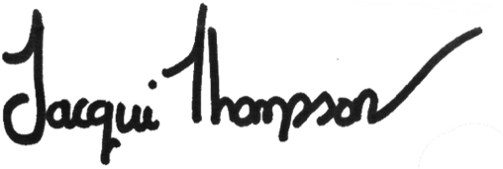

JACQUI THOMPSON
Operations Director

