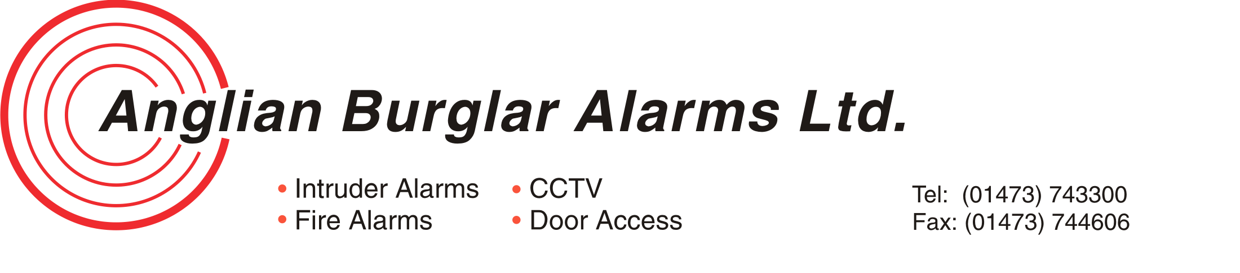

COMPANY NAME: ANGLIAN SECURITY & FIRE LTD

ADDRESS: UNIT 21

FARTHING ROAD INDUSTRIAL ESTATE

IPSWICH, SUFFOLK, IP1 5AP

FAX NO/e-mail
For Remittance Advices: 01473 744606 heather@anglianburglaralarms.co.uk

BANK NAME: LLOYDS TSB

ADDRESS: 13 CORNHILL

IPSWICH

IP1 1DG

A/c NAME: ANGLIAN SECURITY & FIRE LTD

SORT CODE: 30-94-55

BANK ACCOUNT NO: 02579155

IBAN: GB57 LOYD 3094 5502 5791 55

SWIFT CODE: LOYD GB 2L

SIGNED:
FINANCIAL DIRECTOR

